World and Native Languages Standards

Introduction
The World and Native Languages Standards describe what students should know and be able to do as they study and learn to communicate in languages other than English. By engaging in learning a world language, students build 21st century literacy skills. Reading, writing, listening, speaking, and viewing are integral to the language learning process. When students learn a second language they build proficiency in three modes of communication: interpersonal (person-to-person speaking or writing), interpretive (listening and reading), and presentational (one-way speaking and writing). Students learn to maneuver the structures, functions, and patterns of language. They learn to ask and answer questions, identify words, describe, retell stories, interpret text, and apply the conventions of language within the constructs of a particular culture.

Learners benefit by having the language proficiency to communicate with global audiences, the insight into the cultural perspectives that shape those audiences, and the ability to behave appropriately in a variety of cultural contexts. These standards are organized under two broad categories: Communication and Cultural Competencies. They are not intended to be taught as separate entities, but should be interconnected during instruction. Students must not only communicate, but be able to do so in a culturally appropriate manner. A culture’s perspectives reflect the values, beliefs, and attitudes of its people. Through contact with products (monuments, laws, music, etc.) developed by a culture and practices (eating habits, shopping behaviors, use of space, etc.) demonstrated by its people, we come to understand the perspectives (values, attitudes, beliefs, etc.) of a people. Through these standards, Arizona seeks to nurture and develop indigenous, heritage, and world languages. Students who develop world languages, heritage language, and cultural skills will be better-positioned to live and work in an increasingly multilingual environment.
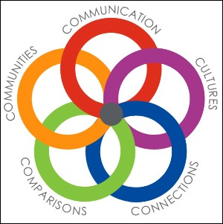
Image courtesy of ACTFL

Arizona’s World and Native Languages Standards can be used to create a variety of classes, courses, and programs across multiple grade levels. Many factors influence the rate of progress through three performance levels (Novice, Intermediate, and Advanced) and the level acquired by learners at the end of the program. Among those factors are types of program models, the category or difficulty of the language, student motivation, and the degree of exposure in the target language. These standards allow for multiple entry points into language learning (elementary, middle, or high school) and for instruction through various programs and/or models. In these standards, “the target language” may indicate world language, foreign language, classical languages, second language, languages other than English, Native American languages, heritage languages, or American Sign Language.

Rationale
These World and Native Languages Standards have substantive changes from Arizona’s 1997 Foreign and Native Language Standards in response to the needs of the field. Revision of these standards provides opportunity for students to enter into study of a new language at any point in the K-12 continuum and the standards reflect student performance expectations based on when that entry point occurs. The American Council on the Teaching of Foreign Languages
(ACTFL) Anticipated Outcomes Table (below) illustrates grade-level targets for performance levels based on when students enter the study of the target language.
Table courtesy of ACTFL

This approach to language learning focuses on performance and aims to build learners’ capacity to use the language(s) in functional and meaningful ways. These standards state what students need to know about languages and cultures, including their own; what students need to be able to do to demonstrate language proficiency; and how this knowledge and these abilities relate to the subject matter of other core areas.

While Arizona’s State Board of Education does not require second language credits for graduation, many post-secondary institutions, including all three state universities in Arizona, require students to complete two years of one world/foreign language for entering freshman admissions. These credits include Native American Languages (see ABOR Policy 2-121: Undergraduate Admission Requirements).

Organization of the Standards
Arizona’s World and Native Languages Standards are organized into nine strands under two broad categories: Communication and Cultural Competencies. Communication is divided into three modes (interpersonal, interpretive, and presentational) and these are further divided into five strands. The Cultural competencies are divided into four different strands.
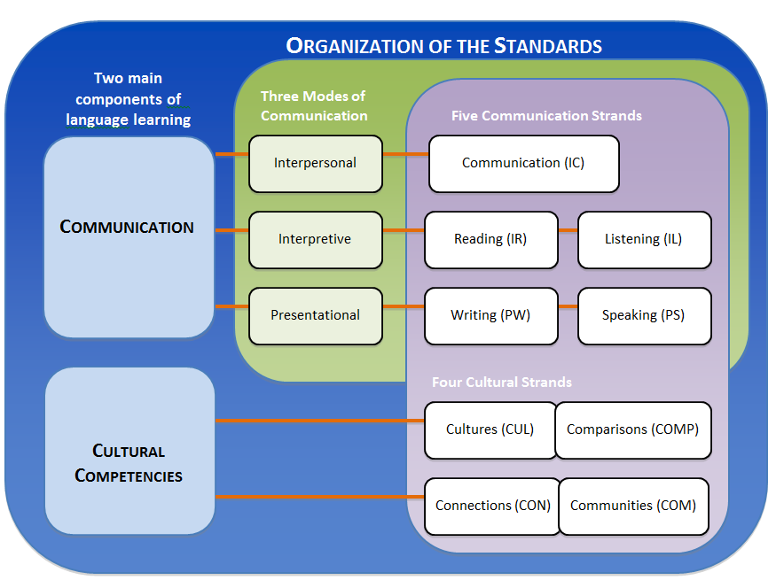

These nines strands are not intended to be taught separately and should be interconnected during instruction. The standards recognize that the needs of Native American speakers and heritage students are often unique from non-native speakers and non-heritage speakers. This includes the need for preservation and revitalization of the languages. It is recognized that with diverse languages (including Native American, Classical, alphabetic, logographic, and American Sign Language), not all language expectations within the standards may be applicable. Each language has its own linguistic and cultural characteristics and may require different content and pedagogical approaches. The standards are not linear; they have a dynamic nature to accommodate individual student or language needs.

Performance Towards Proficiency Levels
The degree of performance and proficiency in a language is proportional to the amount of time spent by students in meaningful study, with some languages requiring more time than others to attain the same degree of proficiency. Proficiency can be defined as the ability to spontaneously communicate in a culturally appropriate manner. While proficiency is the long-term goal of language programs, language teachers must provide explicit instruction and target language input that includes the development of authentic situations so that students can practice or “perform” in these settings before someday going out into the real world where their true proficiency will be tested. As students acquire language, the teacher must provide linguistic support or “scaffold” instruction to help the student practice and perform at the next level. Over time, the support is removed and the learners can gradually demonstrate the higher level performance on their own. The standards can be used to help teachers plan for instruction and assessments of student practices and performances in order to determine where a student’s true proficiency might lie.
While language study can begin at any grade level, the use of the terms Novice, Intermediate, and Advanced indicate general performance and proficiency levels. Each level considers how well a speaker uses vocabulary, text type, language functions, context, accuracy control, and communication strategies. Additionally, each level takes into consideration how well the speaker is comprehended by others. A brief overview follows:
- Novice: The student communicates with words/characters and phrases to express basic needs on familiar topics that have been highly practiced and memorized. The learner controls the accuracy within the memorized and practiced context and can be understood by one accustomed to dealing with language learners (a sympathetic listener).
Example: “gloves”, “need gloves”, “I need gloves.”
- Intermediate: The student communicates with sentences and some connected sentences while expressing and elaborating on basic needs. The learner controls the language with enough accuracy to be understood by one accustomed to dealing with language learners.
Example: “I need winter gloves because my hands are cold.”
- Advanced: The student communicates in various time frames in extended, organized paragraph length discourse to respond to and resolve problems. The learner controls the language sufficiently enough to interact effectively with someone unaccustomed to dealing with language learners.
Example: “If gloves are on sale when I get my next paycheck, I might go get a pair to keep my hands warm.”

As students acquire language skills, they will progress through these proficiency levels with varying degrees of language control, expanding the range of listeners with whom they will be able communicate. Students in the Novice and Intermediate levels, in particular, will tend to make many errors in their communication; this is normal. In general, students communicating at the Novice level will be comprehensible only to very sympathetic listeners such as teachers and fellow language learners. As students move into the Intermediate level, they become more comprehensible to sympathetic listeners in a wider range of situations, and their expanding skills should afford them the ability to sometimes be understood by some native speakers. By the time they reach Advanced proficiency, students should have a higher degree of accuracy, and they should be largely comprehensible to most native speakers.

The graphic below illustrates a full scope of student performance and proficiency in a target language over many years of study and across 5 levels of proficiency. These levels are generalizations and vary according to the time spent in the language as well as the difficulty of the language studied. These proficiency levels are based on the American Council on the Teaching of Foreign Languages (ACTFL) Proficiency Guidelines 2012 and can be used to measure performance in an instructional setting. The levels of Novice, Intermediate, and Advanced are further subdivided into sub-levels Low, Mid, and High. As students spend more time in the target language, their performance towards their true proficiency level begins to expand. The highest two levels (Superior and Distinguished) are not included in Arizona’s World and Native Languages Standards because these levels are generally not considered outcomes of K-12 learning.

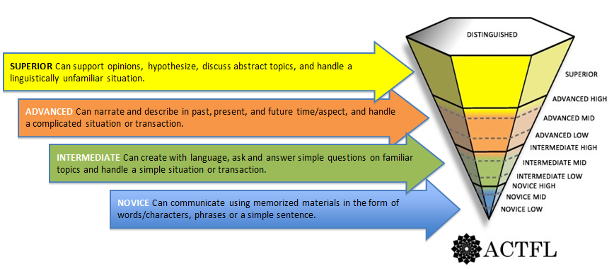
Pyramid image courtesy of ACTFL

Coding Structure
The coding structure of the World and Native Languages Standards (WNL) follow the format below:
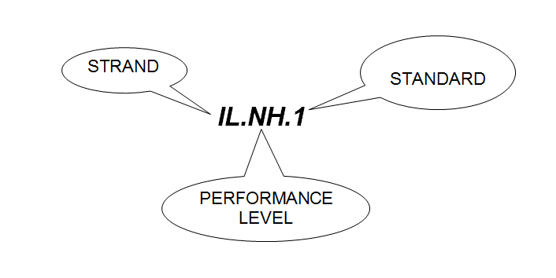
Examples:

Code | Strand | Performance level | Standard
IL.NH.1 | Interpretive Listening (IL) | Novice High (NH) | 1
IC.AM.4 | Interpersonal Communication (IC) | Advanced Mid (AM) | 4
CUL.N.1 | Cultures (CUL) | Novice (N) | 1
COM.I.2 | Communities (COM) | Intermediate (I) | 2

Methodology
The committee that worked to develop Arizona’s World and Native Languages Standards consisted of a representative sample of K-12 and post-secondary language educators from around the state. This committee represented large and small schools; rural, suburban, and urban districts and charters; ethnic and geographic diversity; a diversity of languages taught; and a variety of language programs and/or models. The standards committee reviewed standards and information from a variety of states and professional organizations to develop standards based on current research on student language learning (see Resources and Works Cited). External reviews by the public and all levels of language professionals provided additional guidance and perspective to the committee.

Resources and Works Cited
ABOR Policy 2-121: Undergraduate Admission Requirements. Web. 16 April.2015
American Council on the Teaching of Foreign Languages (ACTFL). (2012). ACTFL Performance Descriptors for Language Learners 2012. Alexandria, VA: ACTFL. Web. 16 April.2015
American Council on the Teaching of Foreign Languages (ACTFL). (2012). ACTFL Proficiency Guidelines 2012. Alexandria, VA: ACTFL. Web. 16 April.2015
American Council on the Teaching of Foreign Languages (ACTFL). (2013). NCSSFL-ACTFL can-do statements. Alexandria, VA: ACTFL. Web. 16 April.2015
The Center for Applied Second Language Studies. The Northwest National Foreign Language Resource Center. Eugene, OR,
Florida Department of Education (2011). 2011 Florida Next Generation World Languages Standards.
Jackson, A. W., Kolb, Charles, E. M., & Wilson, John I. National Imperative for Language Learning. Web. 16 April.2015
Kentucky Department of Education (2014). Kentucky Standard for World Language Proficiency.
National Council of State Supervisors for Languages (NCSSFL).
The National Standards Collaborative Board. (2015). World-Readiness Standards for Learning Languages: Fourth Edition (W-RSLL). Alexandria, VA: Author. Retrieved from: http://www.actfl.org/publications/all/world-readiness-standards-learning-languages.
New Jersey Department of Public Instruction (2014). New Jersey Core Curriculum Content Standard for World Languages.
Succeeding Globally Through International Education and Engagement: US Department of Education International Strategy 2012-16. Web. 16 April.2015
Communication
Interpersonal Communication (IC)
Interact and negotiate meaning in spoken, written, or signed conversations to share information, reactions, feelings, and opinions. The student can:
NOVICE |  |  | INTERMEDIATE |  |  | ADVANCED
Low | Mid | High | Low | Mid | High | Low | Mid | High
1. Communicate on some very familiar topics using single words and phrases that have been practiced and learned. | 1. Communicate on very familiar topics using a variety of words and phrases that have been practiced and learned. | 1. Communicate and exchange information about familiar topics using phrases and simple sentences. | 1. Participate in conversations on familiar topics by using simple sentences. | 1. Participate in conversations on familiar topics by using a series of sentences and a few connecting words. | 1. Participate with ease and confidence in conversations on familiar topics by using connected sentences. | 1. Engage in conversations about familiar and some academic topics that go beyond everyday life using multiple simple sentences. | 1. Engage fully in conversations and discussions not only on familiar topics, but also on some concrete social, academic, and professional topics using connected sentences. | 1. Engage fully and spontaneously in conversations and discussions on complex issues and concrete topics using connected sentences.
 |  | 2. Carry out short social interactions in everyday situations by asking and answering simple questions. | 2. Carry out short social interactions in everyday situations by asking and answering simple questions. | 2. Manage short social interactions in everyday situations by asking and answering a variety of questions. | 2. Manage social interactions in everyday situations, even when there is an unexpected complication. | 2. Manage familiar situations with an unexpected complication. | 2. Confidently communicate in routine situations with an unexpected complication. | 2. Confidently communicate beyond routine situations with an unexpected complication.
 |  |  |  | 3. Communicate about events and experiences of daily activities and personal life. | 3. Communicate about events and experiences with some detail in various time frames. | 3. Communicate in an organized way and with some descriptive detail about events and experiences in various time frames. | 3. Communicate using descriptive detail about familiar and some unfamiliar events and experiences in various time frames. | 3. Communicate using descriptive detail about events and experiences in multiple time frames.
 |  |  |  |  |  |  | 4. Express one’s point of view in conversations and discussions on some complex issues. | 4. Express and support opinion and develop hypotheses on topics of particular interest or personal expertise.

Interpretive Listening (IL)
Understand, interpret, and analyze what is heard (communicated in ASL) on a variety of topics. The student can:
NOVICE |  |  | INTERMEDIATE |  |  | ADVANCED
Low | Mid | High | Low | Mid | High | Low | Mid | High
1. Recognize a few familiar words or phrases. | 1. Recognize some familiar words and phrases. | 1. Understand words, phrases, and simple sentences related to everyday life; sometimes understand the main topic of what is heard. | 1. Understand the main idea in short, simple messages, presentations, and overheard conversations on familiar topics. | 1. Understand the main idea in messages, presentations, and overheard conversations on a variety of topics related to everyday life, personal interests, and studies. | 1. Understand the main idea and a few details in messages, presentations, and overheard conversations (even when something unexpected is expressed) on a variety of topics related to everyday life, personal interests, and studies. | 1. Understand the main idea and some supporting details in organized speech on a variety of topics of personal and general interest. | 1. Understand the main idea and most supporting details on a variety of topics of personal and general interest as well as some topics of professional interest. | 1. Follow narrative, informational, and descriptive speech.
 |  |  |  |  | 2. Understand a few details of conversations, even when something unexpected is expressed; sometimes follow what is heard about events and experiences in various time frames. | 2. Follow stories and descriptions of various lengths and time frames. | 2. Follow stories and descriptions of some length with supporting details and in various time frames. | 2. Understand discussions on most topics that deal with special interests, unfamiliar situations, and abstract concepts.
 |  |  |  |  |  | 3. Understand information presented in a variety of genres on familiar topics, even when something unexpected is expressed. | 3. Understand information presented in most genres even when not familiar with the topic. | 3. Sometimes follow extended arguments and different points of view.

Interpretive Reading (IR)
Understand, interpret, and analyze what is read or viewed on a variety of topics. The student can:
NOVICE |  |  | INTERMEDIATE |  |  | ADVANCED
Low | Mid | High | Low | Mid | High | Low | Mid | High
1. Recognize a few letters or characters and learned words and phrases. | 1. Recognize and understand some characters, words, and phrases. | 1. Understand familiar words, phrases, sentences, and sometimes the main idea within short and simple texts related to everyday life. | 1. Understand the main idea of short and simple texts when the topic is familiar. | 1. Understand the main idea of texts related to everyday life, personal interests, and studies. | 1. Understand the main idea of texts related to everyday life, personal interests, and studies. | 1. Understand the main idea and some supporting details on a variety of topics of personal and general interests. | 1. Understand the main idea and relevant supporting details on a variety of topics of personal and general interests as well as some professional topics. | 1. Understand what was read on most topics that deal with special interests, unfamiliar situations, and abstract concepts.
 |  |  |  |  | 2. Sometimes follow stories and descriptions about events and experiences in various time frames. | 2. Follow stories and descriptions of various lengths, time frames, and genres. | 2. Follow stories and descriptions of considerable length, various time frames, and genres, even with an unfamiliar topic. | 2. Easily follow narrative, informational, and descriptive texts of various lengths and in various time frames and genres.
 |  |  |  |  |  |  |  | 3. Sometimes follow extended arguments and different points of view.

Presentational Speaking (PS)
Present information, concepts, and ideas to inform, explain, persuade, and narrate on a variety of topics using appropriate media and adapting to various audiences of listeners or viewers. The student can:
NOVICE |  |  | INTERMEDIATE |  |  | ADVANCED
Low | Mid | High | Low | Mid | High | Low | Mid | High
1. Present information about self and other familiar topics using single words or practiced phrases. | 1. Present information about self and other familiar topics using a variety of words, phrases, and practiced expressions. | 1. Present basic information on familiar topics using learned phrases and simple sentences. | 1. Present information on familiar topics by using a series of simple sentences. | 1. Make simple presentations on a wide variety of familiar topics using connected sentences. | 1. Make general presentations on events and experiences with some control of various time frames. | 1. Deliver detailed presentations on events, interests, experiences, and academic topics in various time frames. | 1. Deliver detailed presentations on a variety of events, experiences, academic topics, and issues in various time frames. | 1. Deliver detailed presentations with accuracy, clarity, and precision on a variety of events, experiences, and academic and professional topics in various time frames.

Presentational Writing (PW)
Present information, concepts, and ideas to inform, explain, persuade, and narrate on a variety of topics using appropriate media and adapting to various audiences of readers or viewers. The student can:
NOVICE |  |  | INTERMEDIATE |  |  | ADVANCED
Low | Mid | High | Low | Mid | High | Low | Mid | High
1. Copy some familiar words, characters, or phrases. | 1. Write lists and practiced phrases on familiar topics. | 1. Write short messages and notes using phrases and simple sentences on topics related to everyday life. | 1. Write and share short messages about familiar topics using a series of simple sentences. | 1. Write and share material about a variety of familiar topics using connected sentences. | 1. Write and share simple paragraphs about events, experiences, and academic topics with some control of various time frames. | 1. Write and present organized paragraphs appropriate to an audience on a variety of topics, events, and experiences in various time frames. | 1. Write and present papers/essays on events, experiences, and academic and professional topics in various time frames using well-organized, detailed paragraphs. | 1. Write and present in-depth, well-organized reports with clarity and precision on a variety of topics, issues, and interests in various time frames.

Cultural Competencies
Cultures (CUL)
Use the target language to investigate, explain, and reflect on the relationship between the practices, products, and perspectives of cultures studied. The student can:
NOVICE | INTERMEDIATE | ADVANCED
1. Recognize basic practices, products, and perspectives of cultures where the target language is spoken (e.g., greetings, holiday celebrations, body language, gestures, traditions). | 1. Investigate and describe similarities and differences in practices, products, and perspectives used across cultures (e.g., holidays, family life, historical and contemporary figures) to understand one’s own and others’ ways of thinking. | 1. Analyze and evaluate practices, products, and perspectives of the culture studied and describe how they are interrelated to topics of philosophy, social issues, regionalisms, history, and traditions of their own cultures (as applicable).
2. Participate in age-appropriate and culturally authentic activities such as celebrations, songs, games, and dances; recognize products of culture (e.g., food, shelter, clothing, transportation, toys). | 2. Use appropriate language and behaviors while participating in familiar culturally authentic activities and situations (e.g., presentations, virtual activities, community celebrations, theatrical productions, concerts, interviews). | 2. Interact at a culturally competent level in familiar and some unfamiliar cultural situations (e.g., community events, travel, service activities, interactions).

Connections (CON)
Build, reinforce, and expand knowledge of other content areas and evaluate information and diverse perspectives while using the target language to develop critical thinking and creative problem solving. The student can:
NOVICE | INTERMEDIATE | ADVANCED
1. Identify and use familiar vocabulary and phrases in the target language supported by resources (e.g., maps, graphs, visuals, audio, digital media) to reinforce prior knowledge and make connections to new knowledge of familiar topics in other content areas (e.g., geography, history, arts, math, science). | 1. Access and interpret information in the target language on familiar topics and use it to reinforce and further knowledge in other content areas. | 1. Analyze and synthesize information gathered in the target language to think critically and solve problems in other content areas and real world situations in the culture(s) studied and (as applicable) in one’s own culture.

Comparisons (COMP)
Use the language to investigate, explain, and reflect on the nature of language and the concept of culture through comparisons of the target language and cultures studied to one’s own. The student can:
NOVICE | INTERMEDIATE | ADVANCED
1. Recognize and compare words, true and false cognates, sound patterns, and basic grammatical structures of the target language with his/her own language (as applicable). | 1. Explain and compare features of target language (e.g., language patterns, expressions, sentence structures) with his/her own language (as applicable). | 1. Analyze and compare features of different registers of language, cultural perspectives as reflected in a variety of genres (e.g., literature, blogs, podcasts, newspaper articles), and regional varieties (e.g., differences in pronunciation, intonation, stress, dialects, vocabulary, grammar).
2. Identify and compare products and practices (e.g., celebrations, dances, oral stories, food) typical of the target culture with his/her own culture (as applicable). | 2. Compare and contrast familiar topics (e.g., geography, history, the arts) and discuss the impact on the target culture and one’s one culture (as applicable). | 2. Research cultural traditions and authentic works in order to analyze the viewpoints and their impact on cultures (e.g., recognize stereotypes).

Communities (COM)
Use the target language to participate in the community and in the globalized world, for enjoyment, enrichment, and advancement. The student can:
NOVICE | INTERMEDIATE | ADVANCED
1. Communicate using key words and phrases in the target language within the school setting (and beyond, as applicable). | 1. Use expanded vocabulary and structures in the target language to access and interact with different media and community resources within the school setting (and beyond, as applicable). | 1. Use language skills and cultural understanding to interact in the target language on a variety of topics within the school setting (and beyond, as applicable).
2. Participate in simple activities and cultural events within the school setting (and beyond, as applicable). | 2. Use the target language to participate in activities for personal enjoyment and community involvement within the school setting (and beyond, as applicable). | 2. Use target language to communicate with organizations or individuals to access information on personal and professional growth opportunities within the school setting (and beyond, as applicable).

