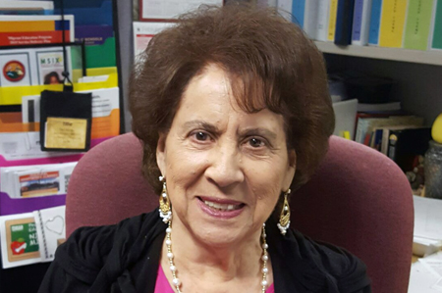

Tillie Peralta is Southeast Maricopa's 2017 Champion for Young Children
​Tillie Peralta has been selected as the 2017 Southeast Maricopa First Things First Champion for Young Children. ​
The award is given to local champions who actively volunteer their time to raise public awareness of the importance of early childhood development and health. Champions spend a significant amount of time volunteering with FTF and building public awareness about the importance of early childhood issues.
Peralta engaged in awareness-raising efforts such as:
- Bridging a connection to early childhood resources that will ensure the needs of the families are met.
- Organizing and facilitating an FTF early childhood training with Mesa Public Schools' migrant teachers.
- Organizing regular presentations with groups of migrant parents and co-presenting with FTF staff and invites elected officials to provide updates in the education field.
- Helping sign up parents to receive the FTF e-newsletter.
- Hosting the graduation ceremony of 50 young children of migrant families where FTF was the guest speaker.
- Networking with a number of FTF partners such as Adelante Clinic, Child Crisis Arizona and dental clinics that will assure that parents of young children have information on nutrition and important health issues.
- Working with local churches to provide donations of books, and supplies such as colors, paints and paper that help young children build a strong foundation and be ready for their preschool or kindergarten experience.
We recently caught up with Peralta, who works as a migrant family liaison in the English Language Acquisition Department that supports English Language Learners in Mesa Public Schools.
In that role, Peralta facilitates cooperation between families and community agencies, to provide support in meeting the social, physical, and emotional needs of English learner students and their families. Peralta has been working extensively with migrant families in Mesa for the past 38 years.
Question: Why do you feel early childhood development and health is so important?
Answer: I feel that the early years and health are very important in order for our children to have a successful future. It is a known fact that learning begins at birth and parents need to have the right tools to support their children (right after birth) with a healthy and early education so they can succeed in school.
Q: What caused you to get involved in efforts to increase public awareness in early childhood issues?
A: My passion has always been working with children. In all the 56 years that I have been involved in working with preschoolers, elementary, junior high, high school, and the juvenile and state parole system, my main efforts has been to increase public awareness focused in early childhood issues.
Why? Because learning begins at birth and children whose parents support their health, stable environment and early education, will do better in school and most likely attend college and have a successful career. In working with an average of 250 to 300 families per month (conducting home visits—school issues, medical, and "other") I can see that a lot of these students did not have the family support needed in their early childhood years to succeed in school. Some had problems reading by 4th grade and some later dropped out of high school. I took a few students to court (while working as a Juvenile Probation Officer) for minor crimes, but later convinced them to return to school. I also have workshops and parent meetings to educate the parents by enrolling them in parenting classes, Adult ESL classes, and nutrition classes. I also invite presenters from the educational, medical and other support agencies to advise the parents of the services that they provide.
Q: Why do you feel building awareness in early childhood and developmental health is so important for families and communities?
A: I feel that by building awareness in early childhood and developmental health is very important for families and communities the children will have a better chance of succeeding in school, will have better grades, will be healthier and most likely graduate from high school and attend college.
Q: How have you seen awareness for the early years change in your community?
A: I see more parents getting involved in their child's early education, in parenting classes, nutrition classes and English classes.
Q: How do you suggest other people in your community get involved?
A: By participating more in school functions, community health fairs, preschool classes, community preschool events.

