Picture a Kid
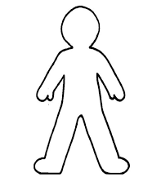
________________________________________________________________________________________________________________________________________________________________________________________________________________________________________________________________________________________________________________________________________________________________________________________________________

Picture a Kid
________________________________________________________________________________________________________________________________________________________________________________________________________________________________________________________________________________________________________________________________________________________________________________________________________

