SIG Cohort 3 Year 4
Sustainability Grant

Arizona Department of Education
Support and Innovation

2017-18

SIG Sustainability 2017-2018 SY Application
LEA/Charter Name | NCES ID# | CTDS# | Entity ID#
Board President | Email
Superintendent/ Charter Holder | Email |  | Phone #
Fiscal Manager | Email |  | Phone #
Federal Programs Director | Email |  | Phone #

School Board President Signature _____________________________________ Date_________________

Superintendent Signature____________________________________________ Date_________________

Charter Holder Signature____________________________________________ Date ________________

Fiscal Manager Signature ___________________________________________ Date ________________

Federal Programs Director Signature__________________________________ Date_________________

Purpose

The purpose of the 1003(g) School Improvement (SIG) Sustainability Grant is to provide local educational agencies (LEAs) that demonstrated successful implementation of the selected model during the previous three years and demonstrate strong commitment to sustainability.

Eligible Applicants

Eligible applicants are current SIG Cohort 3 Schools who have successfully implemented the Transformation or Turnaround model, put systems in place to ensure continued improvement, and increased student achievement.

Grant awards will not be made to Local Education Agencies (LEAs) that are out of compliance with state or federal requirements, fiscal or programmatic.

Process
This is a competitive grant.

- The SIG Cohort 3 Sustainability Grant application release on Feb. 22, 2017.
- The SIG Cohort 3 Sustainability Grant application webinar on Feb. 23, 2017 at 3:30.
- The SIG Cohort 3 Sustainability Grant application is due March 30, 2017 by close of business.
- Email a signed PDF copy to Devon Isherwood, devon.isherwood@azed.gov .
- Submission of completed application with all required documents and evidence is required by due date. Additional inquiries from ADE will not be made.

I. DIRECTIONS
- LEA and School teams collaborate to write a strong, detailed sustainability application, provide all required documents, provide evidence of compliance and check and sign assurances.
  - LEA’s assigned specialist is available for assistance.
  - It is highly recommended that the rubric is used when completing application.
  - Webinar will be held February 23, 2017 at 3:30.
  - Archived webinar will be available on SI website
- Email signed PDF application with signed assurances and all required documents and evidence to ADE no later than March 30, 2017, close of business.

Devon Isherwood, Deputy Associate Superintendent, Support and Innovation
Arizona Department of Education
devon.isherwood@azed.gov
Note: Sometimes your system does not allow large files to be sent. To avoid sending multiple emails, you can use Dropbox and invite Devon Isherwood to view it. https://www.dropbox.com/?landing=cntl

- Submission of completed application with all required documents and evidence is required. Additional inquiries from ADE will not be made.
- The application will be scored using the scoring rubric provided during the week of April 3, 2017
- Awards will be made based on the scored application and the demonstrated capacity and commitment to continued implementation of selected model and sustainability plan. Seventy percent of points are required for funding.
- LEAs will be notified of award or non-award by April 10, 2017.

II. LEA Level Team Participants

Identify the LEA level team members who will have the primary responsibility for ensuring implementation and sustainability of the selected Intervention Model
Name | Role |  |  | Email |  | Phone #
III. School/s
School Name | NCES# | Label |  |  | Transformation |  | Turnaround

- School Level Team Participants
School Name |  | NCES ID# | CTDS# | Entity ID#
Name | Role | Email |  | Phone #
 | Principal
Identify the school level team members who will have the primary responsibility for ensuring implementation of the selected Intervention model
Principal Signature_________________________________________________ Date___________________

School Name |  | NCES ID# | CTDS# | Entity ID#
Name | Role | Email |  | Phone #
 | Principal
Principal Signature__________________________________________________ Date___________________

School Name |  | NCES ID# | CTDS# | Entity ID#
Name | Role | Email |  | Phone #
 | Principal

Principal Signature__________________________________________________ Date___________________

V. Total LEA Request: Indicate the total amount of funding you are requesting for both the LEA and each school. Add lines as necessary.
Please note that detailed individual budgets will be required.

VI. Assurances
The School Board President and Superintendent must sign below to indicate their approval of the contents of the application and agreement to the following LEA assurances.
This agreement made the day of , 2017, by and between , hereafter called the LEA and Arizona Department of Education (ADE), hereafter called the SEA.
By indicating with an X on the below items, the LEA or Charter Holder fully and completely assures that it will:
Federal Assurances:
- Use its School Improvement Grant 1003(g) funds to fully and effectively implement and sustain the selected intervention model in each school that the LEA commits to serve consistent with final requirements.
- Establish annual performance targets for student achievement on the state's assessment in both reading/language arts and mathematics and measure progress on the leading indicators in section Ill of the final requirements.
- Monitor and evaluate the actions a school has taken, as outlined in the approved School Improvement Grant application, to recruit, select and provide oversight to external partners to ensure their quality.
- Monitor and evaluate the actions a school has taken, as outlined in the approved School Improvement Grant application, to sustain the reforms after the funding period ends and that it will provide technical assistance to school(s) on how they can sustain progress without SIG funding.
- Report to ADE the school-level data required under section Ill of the final requirements.
State Assurances:
- Complete and submit the Comprehensive Needs Assessment (CNA).
- Develop and implement an LEA and School Integrated Action Plan (L/S IAP) based on the Comprehensive Needs Assessment.
- Establish annual goals (performance targets) for student achievement addressing all students, and all applicable subgroups, based on ELA/reading and mathematics AzMERIT scores and high school graduation rates (if applicable).
- Provide an LEA level leadership team who will have the primary responsibility for ensuring implementation and sustainability of the selected intervention model(s) for the school(s) served.
- Align current and future funding sources in support of improvement efforts (i.e. Title I) including a commitment to reallocate existing local funds for the purpose of sustaining the improvement efforts.
- Provide data on attainment of performance targets to ADE to inform decisions to continue funding.
- Complete and submit the Data Summary three times a year.
- Complete and submit ED Facts data when requested by ADE.
- Monitor and evaluate the effectiveness of the selected intervention model, and annually revise the LEA and School Integrated Action Plans (IAP) to reflect necessary adjustments.
- Review IAP, including strategies and action steps, quarterly, adding and retiring strategies and action steps as needed.
- Commit to engaging in significant mid-course corrections if the data does not indicate attainment of or significant progress toward achievement targets.
- Identify an LEA contact person who will oversee implementation activities, maintain contact with the SI staff and accompany SI staff upon request at school site visits.
- Ensure appropriate fiscal oversight the use of grant funds, ensure that purchases are consistent with the terms and conditions of the School Improvement Grant and state and federal accounting requirements, and that the LEAs accounting system meets the standards required of its financial management system as detailed in 34 CFR § 80.20.
- Maintain appropriate fiscal and program records. Submit amendments for any fiscal or programmatic change. Receive approval for amendment prior to implementing any change in spending or program.
- Submit monthly reimbursement requests.
- Submit quarterly detailed expense reports to SI Specialist.
- If needed, select a new school leader using locally adopted competencies necessary to turnaround a school (reference Public Impact Report

Signatures below indicate knowledge and approval of the contents of the application.
Signatures below indicate knowledge and commitment to fulfilling all assurances checked in this document.
Board President Signature__________________________________________________________Date___________________________
Superintendent Signature _________________________________________________________Date___________________________

As a partner with the LEA in the School Improvement Grant, the SEA (ADE) assures that it will:
- Assign an ADE program staff as appropriate to the LEA.
- Provide differentiated technical assistance, professional development, progress monitoring and compliance monitoring for the LEA on development and implementation of LEA and School Integrated Action Plans.
- Provide feedback on attainment of performance targets and LEA and School Continuous Improvement Plans
- Provide the LEA with guidance on any changes and interventions each of the models require.
- Meet regularly with LEA and school(s) to review performance data and implementation of selected intervention model.
- Provide fiscal technical assistance

Funding is dependent on the receipt of Federal Funds.

Funding requires completion of the full Comprehensive
Needs Assessments (CNA) and approval of the Integrated
Action Plan by the established deadline (TBD).

LEAs receiving funds must be in fiscal and programmatic compliance.

VII. Required Documents (attach to emailed application)
Document | YES | NO
Completed Application

Comprehensive Needs assessment (school Level) Preliminary…complete CNA will be required by July 15, 2017.

Sustainability Budget, including other funding sources

Integrated Action Plan will be required by date TBD

VIII. Required Compliance Evidence (attach to emailed application)
Evidence
- LEA’s written procedures to implement the requirement to minimize the time elapsing between receipt and expenditure of federal funds.

- Evidence of required Fiscal Compliance during 15-16 and 16-17 to date ((dates of budget approval, reimbursement requests and Completion Report submission).

- Evidence of accurate and timely submission of all required programmatic reports to program areas in ADE during 15-16 and 16-17 to date (dates of data submissions, quarterly expense reports and SCIP completion).

IX. Complete Sections A through I for each school
A. Implementation of the Selected Model Transformation O Turnaround
Indicate strategies and actions steps implemented over the three years of the grant. Fill in detailed information in each column. Add Lines as needed for each element/strategy.

Required Model Elements/  Strategies | Action Steps  Implemented | Implementation Dates | Successful/  Not Successful | Evaluation method | Continued or  Discontinued | If discontinued, what is in place now to address this element?
1.Replace the principal

2.Provide
job-embedded professional development
3.Implement
rigorous
teacher evaluation
4.Offer financial and career advancement incentives
5.Implement comprehensive instructional reform
6.Extend
Learning
time and
teacher-planning time
7.Create community-orientation
8.Provide operating flexibility
9.Provide sustained LEA support

B. Comprehensive Needs Assessment (CNA)
- Describe the process used to gather evidence to complete/score the CNA. Be specific about the involvement of all stakeholders, including families and community members.
- Describe the process used to analyze the data. Be specific about the involvement of all stakeholders, including families and community members.
- What does the Comprehensive Needs Assessment data tell you about specific school needs?
Principles | Concerns/Needs/ Problem Statements
#1 Effective Leadership

#2 Effective Teachers and Instruction
#3 Effective Organization of Time
#4 Effective Curriculum
#5 Conditions, Climate and Culture
#6 Family and Community Engagement
ROOT CAUSE ANALYSIS Resources
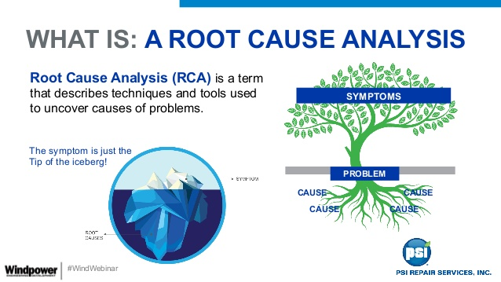

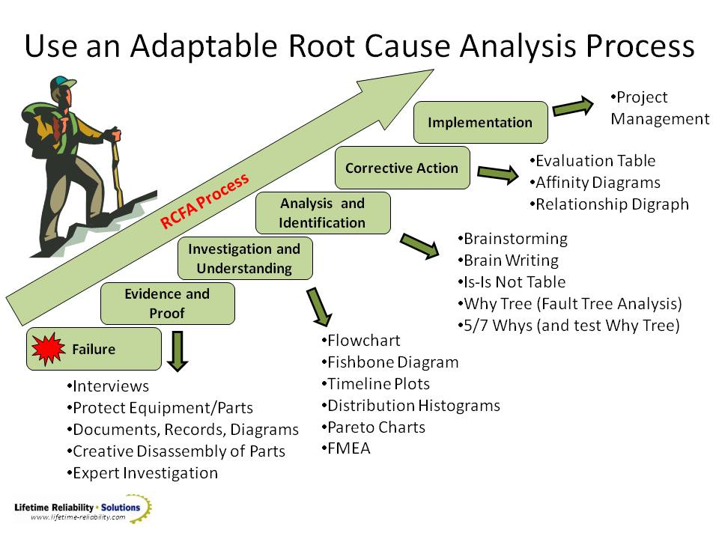

Fishbone Diagram Example
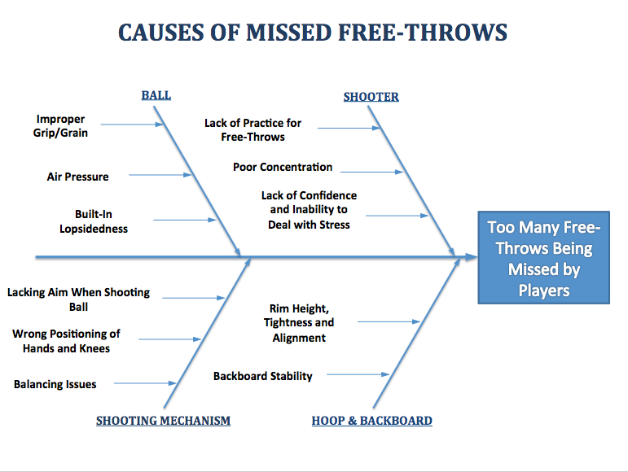

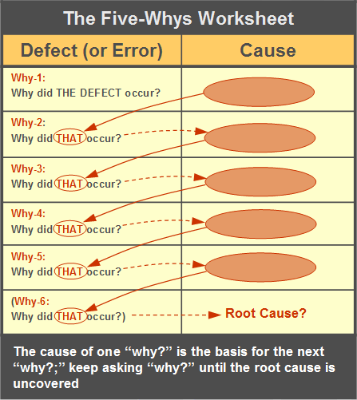
Concern
Problem/Concern
Root Cause Analysis Checklist
Example
Problem Statement | Potential Causes | This is something we can affect. | This is a root cause and not a contributing cause. | We have the data we need to inform planning. | If we need data, where can we get it?
Multiple data sources reveal there is a breakdown in the use of data to help guide decisions at both the school and district level. | We lack the communication in clearly articulating the roles and responsibilities around data and decision making. | Yes | Yes | Yes
 | We are constantly starting over every 2 – 3 years with leadership decisions. | Yes | Yes | Yes

Problem Statement | Potential Causes | This is something we can affect. | This is a root cause and not a contributing cause. | We have the data we need to inform planning. | If we need data, where can we get it?

C. Primary Concerns & Root Causes
- Describe ELA/ reading and math student achievement, using AzMERIT and other assessment data (benchmark, interim, formative, summative, others) for all grade levels served, all students, and applicable subgroups (i.e. ELL, ESS. low socio-economic, gender, race), as well as whole school data.
- Based on the CNA and the student achievement data, what are the top three primary concerns impacting student achievement? Identify gaps; programmatic, service and/or staff related.
- Are these different from previous years? If not, what have you done to address them?
- Conduct Root Cause Analysis-Root Cost Analysis is a problem solving and systematic investigation of contributing causes, to identify the deepest underlying causes of priority concerns that, if resolved, would result in elimination, or substantial reduction, of the priority concerns. Be very careful to differentiate between the symptom (problem) and the cause. Focus on the causes.
- Describe the process
- Identify the primary concerns.
- Write concern/problem statements*.
- Brainstorm possible causes with people knowledgeable about the problem and organize possible causes into groups with common themes into categories.
Problem/concern Statement* | Possible causes
Problem/concern Statement* | Possible causes
Problem/concern Statement* | Possible causes

- Fishbone Diagram
Label the categories with overarching category. Place each category on a fishbone graphic organizer. Add causes under each category on the fishbone diagram. Complete a separate Fishbone Diagram for each concern/problem.
Double click to fill in Fishbone diagram

- Ask “Why” five times, or enough times to identify the root cause/s (dig deeper) for each Problem/Concern Statement*.
NOTE: Too few “whys” may indicate the problem hasn’t been analyzed in enough depth; too many “whys” may indicate over-analysis. Reflect and select causes…Fill out chart below.
worksheet
Problem/Concern Statement*
Why?
Why?
Why?
Why?
Why?
Root Causes | 1.  2.  3.  …ask the following: If you removed this root cause, would this event or problem have been prevented?
Complete chart below
Concern/Problem Statement* | Root cause/s
1.
2.
3.

Determine solutions and countermeasures to fix the root cause and add as action steps in #20-#28.

D. Sustainability Planning
Required Model Strategies/Elements | 20. Specific action steps for solution/s | 21. Addressing which Root Cause | 22. Timeline | 23. Person/s Responsible | 24. SIG funding $$$ | 25. Other  funding  $$$
Replace the principal

Provide
job-embedded professional development
Implement
rigorous
teacher evaluation
Offer financial and career advancement incentives
Implement comprehensive instructional reform
Extend
Learning
time and
teacher-planning time
Create
community-orientation

Provide operating flexibility

Provide sustained support
Add lines for strategies/elements as needed

E. LEA Support
26. How will the LEA provide specific support and resources to ensure continued model implementation and sustainability?
- Describe the LEA’s plan to provide oversight and support to school/s in monitoring and implementing the Integrated Action Plan/s addressing all required elements/strategies of the chosen intervention model.
- How will the LEA align other resources with the selected intervention model (delineate what the resources are)?
- Describe the LEA’s plans to monitor school/s receiving SIG funds, both programmatically and fiscally, including progress monitoring and mid-course adjustments.
- Describe the LEA’s procedure that will allow the school principal the necessary operational flexibility to ensure successful sustainability of school improvement efforts.
- Describe the LEA’s process for Principal and teacher selection, evaluation and retention or transfer in underperforming schools.
- Describe LEA and school balanced assessment system.

F. EXTERNAL PROVIDERS
- Provide a list the proposed/planned new external providers or types of providers; the primary concern and root cause and/or intervention model strategy the provider will address and the expected outcomes/deliverables.
- Describe the rigorous review process the LEA will use to recruit, screen and select external partners.
- How will you evaluate the efficacy of the external provider?
- How will you know the service is changing practice in the school and/or classroom and is increasing student achievement?
- List any external providers you plan to continue using; the primary concern and root cause and/or intervention model strategy the provider will address and the expected outcomes/deliverables
- Describe the evaluation used to evaluate their efficacy
- Provide evidence the service is changing practice in the school and/or classroom and is increasing student achievement

G. Culture, Capacity and Commitment
- Describe the school’s current culture, as it pertains to a culture of learning and/or a culture of achievement.
- Describe the actions the principal and school leadership team will take to improve or maintain a school culture that supports learning for all students.

H. Professional Learning
- List proposed/ planned professional learning to address identified root causes and increase student achievement.
- Describe how this professional learning will impact increased student learning and achievement?
- How will you evaluate the efficacy of the professional learning activities?
- How will staff be held accountable for implementing professional learning in schools and classrooms?
- How will you know this professional learning is changing practice in the classroom and is increasing student achievement?

The next page is an Excel spreadsheet.
Double click to see the whole spreadsheet and enter dollar amounts and detailed narrative.

- Budget

- Turnaround Model
Required Model Elements/  Strategies | Action Steps  Implemented | Implementation Dates | Successful/  Not Successful | Evaluation method | Continued or  Discontinued | If discontinued, what is in place now to address this element?
1.Replace the principal

2.Rehire no more than 50% of staff

3.Provide operating flexibility for principal

4.Provide job-embedded professional
development
5.Implement a research-based, aligned instructional program
6.Extend learning and teacher-planning time
7.Create a community-orientation

8.Offer financial and career advancement incentives
9.NA

20. Turnaround  Required Model Strategies/Elements | - Addressing which Root Cause | - Specific action steps for solution/s | - Timeline | - Person/s Responsible | 24. SIG funding $$$ | 25. Other funding  $$$
Replace the principal

Rehire no more than 50% of staff

Provide operating flexibility for principal
Provide job-embedded professional
development
Implement a research-based, aligned instructional program
Extend learningand teacher-planning time

Create a community-orientation

Offer financial and career advancement incentive

D
Root Cause Analysis Checklists Combined
Problem Statement | Potential Causes | This is something we can affect. | This is a root cause and not a contributing cause. | We have the data we need to inform planning. | If we need data, where can we get it?
Multiple data sources reveal there is a breakdown in the use of data to help guide decisions at both the school and district level. | We lack the communication in clearly articulating the roles and responsibilities around data and decision making. | Yes | Yes | Yes
 | We are constantly starting over every 2 – 3 years with leadership decisions. | Yes | Yes | Yes

Problem Statement | Potential Causes | This is something we can affect. | This is a root cause and not a contributing cause. | We have the data we need to inform planning. | If we need data, where can we get it?
According to state and district assessments, student achievement is low in math across grade levels. | We do not have math coaches like we have reading coaches | Y | Y | N | Survey the teachers to find what support they need.
 | The district does not have a balanced focus on reading and math | Y | Y | N | Information about the budget. Inventory of teachers’ strengths.
 | We fear the ramifications of our test scores | Y | Y | N | Longitudinal data tracking students across years
 | The district has not been focusing on school improvement plans | Y | Y | Y

Problem Statement | Potential Causes | This is something we can affect. | This is a root cause and not a contributing cause. | We have the data we need to inform planning. | If we need data, where can we get it?
There is no evidence that there is a consistent and equitable multi-tiered system of support. | There is no communication or collaboration across all levels in the district (instructional teams, school teams, district teams). | Yes | Yes | Yes (DLT effectiveness survey)
 | There is no protocol for the collection and analysis to identify students. | Yes | Contributing
 | MTSS is not a priority because district leaders do not understand how MTSS can help the district reach student achievement goals. | Yes | Yes | No | - Research/resources on the impact MTSS has on student achievement
 | The district does not have a curriculum aligned with the Illinois Learning Standards. | Yes | Contributing

Problem Statement | Potential Causes | This is something we can affect. | This is a root cause and not a contributing cause. | We have the data we need to inform planning. | If we need data, where can we get it?
Three out of four of the reporting schools have “low” parental involvement in being active in their child’s learning. | Parents don’t have the educational background to gain knowledge or bring knowledge to help their students. | Yes | Yes | No | We might need site-based data (.e.g. change registration form).
 | Parents lack the resources to be physically and visibly involved. | Yes | Yes | No | Compile all resources (e.g., social worker may have resources that are not available to all staff or students).
 | All stakeholders lack concern and respect for the profession. | Yes | Yes | No | Consider a survey or personal interview of teachers.
 | The realities of generational and societal life stressors of home and community prevent them from being involved. | Yes | Yes | No | Consider reviewing current demographic data (e.g. undocumented parents, home foreclosures, transient) population, homeless, etc.).
 | Poor communication among all stakeholders leads to a lack of confidence. | Yes | Yes | Yes (e.g., website not current, messages sent in English and Spanish). | Poor communication among all stakeholders leads to a lack of confidence.

Problem Statement | Potential Causes | This is something we can affect. | This is a root cause and not a contributing cause. | We have the data we need to inform planning. | If we need data, where can we get it?
There is a lack of communication between the district leadership team, the school leadership team, and the instructional leadership team. | The past is driving the present. | Yes | Yes | Yes
 | There is a high turnover in administration. | Yes | Yes | Yes

