19

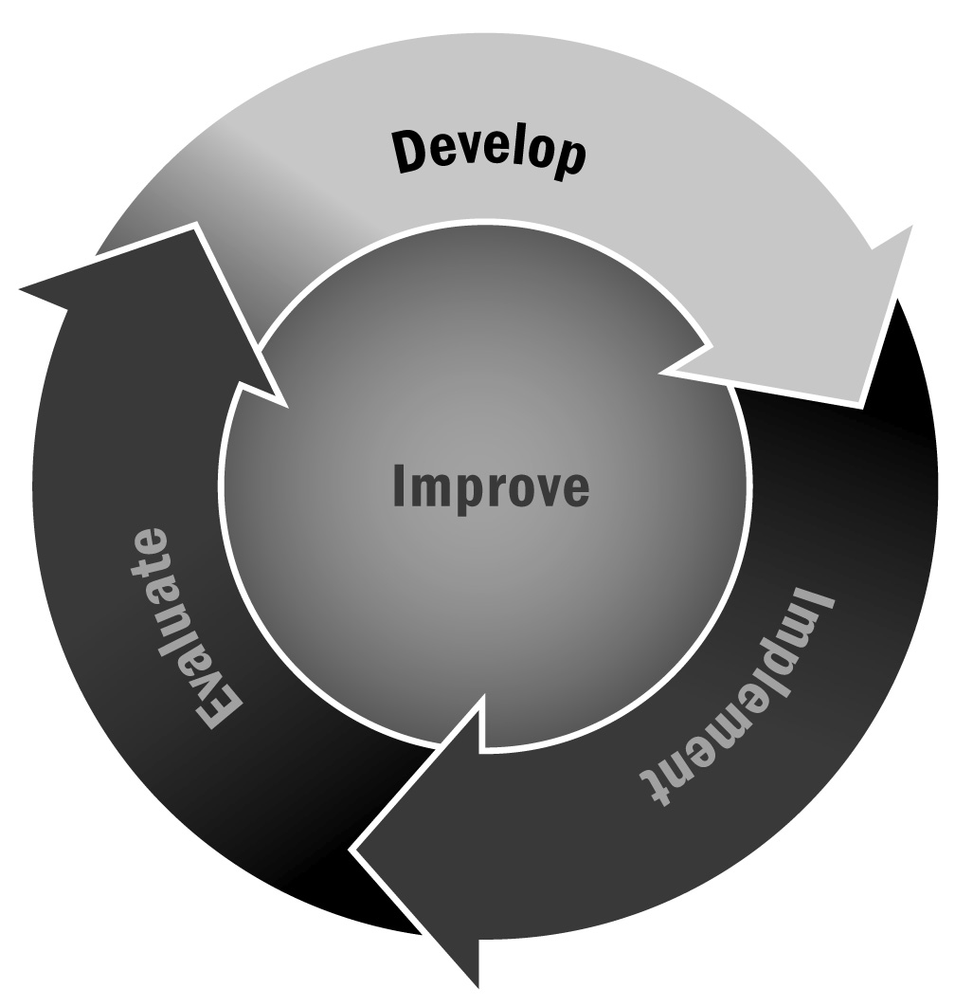
Job Description for Program Staff
In Chapter 1, you learned that you should provide staff members a detailed job description that lists the qualifications for the position, the duties and benefits of the position, and the expectations associated with the position. A good job description will help your program attract qualified candidates and establish a positive culture of accountability.
Directions: This tool is divided into three parts. First, consider the following job description questions to identify the necessary requirements for your program. Second, read the example job description for this position. Finally, use the requirements identified in Part I and the example provided in Part II to complete the job description template in Part III.

Part I. Job Description Questions and Considerations
Job Description Section | Questions and Considerations | Requirements for Your Program
Position Title | - What is the name of the position?  - What title have others previously used?
Position Definition/ Description | - What role will this individual play within the organization? Summarize the role in one or two sentences.
Responsibilities | - What will this individual do on a day-to-day basis?  - What duties will be assigned?
Required Qualifications | - What educational background should this person have?  - How many years of work experience should this person have?  - Does it matter where the work experience has been?  - Should this person have experience working with youth?  - Does this position require any certifications?  - Are there other skills that are necessary for fulfilling this role on a day-to-day basis?
Preferred Competencies and Skills | - Are there certain skills that you feel would be beneficial but that are not necessary for fulfilling this role? Should this person have other professional skills such as time management, multitasking, or decision-making?  - Are there any educational experiences you think would benefit a person in this position?  - Are there any training or professional development certifications that would enable a person to better perform in this role?
Salary | - Do you want to state the salary in this job description?  - If so, what is the salary for this position?  - Is this a salaried position or paid at an hourly rate?  - Are benefits included with this position? If so, what are they?
How to Apply | - What materials should an interested applicant submit to be considered for this position?  - How and to whom should potential applicants submit their materials for this position?
Statement of Nondiscrimination | - It is important to include a statement that describes your organization as an equal opportunity employer that does not discriminate on the basis of race, color, sex, age, disability, religion, or national origin.

Part II. Example Job Description for Afterschool and Expanded Learning Staff
Position Title
Activity Leader – Facilitator
Position Description
This individual will lead program activities with elementary and middle school–age youth during weekday programming.
Responsibilities
- Works collaboratively with the afterschool and expanded learning team to support young people’s opportunities for positive growth and development
- Follows the direction of the program leader and/or the center’s management with regard to policies and procedures
- Leads, participates in, and is responsible for program activities at the assigned site
- Creates a quality program environment and implements age-appropriate activities or projects
- Serves as a member of the program team
- Participates in program planning and design
- Participates fully (i.e., facilitates, provides individual attention) in all activities at the assigned site
- Identifies needed supplies and resources and informs the program leader of needed supplies
- Assists the program leader to ensure the integration and coordination of multiple program activities
- Maintains effective communication with the program leader and/or program partners at the assigned site
- Meets with families, youth, and community members; addresses concerns in a respectful, sensitive manner
- Respects cultural diversity and creates an inclusive, welcoming, and respectful environment
- Ensures the safety and wellness of youth by upholding policies through the program’s procedures
- Prepares reports as required in an accurate, timely manner
- Participates in professional development and program-related trainings as assigned
- Other responsibilities as assigned
Required Qualifications , Competencies, and Skills
- Holds a high school diploma
- Must pass a criminal background check
- Has prior experience in activities development and implementation
- Has prior experience working with youth
- Has a desire to work collaboratively with youth
- Able to multitask
- Able to resolve challenging situations productively and without personalization
- Able to manage time and classroom group
- Pays attention to detail
- Able to work well under stress
- Shows willingness to work evenings, nights, and weekends
- Has a valid driver’s license and personal vehicle insurance or access to reliable transportation
Preferred Qualifications, Competencies, and Skills
- Holds a bachelor’s degree in education, recreation, or a related field
- Understands program assessment techniques and tools
- Has prior experience in an educational or recreational setting, in a school- or community-based organization
- Is committed to afterschool and expanded learning
- Has strong knowledge of one or more content areas (e.g., STEM, arts, health and wellness)
- Has knowledge of the local community
- Has a recommendation from program partners
Salary
Hourly rate is commensurate with experience. Please inquire for details.
How to Apply
Please submit your letter of intent, résumé, and any additional materials to John Smith at jsmith@abcprogram.org.
ABC Program provides equal employment opportunities without regard to race, color, sex, age, disability, religion, or national origin. ABC Program uses only job-related criteria in making decisions concerning applicants and employees.

Part III. Job Description Template
Position Title

Position Description

Responsibilities

Required Qualifications , Competencies, and Skills

Preferred Qualifications, Competencies, and Skills

Salary

How to Apply

[Agency Name] provides equal employment opportunities without regard to race, color, sex, age, disability, religion, or national origin. [Agency Name] uses only job-related criteria in making decisions concerning applicants and employees.

