80

Homework Help Tool
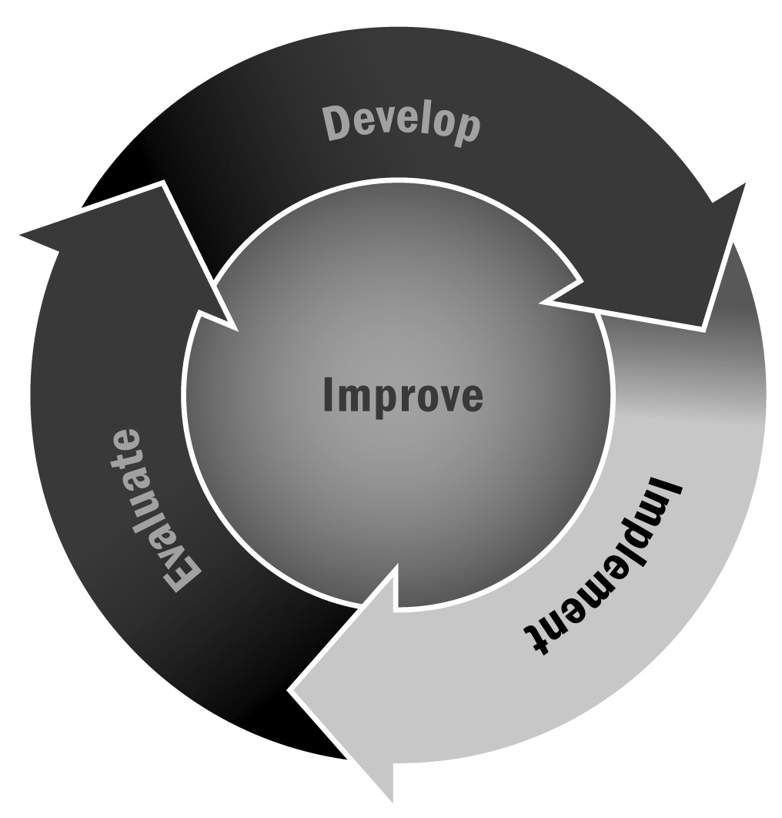
In Chapter 4, you learned about the difference between homework help and tutoring. Providing structured and intentional homework help activities for youth will help youth complete their homework assignments as well as develop the skills and content knowledge to complete assignments independently in the future.
Directions: Consider these tips, based on the suggestions of the homework expert Dr. Harris Cooper, when designing homework help activities for your program. After reviewing the tips in each category, use the prompts to think about how to improve your own homework help activities.

Homework Help Tips
Environment
- The program sets aside time for the completion of homework assignments and provides a schedule for when the homework can be completed. (This time can run simultaneously with other program activities.)
- The program sets aside space for the completion of homework assignments in a clearly marked area away from other competing activities. Only homework is done in this space, and youth can enter only once.
- The program provides materials (such as paper, pencils, calculators, and computers) that are needed for the successful completion of assignments. It also provides tools (such as reference works, study guides, and test preparation materials) to support independent learning.
- The program creates a learning environment that supports both independent and group learning during homework time.
- The program provides study or learning opportunities for youth who do not have homework or who already have completed their assignments. Possibilities include high-interest reading materials, test study groups, test practice areas, mathematics games, and art materials.
How can we improve the environment of our homework help sessions?
Staffing
- Staff members view homework as an important element within an active learning environment. They have the necessary training to understand the importance of adult roles meant to motivate, mentor, and monitor the homework process.
- Staff members have the skills needed to assist youth with proper homework behavior. They have had training on techniques such as mentoring and the use of basic reference materials.
- Staff members are trained in techniques for helping with homework, study skills that can be taught to youth, and basic test-taking techniques.
- Additional non-staff resources are available to assist with homework assignments, including cross-age, peer, and adult volunteer tutors.
How can we improve the staffing of our homework help sessions?
Youth Development
- The program seeks to develop youth study skills in a time separate from that used for homework. Staff members teach assignment tracking, how to use resource materials, or other topics.
- The program includes training in time management skills for youth.
- The program fosters self-direction, self-discipline, inquisitiveness, and independent problem solving.
- The program teaches youth when and how to seek assistance.
How can we incorporate more youth development practices into our homework help sessions?
Links Between School and Home
- The program has mechanisms (such as homework or learning contracts and logs) that help youth focus their attention on academic tasks.
- The program uses homework to facilitate communication among youth, teachers, and families. It encourages the sharing of information about successes and problem areas.
How can we improve the links between home and school in our homework help sessions?
Adapted from Homework in the Afterschool Program, by Harris Cooper, Ph.D. (2005). Reprinted with permission.

