If you have not yet started entering data into the “A-F CCRI Self Reporting Spreadsheet” then download a new version available on ADEConnect.

If you already started entering student-level data, follow the steps below to correct the error.

1. Open “A-F CCRI Self Reporting Spreadsheet,” “Self Reporting” tab.

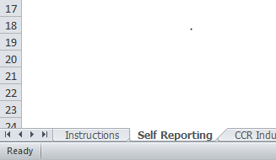

1. Select “Review” from the ribbon at the top.

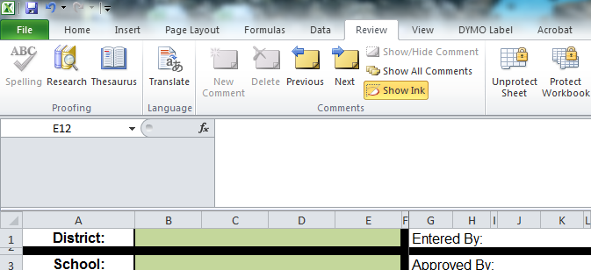

1. Click “Unprotect Sheet” enter password **AFCCRIsrs** or **afccri2srs** (one of the 2 passwords should unprotect the sheet) [copy and paste password to ensure you are entering the correct password] and click “OK.”

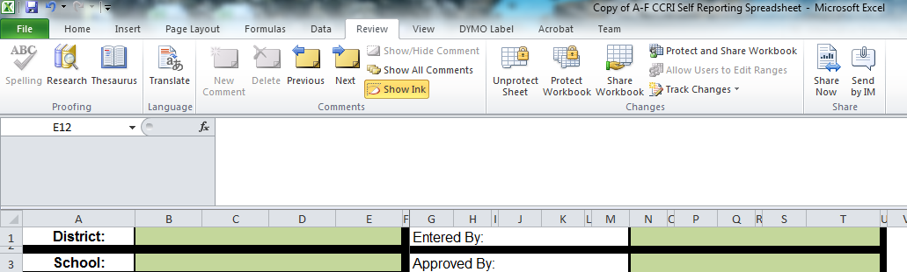

1. Copy the following (CTRL-V):

=IFERROR(IF(E11="","",IF(AND(B11>=1,C11>=1),17,IF(A11>=2,15,IF(A11>=1,7.5,IF(A11<1,0,"Error"))))),"")

1. In the “A-F CCRI Self Reporting Spreadsheet” on the “Self Reporting” tab go to cell “D11.”

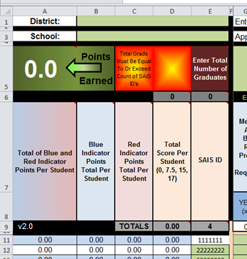

1. Go to the Formula Bar, highlight and delete the formula.

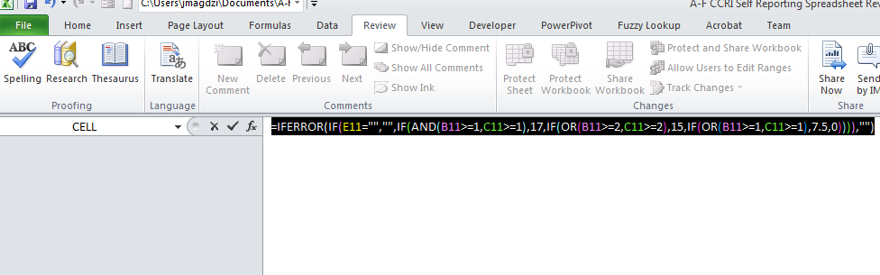

1. Paste using “Ctrl-V” and press enter.
2. Reselect cell “D11.”
3. In the lower right hand corner is a black box referred to as the “Fill Handle.” The cursor will change to a plus sign (no arrows). **Double click the Fill Handle** to copy the formula down the entire 1500 rows.

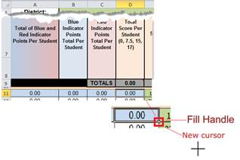

1. Select “Review” from the ribbon at the top.

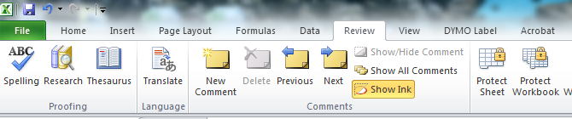

1. Click “Protect Sheet” enter password **afccri2srs** (you may need to enter it twice). *It is highly recommended that you “lock” the sheet again. This can prevent errors and mistakes in the calculations.*

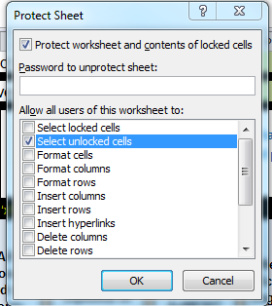

1. Click “File-Save.”

