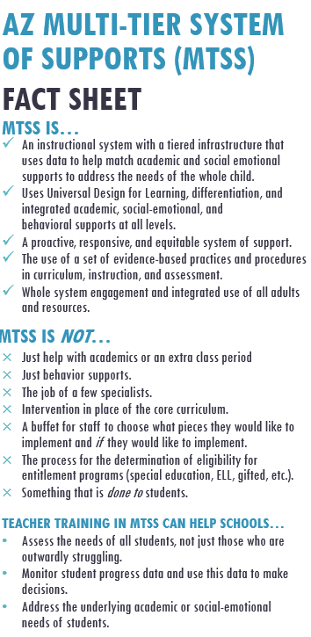

UNIVERSAL SUPPORT

Highly effective core academic instruction and social emotional learning

ADDITIONAL SUPPORT

Small group evidence-based academic instruction and social emotional learning

INTENSIFIED SUPPORT

Individualized, high intensity evidence-based academic instruction and social emotional learning

A close up of a logo

Description generated with very high confidence

