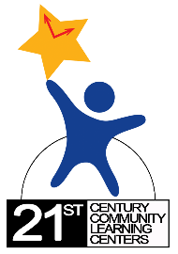



**Professional Development 2018**

|  |  |  |  |  |  |  |
| --- | --- | --- | --- | --- | --- | --- |
| September | October | November | December | January | February |  |
|  |  |  |  |  |  |  |

|  |  |  |  |  |  |
| --- | --- | --- | --- | --- | --- |
| September | October | November | December | January | February |
|  | [Schools Out Make It Count Conference](https://azafterschool.org/upcoming-events/conference-2018/)  (Arizona Center for Afterschool Excellence)  **$**  Saturday  10-20-18  Phoenix Convention Center | **21st CCLC Network Meeting**  Family Engagement  WESD District Office  11-1-18 | 9 to Noon  4650 W. Sweetwater, Glendale, AZ 85304  [ESSA Conference](https://www.thecenterweb.org/essa/)  Tucson, AZ - Nov 14 & 15 |  |  |  |

|  |  |  |  |  |  |
| --- | --- | --- | --- | --- | --- |
| March | April | May | June | July | August |
|  |  |  |  |  | **21st CCLC Grantee Leadership Orientation**  **$**  **Northern Arizona – 8-24-18**  **Central Arizona – 8-27-18 Southern Arizona – 8-29-18** |

*Training and dates are subject to change. Please refer to the 21st CCLC website periodically for updates.

**Registration is required for participation.

***The 21st Century Community Learning Center afterschool program is funded by a federal grant from the U.S. Department of Education and administered by the Arizona Department of Education.  For more information visit:  <http://www.azed.gov/21stcclc/>

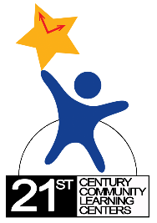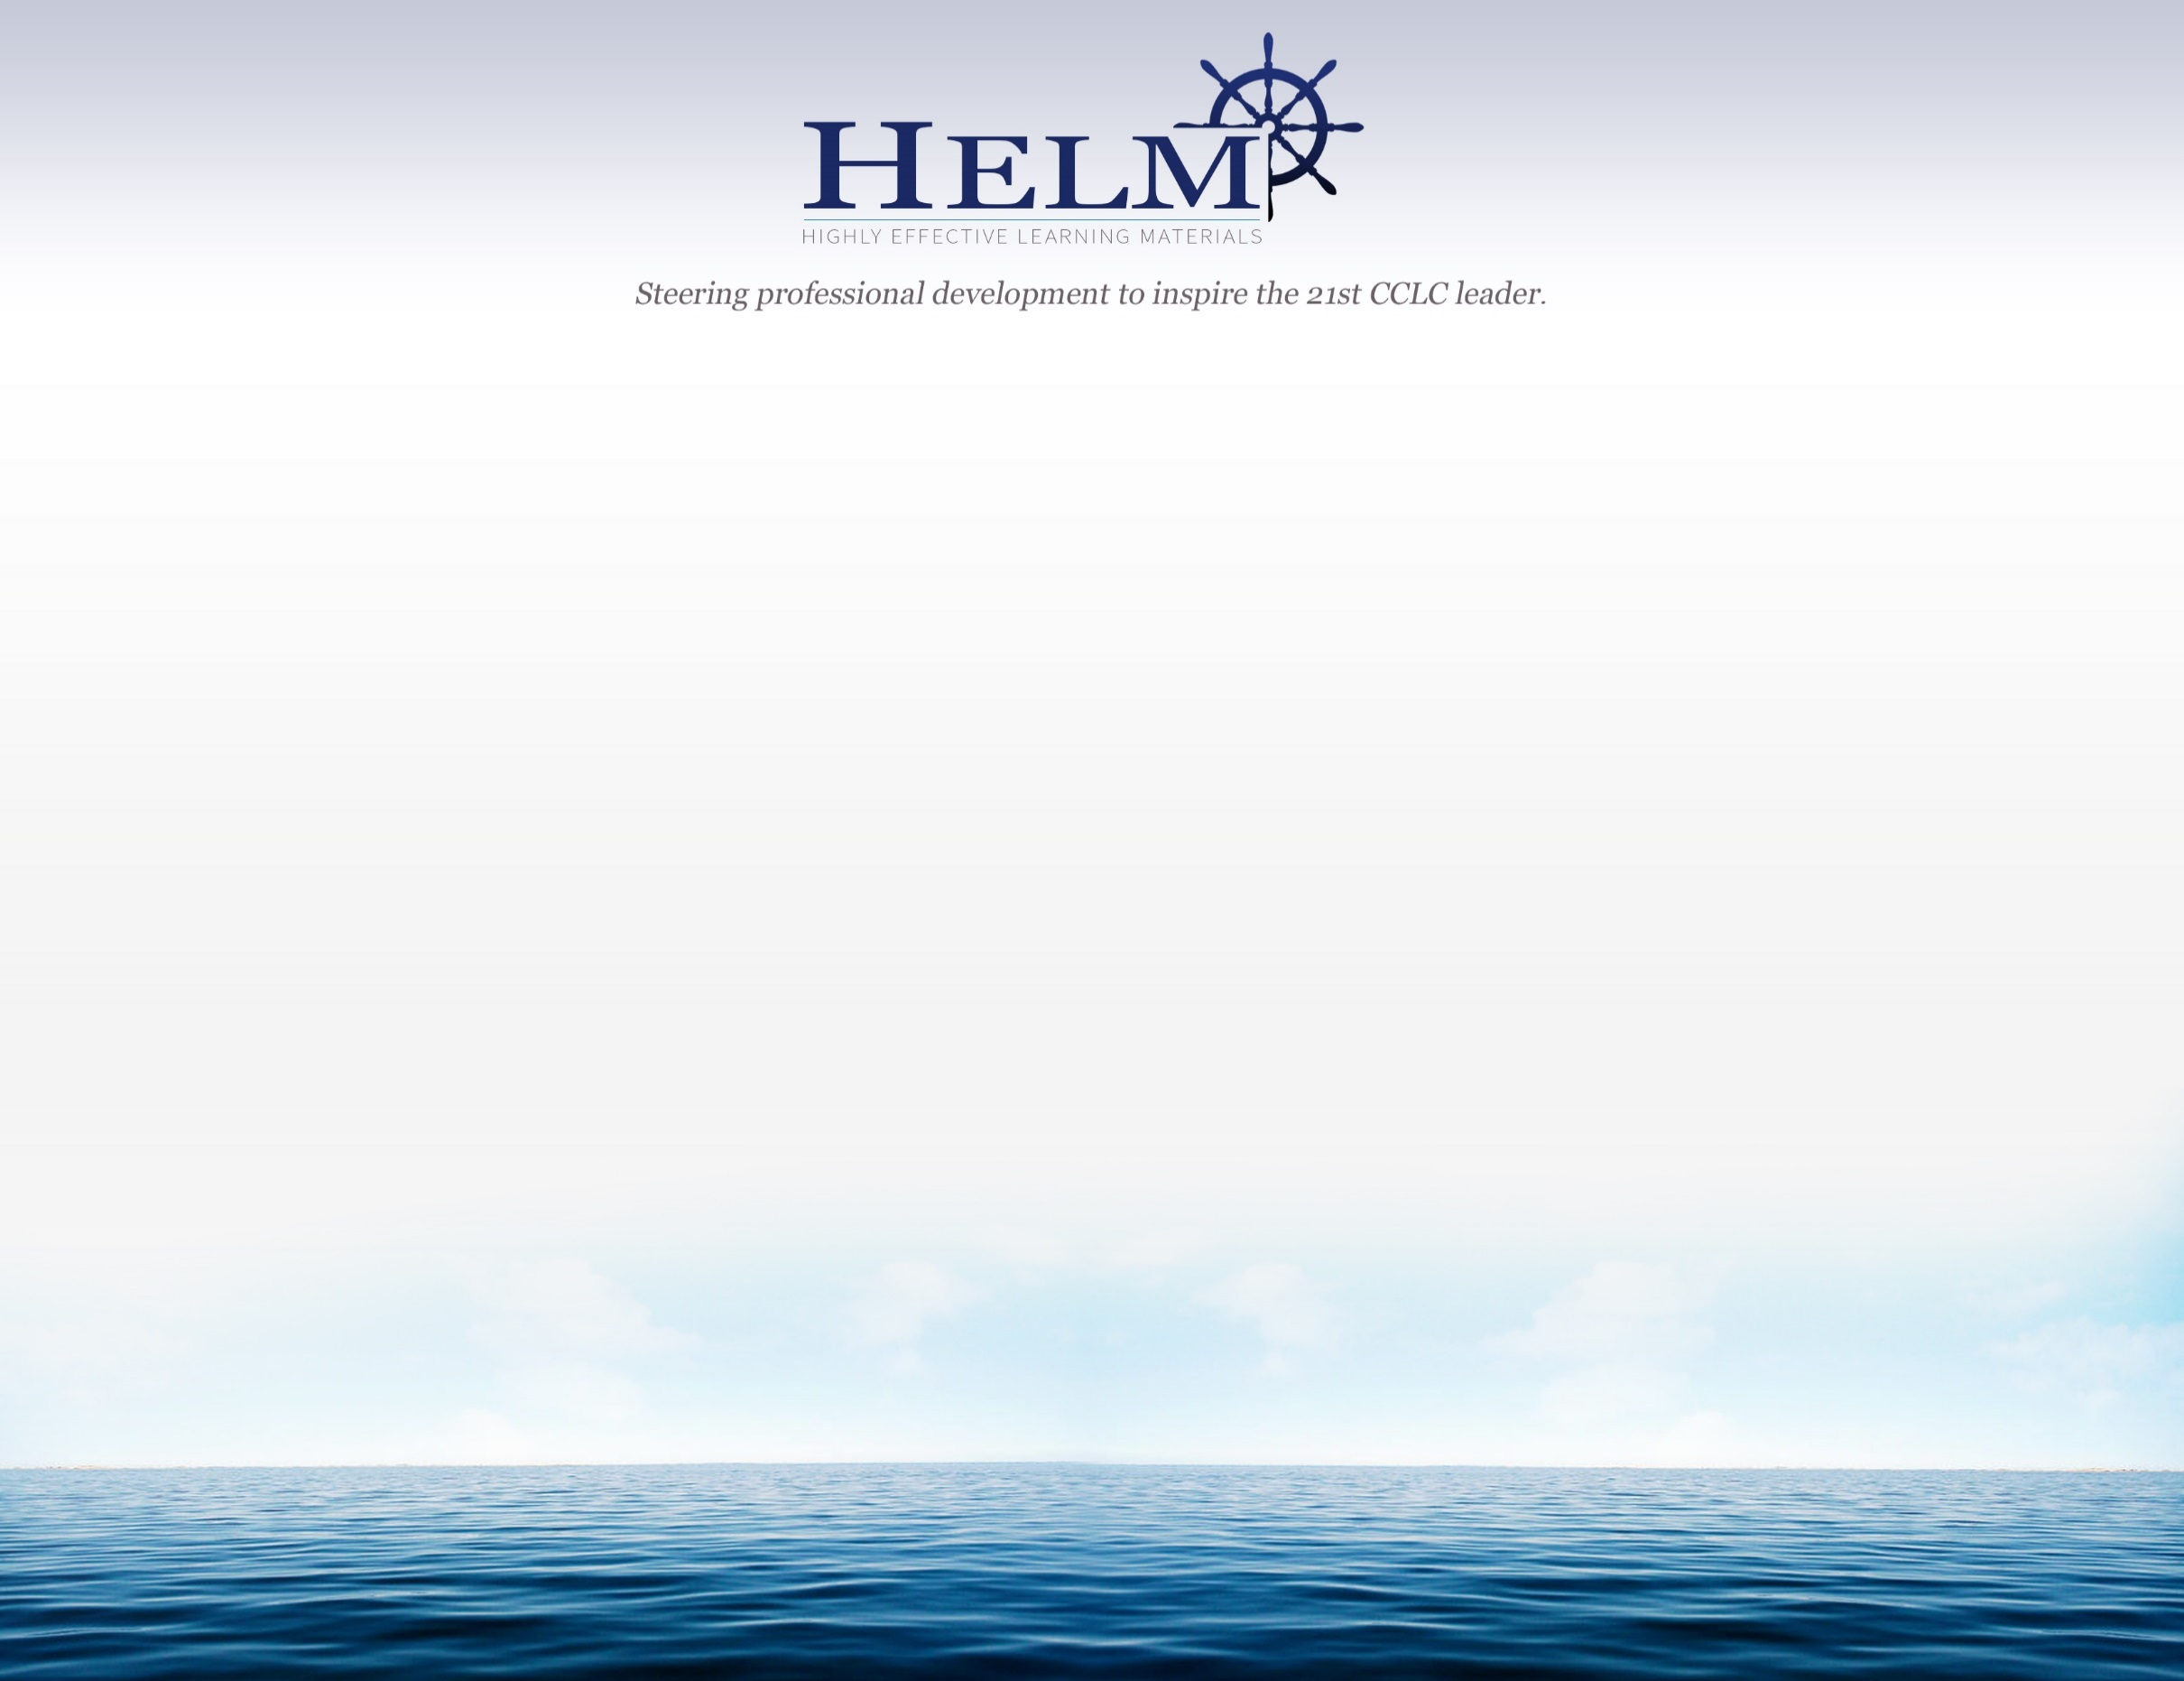

*Training and dates are subject to change. Please refer to the 21st CCLC website periodically for updates.

**Registration is required for participation.

***The 21st Century Community Learning Center afterschool program is funded by a federal grant from the U.S. Department of Education and administered by the Arizona Department of Education.  For more information visit:  <http://www.azed.gov/21stcclc/>

|  |  |  |  |  |  |
| --- | --- | --- | --- | --- | --- |
| September | October | November | December | January | February |
|  |  |  |  |  |  |

|  |  |  |  |  |  |
| --- | --- | --- | --- | --- | --- |
| March | April | May | June | July | August |
| **21st CCLC Network Meeting**  Date & Location  **TBD** |  |  | **Leading Change Conference**  **$**  Date and location TBD |  |  |

|  |  |  |  |  |  |  |
| --- | --- | --- | --- | --- | --- | --- |
| September | October | November | December | January | February |  |
|  |  |  |  | **21st CCLC Reporting 101** **Southern Arizona- 1-30-19** | **21st CCLC Reporting 101**  **Central Arizona- 2-04-19**  **Northern Arizona-2-13-19** |  |

**Professional Development 2019**