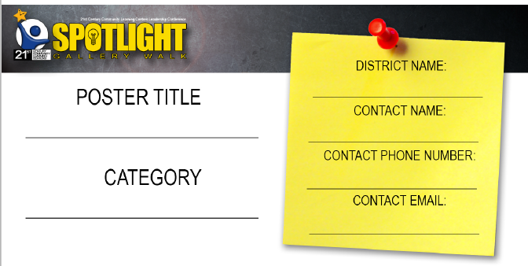

Insert information

Insert information

Insert information

Insert information



Add your own images, clip art, text boxes. Right Click images, Select Wrap Text, Select Behind or In Front of text to move to desired location.

Insert Information

Insert information