ROOT CAUSE ANALYSIS Resources
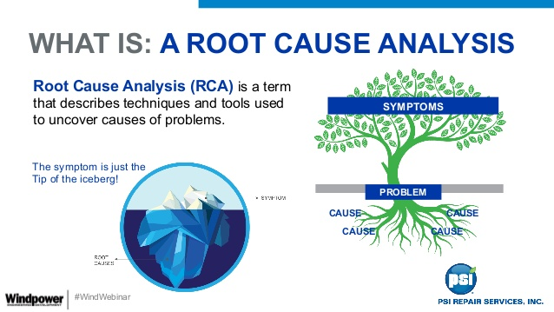

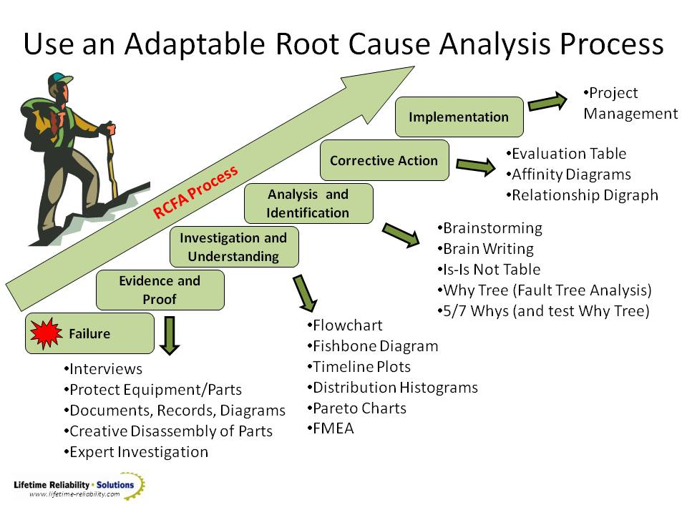

Fishbone Diagram Example
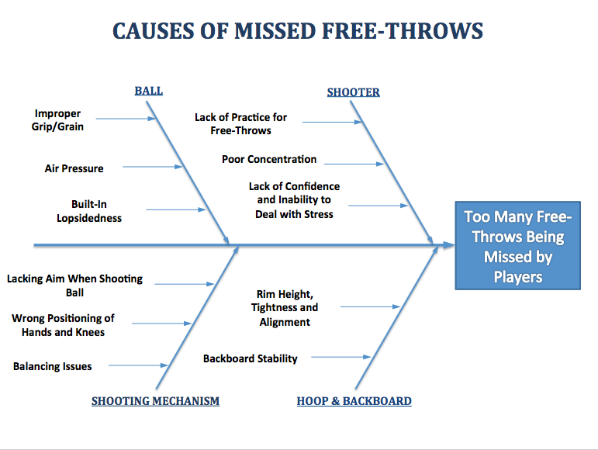

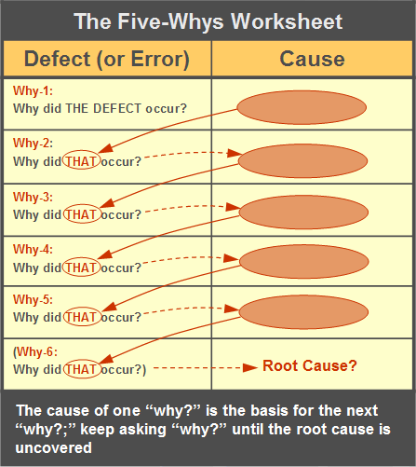
Concern
Problem/Concern
Problem/Concern Statement*
Why?
Why?
Why?
Why?
Why?
Root Causes | 1.  2.  3.  …ask the following: If you removed this root cause, would this event or problem have been prevented?

Root Cause Analysis Checklist
Example

Problem Statement | Potential Causes | This is something we can affect. | This is a root cause and not a contributing cause. | We have the data we need to inform planning. | If we need data, where can we get it?
Multiple data sources reveal there is a breakdown in the use of data to help guide decisions at both the school and district level. | We lack the communication in clearly articulating the roles and responsibilities around data and decision making. | Yes | Yes | Yes
 | We are constantly starting over every 2 – 3 years with leadership decisions. | Yes | Yes | Yes

Problem Statement | Potential Causes | This is something we can affect. | This is a root cause and not a contributing cause. | We have the data we need to inform planning. | If we need data, where can we get it?
There is a lack of communication between the district leadership team, the school leadership team, and the instructional leadership team. | The past is driving the present. | Yes | Yes | Yes
 | There is a high turnover in administration. | Yes | Yes | Yes

Problem Statement | Potential Causes | This is something we can affect. | This is a root cause and not a contributing cause. | We have the data we need to inform planning. | If we need data, where can we get it?
Three out of four of the reporting schools have “low” parental involvement in being active in their child’s learning. | Parents don’t have the educational background to gain knowledge or bring knowledge to help their students. | Yes | Yes | No | We might need site-based data (.e.g. change registration form).
 | Parents lack the resources to be physically and visibly involved. | Yes | Yes | No | Compile all resources (e.g., social worker may have resources that are not available to all staff or students).
 | All stakeholders lack concern and respect for the profession. | Yes | Yes | No | Consider a survey or personal interview of teachers.
 | The realities of generational and societal life stressors of home and community prevent them from being involved. | Yes | Yes | No | Consider reviewing current demographic data (e.g. undocumented parents, home foreclosures, transient) population, homeless, etc.).
 | Poor communication among all stakeholders leads to a lack of confidence. | Yes | Yes | Yes (e.g., website not current, messages sent in English and Spanish). | Poor communication among all stakeholders leads to a lack of confidence.

