History and Social Science Standards

2018
___________________________________________________________________________
Arizona Department of Education
Sixth Grade – Eight Grade

Introduction

An important aspect of our Republic is that an educated and engaged citizenry is vital for the system to work. In a government where the final authority and sovereignty rests with the people, our local, state, and federal governments will only be as responsive as the citizens demand them to be. Preparing students for the contemporary society cannot be accomplished without a strong emphasis on civics, economics, geography, and history – the core disciplines of the social studies. It is imperative that each generation gains an understanding of the knowledge, skills, and dispositions to participate fully in civic life in a rapidly changing world.

The Arizona History and Social Science Standards are premised upon a rigorous and relevant K-12 social studies program within each district and school in the state. Engaging students in the pursuit of active, informed citizenship will require a broad range of understandings and skills including:

Think analytically by
- Posing and framing questions
- Gathering a variety of evidence
- Recognizing continuity and detecting change over time
- Utilizing chronology to examine cause and effect relationships
- Drawing and combining reasonable inferences from a variety of sources to build an understanding of complex questions

Read widely and critically by
- Examining, interpreting, and contextualizing primary sources focusing on author, purpose, and audience of each source
- Identifying and comparing historical, geographic, economic, and political science interpretations from a wide variety of secondary sources
- Utilizing broader understanding to discern subtext in primary and secondary sources

Communicate cogently and in a compelling manner by
- Developing and defending evidenced based arguments
- Utilizing multiple perspectives for comprehensive explanations
- Practicing and cultivating a wide variety of diverse types of writing
- Engaging in constructive conversations around history and social science topics

The Arizona History and Social Science Standards, through the emphasis on content knowledge, disciplinary skills, and process and the integration of inquiry elements will prepare Arizona students to engage actively in civic life and meet the needs and challenges of the 21st century.

K-8 Grade Level Storylines and Content Focus
To create a coherent sequence from one grade to the next, to avoid unneeded repetition, and to close content gaps, each elementary grade level has a storyline and content focus for the year. A more detailed storyline can be found later in this document on the specific grade level standards page. This is not the case for the high school standards.
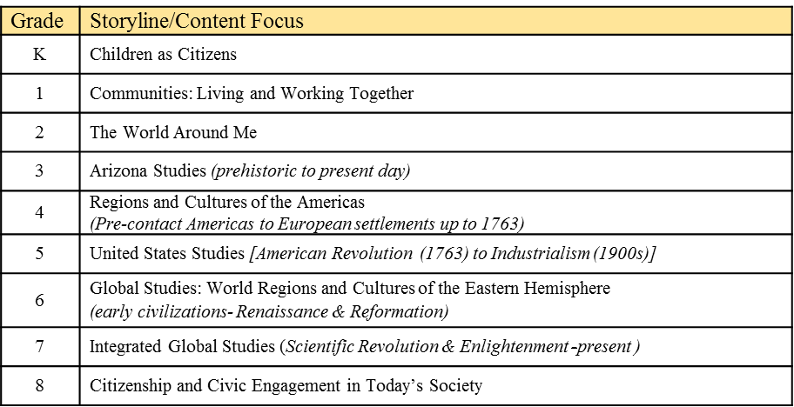
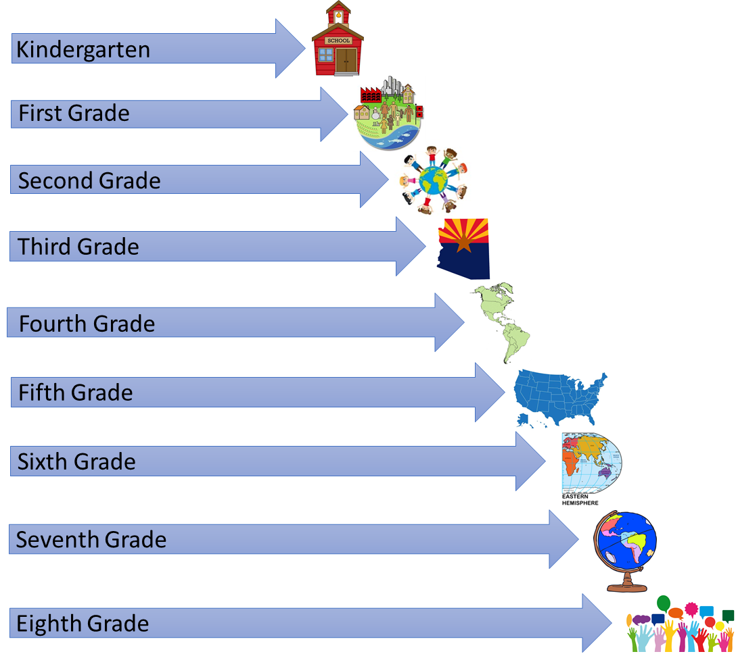

Core Discipline Descriptors

The content standards are organized under the four core disciplines in social studies. These disciplines - civics, economics, geography, and history - offer a unique way of thinking about and organizing knowledge. Disciplinary skills and processes offer a means for students to verify that knowledge. Descriptions of the core disciplines are included below. The disciplinary skills and processes are described in the next section.

Civics
The civics standards promote the knowledge, skills, and dispositions necessary for informed, responsible participation in public life. Productive civic engagement requires knowledge of the history, principles, and foundations of our Constitutional Republic and that each person has both human and civil rights. People demonstrate civic engagement when they address public problems individually and collaboratively and when they maintain, strengthen, and improve their communities and society. Civics also requires an understanding of local, state, national, and international institutions. Civics encompasses practices such as voting, volunteering, jury service, contributing to public processes, and the public discourse.

Economics (including financial literacy)
The economic and financial literacy standards promote the concepts and tools necessary to make reasoned judgements about both personal economic questions and broader questions of economic policy. Economic decision making requires a strong understanding of the ways in which individuals, businesses, governments, and societies make decisions to allocate resources among alternative uses. This process involves the consideration of costs and benefits with the goal of making decisions that will enable individuals and societies to be as well off as possible. The study of economics explains historical developments and patterns, the impacts of trade, and the distribution of income and wealth in local, regional, national, and international economies. Economics also gives students the skills to analyze current issues and public policies.

Geography
The geography standards promote the use of multiple geographic tools and emphasize geographic reasoning to understand local, national, regional, and global issues. Geographic reasoning rests on deep knowledge of the Earth’s physical and human features including the location of places and regions, the distribution of landforms and bodies of water, and changes in political boundaries. Geography provides an understanding of the Earth’s places and regions, how people with diverse backgrounds interact with their environment and enhances understanding of history, civics, and economics.

History
The history standards promote both historical content and historical thinking skills to prepare students to apply historical thinking to any historical era and context. The study of history is vital because it promotes the development of analytical skills, comparative perspectives, and question and answers modes of critical judgement that promote thoughtful work in any field or career. It is vital for students to study both United States and world history, so they can analyze the human experience through time, recognize the relationship of events and people, and interpret significant patterns, themes, ideas, and turning points in American and world history. Students apply the lessons of history to their lives as citizens of the United States and members of the world community.

Anchor Standards

The Arizona History and Social Science Standards are organized into five social studies content areas. Within these content areas are four to five major core concepts referred to as Anchor Standards. Grade level standards are written to support these Anchor Standards. There are twenty-one Anchor Standards. Seventeen of these Anchor Standards center around the content areas of civics, economics, geography, and history. The remaining four standards focus on the disciplinary skills and processes that all students need to know and apply to any historical era, context, or content area. Using these tools, students think like historians, geographers, political scientists, and economists. These skills and processes are especially critical in a time when students are exposed to massive amounts of information in numerous forms and must develop the skills to make sense of it. The Anchor Standards are listed below.

Disciplinary  Skills and Processes | Civics | Economics | Geography | History
SP1: Chronological reasoning requires understanding processes of change and continuity over time, which means assessing similarities and differences between historical periods and between the past and present. | C1: Civic virtues and democratic principles are key components of the American political system. | E1: A financially literate individual understands how to manage income, spending, and investment. | G1: The use of geographic representations and tools helps individuals understand their world. | H1: The development of civilizations, societies, cultures, and innovations have influenced history and continue to impact the modern world.
SP2: Thinking within the discipline involves the ability to identify, compare, and evaluate multiple perspectives about a given event to draw conclusions about that event since there are multiple points of view about events and issues. | C2: Citizens have individual rights, roles, and responsibilities. | E2: By applying economic reasoning, individuals seek to understand the decisions of people, groups, and societies. | G2: Human-environment interactions are essential aspects of human life in all societies. | H2: Cycles of conflict and cooperation have shaped relations among people, places, and environments.
SP3: Historians and Social Scientist gather, interpret, and use evidence to develop claims and answer historical, economic, geographical, and political questions and communicate their conclusions. | C3: An understanding of civic and political institutions in society and the principles these institutions are intended to reflect including knowledge about law, politics, and government are essential to effective citizenship. | E3: Individuals and institutions are interdependent within market systems. | G3: Examining human population and movement helps individuals understand past, present, and future conditions on Earth’s surface. | H3: Economic, political, and religious ideas and institutions have influenced history and continue to shape the modern world.
 |  | E4: The domestic economy is shaped by interactions between government, institutions, and the private sector.
SP4: Thinking within the discipline involves the ability to analyze relationships among causes and effects and to create and support arguments using relevant evidence. | C4: Process, rules, and laws direct how individuals are governed and how society addresses problems. | E5: The interconnected global economy impacts all individuals and groups in significant and varied ways. | G4: Global interconnections and spatial patterns are a necessary part of geographic reasoning. | H4: Patterns of social and political interactions have shaped people, places, and events throughout history and continue to shape the modern world.

The twenty-one Anchor Standards are represented within each of the grade bands; K-2, 3-5, 6-8, and high school, but not all Anchor Standards are at each grade level. Specific grade level standards are organized under each of the Anchor Standards.

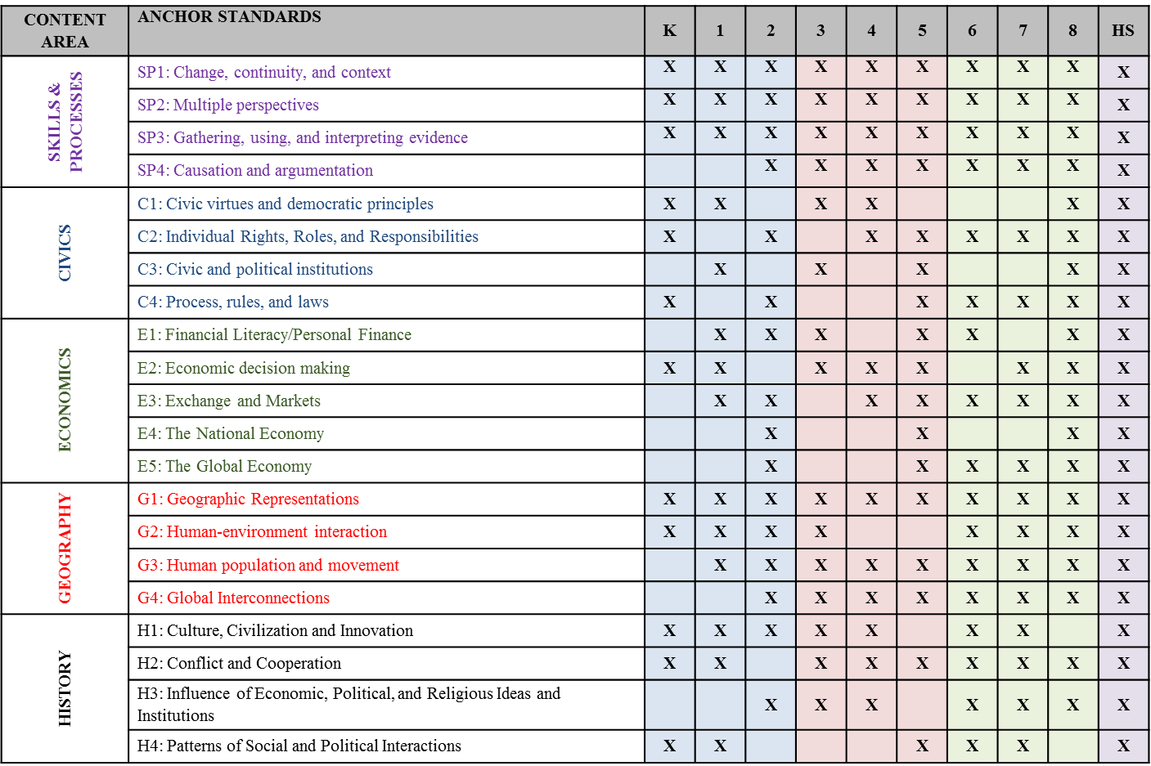

Inquiry Arc
Children and adolescents are naturally curious and - in their effort to understand the world around them - have a bottomless well of questions. Learning to investigate questions in the social studies discipline areas results in a deeper understanding of content and a stronger connection to the material. Students must gather and evaluate evidence, formulate arguments, critique counter claims, and communicate their conclusions through many modes including writing, speaking, and visualizing. The six components of the Inquiry Arc are found in the Disciplinary Skills and Processes Anchor standards and appear at each grade level. Incorporating inquiry using the content standards reinforces the same skills and processes contained in the Arizona English Language Arts (ELA) standards. As students utilize inquiry processes in their content area, they reinforce and use the ELA reading, writing, speaking, and listening standards.

The Six Elements of the Inquiry Arc
- Inquiry Element 1: Developing Compelling Questions
Central to a rich social studies experience is the capability for developing questions that can frame and advance inquiry. Those questions come in two forms: compelling and supporting questions. Compelling questions focus on enduring issues and concerns.

- Inquiry Element 2: Constructing Supporting Questions
Supporting questions focus on descriptions, definitions, and processes on which there is general agreement within the social studies disciplines and require students to construct explanations that advance claims of understanding in response.

- Inquiry Element 3: Gathering and Evaluating Sources
Students, whether they are constructing opinions, explanations, or arguments, gather information from a variety of sources and evaluate the relevance of the information. In evaluating these sources there are literacy skills, such as identifying an author’s purpose, main idea, and point of view, that will help in evaluating the usefulness of a source.

- Inquiry Element 4: Developing Claims
Once students analyze information, they need to develop claims and counterclaims to answer social studies questions. Evidence is used to support these claims.

- Inquiry Element 5: Communicating Conclusions
Students formalize their arguments and explanations and communicate their results through various products to a wide range of audiences. Students also have opportunity to critique their scholarship as well as the scholarship of others.

- Inquiry Element 6: Taking Informed Action
To prepare students for civic life, students use their disciplinary knowledge, skills, and perspectives to inquire about problems involved in public issues, deliberate with others on how to define and address these issues, take constructive and collaborative action, and reflect on that action.

Design of the Arizona History and Social Science Standards

The Arizona History and Social Science Standards define the knowledge, understanding, and skills that need to be effectively taught and learned for all students to be ready to succeed in credit-bearing, college-entry courses, in the workplace, in military service, and in civic life as the member of a constitutional republic. The
Standards present a vision of what it means to be a civic, economic, geographic, and historically literate person in the 21st century.

The Arizona History and Social Science Standards outline what all students need to know, understand, and be able to do by the end of high school and reflect the following guiding principles and shifts for social studies education:
- Social studies prepares the nation’s youth for college, career, and civic life.
- Inquiry is at the heart of social studies.
- Social studies involves interdisciplinary application and welcomes integration with other content areas.
- Social studies are composed of deep and enduring understandings, concepts, and skills.
- Social studies should have direct and explicit connections to the ELA standards.

The Arizona History and Social Science Standards are:
- Directed in a coherent progression across grades K-12,
- Aligned with college and workforce expectations,
- Focused on rigorous content and applications of knowledge through higher level thinking,
- Research and evidence based,
- Broad in nature, allowing for the widest possible range of student learning, and
- Designed as an integrated approach to content while still maintaining disciplinary integrity.

The Arizona History and Social Science Standards are not curriculum or instructional practices.
While the Arizona History and Social Science Standards may be used as the basis for a district’s or school’s curriculum, they are not curriculum. Therefore, identifying a sequence of instruction at each grade - what specifically will be taught and for how long - requires concerted effort and attention at the local level. Curricular tools, including textbooks, are selected by the district/school and adopted through local governing board. The Arizona Department of Education defines standards, curriculum, and instruction as:

- Standards are what a student needs to know, understand, and be able to do by the end of each grade. They build across grade levels in a progression of increasing understanding and through a range of cognitive demand levels. Standards are adopted at the state level by the Arizona State Board of Education.
- Curriculum refers to resources used for teaching and learning the standards. Curricula are adopted at the local level.
- Instruction refers to the methods or methodologies used by teachers to teach their students. Instructional techniques are employed by individual teachers in response to the needs of the students in their classes to help them progress through the curriculum to master the standards. Decisions about instructional practice and techniques are made at a local level.

The Arizona History and Social Science Standards assume students have regular standards-based social studies instruction every year. The amount of time individual students need to learn these standards will vary. The chart below specifies the expected social studies instructional time necessary for students to learn these standards.

Grade | Assumed Minutes per Week | Assumed Average Minutes per Day
K | 90 minutes/week | 18 minutes/day
1 | 150 minutes/week | 30 minutes/day
2 | 150 minutes/week | 30 minutes/day
3 | 200 minutes/week | 40 minutes/day
4 | 225 minutes/week | 45 minutes/day
5 | 225 minutes/week | 45 minutes/day
6 | 250 minutes/week | 50 minutes/day
7 | 250 minutes/week | 50 minutes/day
8 | 250 minutes/week | 50 minutes/day
HS (3 credits) | 275 minutes/week | 55 minutes/day

The Arizona History and Social Science Standards have been designed so that these time assumptions provide adequate time for instruction and opportunities to learn the standards for each grade level. Depending on local factors, schools may allocate more or less time when determining curriculum programing within a specific context. These time recommendations do not explicitly address students who are far below or far above grade level. No set of grade specific standards can fully reflect the variety in abilities, needs, learning rates, and achievement levels of students in any given classroom. The Arizona History and Social Science Standards do not define intervention methods to support students who are far below or far above grade level or do not speak English as their first language.

Coding of the K-8 Standards
Each K-8 standard is made up of three components. The grade level appears first, followed by the core discipline Big Idea, and finally a standard number. The standard number at the end of the code is designed for recording purposes and does not imply instructional sequence or importance. Examples and explanations of the coding of the standards are below.

K.SP1.2 Explore how events of the past affect students’ lives and community

K
.
SP1
.
2
Kindergarten
Standard Number 2
Standard addresses
Disciplinary Skills and Processes
Anchor Standard 1

6
.
E5
.
1
Grade 6
Standard Number 1
Standard addresses
Economics
Anchor Standard 5
6.E5.1 Describe the factors that influence trade between countries and cultures.

Coding of the High School Social Studies Standards

In Arizona, students are required to take three credits of high school social studies for graduation that are aligned to the state standards for social studies. The Arizona State Board of Education establishes the requirements for high school graduation. The minimum course of study and competency requirements are outlined in Arizona Administrative Code R7-2-302. The statewide minimum course of study requires students to take a minimum of three credits of social studies. The three credits in social studies must include one credit of American history, including Arizona history; one credit of world history/geography; one-half credit of American government, including Arizona government; and one-half credit of economics. LEAs are responsible for creating their courses using the high school standards. It is expected that by the time students graduate from high school, they will be taught all twenty-one Anchor Standards and the standards that fall under them. To support the creation of these courses, course consideration guides were created for each of the disciplinary areas.

Each high school standard is made up of three components. The grade level appears first, followed by the core discipline Big Idea, and finally a standard number. The standard number at the end of the code is designed for recording purposes and does not imply instructional sequence or importance. An example and explanation of the coding of the standards is below.

HS.SP4.2 Distinguish between long-term causes and
triggering events in developing an argument.

HS

.
SP4
.
2
High School
Standard Number 2
Standard addresses
Disciplinary Skills and Processes
Anchor Standard 4
HS.C2.6 Evaluate the contributions of individuals and groups, including Arizonans, who have played a role in promoting civic and democratic principles.

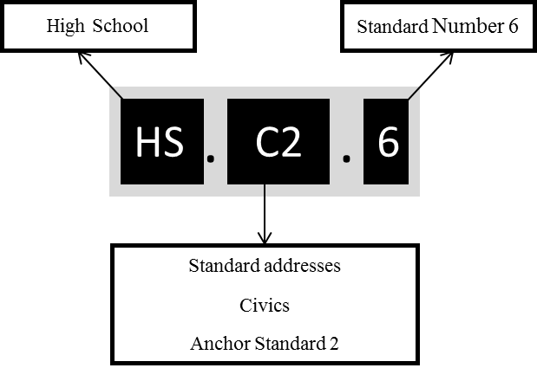

SIXTH GRADE – GLOBAL STUDIES: WORLD REGIONS AND CULTURES OF THE EASTERN HEMISPHERE

early civilizations - Renaissance & Reformation

The content focus will be viewed through geographic and historical lenses. Sixth grade students will understand the cultural, religious, economic, and political systems of selected societies in the Eastern Hemisphere. Regions in the Eastern Hemisphere include the Middle East and North Africa, sub-Saharan Africa, Europe, Asia (east, south, and southeast), and Oceania. A course on world regions and cultures can be approached from many angles and perspectives.

There are many topics to pursue in 6th grade. LEAs should identify topical emphases to allow for depth of study needed to effectively engage student/learners in the inquiry process. Educators may choose to take a regional approach, a thematic approach, or a historical approach to the content.

- Beginnings of human society such as early hominid development, peopling of the earth, and the Neolithic revolution
- Early river civilizations such as Mesopotamia, the Nile River Valley, the Indus River Valley, and the Yellow River Valley
- World religions including, but not limited to Buddhism, Christianity, Confucianism, Hinduism, Islam, Judaism, Shintoism, Sikhism, and Taoism, (origins, founders, major tenets, practices, and sacred writings)
- Classical civilizations such as Greek, Roman, Persian, and Chinese (political, social, religious, and economic systems)
- Rise and fall of empires and the impacts to the region
- Growth of trade networks across the Eastern Hemisphere and impacts such as cultural exchange and diffusion, inventions, ideas, diseases, and language
- Development of feudal systems in medieval Europe and Japan
- Different civilizations in the Eastern Hemisphere during the Middle Ages with regards to political, social, religious, and economic systems
- Origins, accomplishments, and geographic diffusion of the Renaissance and the Reformation
- Ancient and modern geography of the Eastern Hemisphere
- Examination of primary and secondary sources including written and oral histories, images, and artifacts
- Disciplinary skills and processes including change and continuity over time, multiple perspectives, using and understanding sources, and cause and effect

DISCIPLINARY SKILLS AND PROCESSES

Chronological reasoning requires understanding processes of change and continuity over time, which means assessing similarities and differences between historical periods and between the past and present.
- 6.SP1.1 Examine ways that historians and social scientist know about the past.
- 6.SP1.2 Analyze connections among events and developments in various geographic and cultural contexts.
- 6.SP1.3 Classify a series of historical events and developments as examples of change and/or continuity.
- 6.SP1.4 Evaluate the significance of past events and their effect on students’ lives and society.

Thinking within the discipline involves the ability to identify, compare, and evaluate multiple perspectives about a given event to draw conclusions about that event since there are multiple points of view about events and issues.
- 6.SP2.1 Explain how and why perspectives of people have changed throughout different historical eras.
- 6.SP2.2 Analyze how people’s perspective influenced what information is available in the historical sources they created.

Historians and Social Scientist gather, interpret, and use evidence to develop claims and answer historical, economic, geographical, and political questions and communicate their conclusions.
- 6.SP3.1 Define and frame compelling and supporting questions about issues and events in the time-period and region studied.
  - 6.SP3.2 Use evidence to develop claims and counterclaims in response to compelling questions in the time period and region studied.
- 6.SP3.3 Classify the kinds of historical sources used in secondary interpretations.
- 6.SP3.4 Use information about a historical source including the author, date, place of origin, intended audience, and purpose to judge the extent
to which the source is useful for studying a topic and evaluate the credibility of the source.
- 6.SP3.5 Use questions generated about multiple sources to identify further areas of inquiry and additional sources.
  - 6.SP3.6 Construct and present arguments using claims and evidence from multiple sources.
  - 6.SP3.7 Construct and present explanations using reasoning, correct sequence, examples and details with relevant information and data.

Thinking within the discipline involves the ability to analyze relationships among causes and effects and to create and support arguments using relevant evidence.
- 6.SP4.1 Explain the multiple causes and effects of events and developments in the past.
- 6.SP4.2 Organize applicable evidence into a coherent argument about the past.

CIVICS

Citizens have individual rights, roles, and responsibilities
- 6.C2.1 Analyze the beliefs, experiences, perspectives, and values that underlie points of view regarding civic issues in the time period and regions
studied.

Process, rules, and laws direct how individuals are governed and how society addresses problems.
- 6.C4.1 Explain challenges and opportunities people and groups face when solving local, regional, and/or global problems.
- 6.C4.2 Describe and apply civic virtues including deliberative processes that contribute to the common good and democratic principles in school, community, and government.
    - Key concepts include but are not limited to civility, respect for the rights of others, individual responsibility, respect for law, open mindedness, critical examination of issues, negotiation and compromise, civic mindedness, compassion, patriotism, conciliation, and consensus building

ECONOMICS

A financially literate individual understands how to manage income, spending, and investment.
- 6.E1.1 Analyze the relationship between education, income, and job opportunities within the context of the time period and region studied.
- 6.E1.2 Give examples of financial risks that individuals and households face within the context of the time period and region studied.

Individuals and institutions are interdependent within market systems.
- 6.E3.1 Describe the relationship between various costs and benefits of economic production.
- 6.E1.2 Explain the influence the factors of production have on the manufacture of goods and services within different cultures, regions, and
communities.
    - Key concepts include traditional economic systems, manorialism, guilds, taxation systems, and coerced labor
- 6.E3.3 Analyze the influence of specialization and trade within diverse cultures and communities in regions studied.

The interconnected global economy impacts all individuals and groups in significant and varied ways.
- 6.E5.1 Describe the factors that influence trade between countries or cultures.
- 6.E5.2 Explain the effects of increasing economic interdependence within distinct groups.

GEOGRAPHY

The use of geographic representations and tools helps individuals understand their world.
- 6.G1.1 Use and construct maps, graphs, and other representations to explain relationships between locations of places and regions.
    - Key concepts include major landforms and water bodies, countries, cities, ecosystems, climate, languages, religion, economic systems, governmental systems, population patterns, disease, trade routes, and settlement patterns

Human-environment interactions are essential aspects of human life in all societies.
- 6.G2.1 Compare diverse ways people or groups of people have impacted, modified, or adapted to the environment of the Eastern Hemisphere.
    - Key concepts include but are not limited to hunter-gatherer communities, human settlement, Neolithic Revolution, irrigation and farming, domestication of animals, and influence of climate and seasons

Examining human population and movement helps individuals understand past, present, and future conditions on Earth’s surface.
- 6.G3.1 Analyze how cultural and environmental characteristics affect the distribution and movement of people, goods, and ideas.
    - Key concepts include but are not limited to language, land and sea transportation and trade routes
- 6.G3.2 Analyze the influence of location, use of natural resources, catastrophic environmental events, and technological developments on human settlement and migration.
    - Key concepts include but are not limited to development of early river civilization, pastoral societies, rise of cities, innovations in transportation, and collapse of empires

Global interconnections and spatial patterns are a necessary part of geographic reasoning.
- 6.G4.1 Explain why environmental characteristics vary among different world regions.
    - Key concepts include but are not limited to latitude, elevation, landforms, location, and human factors
- 6.G4.2 Describe how natural and human-made catastrophic events and economic activities in one place affect people living in nearby and distant places.
    - Key concepts include but are not limited to disease, war, items exchanged, ideas spread along trade routes, and natural disasters

HISTORY

The development of civilizations, societies, cultures, and innovations have influenced history and continue to impact the modern world.
- 6.H1.1 Compare the development and characteristics of historical cultures and civilizations from different global regions within designated time periods.

- 6.H1.2 Explain the causes and effects of interactions between cultures and civilizations.
    - Key concepts include but are not limited to trade, competition, warfare, slavery, serfdom, innovations, and contributions.

Cycles of conflict and cooperation have shaped relations among people, places, and environments.
- 6.H2.1 Evaluate the causes and effects of conflict and resolution among different societies and cultures.
    - Key factors such as control and use of natural resources, political power, religious rivalry, acquisition of wealth, cultural diversity, and economic rivalry

Economic, political, and religious ideas and institutions have influenced history and continue to shape the modern world.
- 6.H3.1 Analyze the impact of religious, government, and civic groups over time.
- 6.H3.2 Generate questions to examine the similarities and differences between major world religions and the role of religion in the formation of
regions and their cultural, political, economic, and social identity.
    - Key world religions such as Buddhism, Christianity, Confucianism, Hinduism, Islam, Judaism, Shintoism, Sikhism, and Taoism
- 6.H3.3 Explain why communities, states, and nations have different motivations for their choices including individual rights, freedoms, and responsibilities.

Patterns of social and political interactions have shaped people, places, and events throughout history and continue to shape the modern world.
- 6.H4.1 Describe how different group identities such as racial, ethnic, class, gender, regional, and immigrant/migration status emerged and contributed
to societal and regional development, characteristics, and interactions over time.

SEVENTH GRADE - INTEGRATED GLOBAL STUDIES

Scientific Revolution & Enlightenment -present

The content focus will be viewed through historical and geographic lenses. Seventh grade students will understand the relationships and interactions between societies and cultures in both the Eastern and Western Hemispheres. United States history will be taught as it intersects with global issues.

There are many topics to pursue in 7th grade. LEAs should identify topical emphases to allow for depth of study needed to effectively engage student/learners in the inquiry process.

- Influence of the Scientific Revolution on innovation and the Enlightenment on the concept of rights
- Revolutions around the world such as the American Revolution, French Revolution, Russian Revolution, the Cultural Revolution (Mao Zedong), and Latin American revolutions
- Global imperialism and its lasting consequences on regional conflict, stability, indigenous peoples, and human movement, including slavery and involuntary migrations
- Impact of industrialization and the rise of organized labor
- Global depressions
- World War I and World War II including the time period between the wars with the rise of fascism
- Cold War including origins, nuclear deterrence, and outcome
- Global conflicts and their consequences such as the Korean War, Vietnam War, Arab-Israeli Conflict, and Gulf War
- Government and economic systems such as monarchy, dictatorship, theocracy, oligarchy, aristocracy, democracy, constitutional republic, anarchy, and capitalism, socialism, and communism including founders, major tenets, practices, and writings
- Examination of primary and secondary sources including written and oral histories, images, and artifacts
- Disciplinary skills and processes including change and continuity over time, multiple perspectives, using and understanding sources, and cause and effect

DISCIPLINARY SKILLS AND PROCESSES

Chronological reasoning requires understanding processes of change and continuity over time, which means assessing similarities and differences between historical periods and between the past and present.
- 7.SP1.1 Analyze connections among events and developments in broader historical contexts.
- 7.SP1.2 Classify a series of historical events and developments as examples of change and/or continuity.
- 7.SP1.3 Evaluate the significance of past events and their effect on students’ lives and global society.
- 7.SP1.4 Use questions generated about individuals and groups to analyze why they, and the developments they shaped, are historically significant.

Thinking within the discipline involves the ability to identify, compare, and evaluate multiple perspectives about a given event to draw conclusions about that event since there are multiple points of view about events and issues.
- 7.SP2.1 Analyze multiple factors that influence the perspectives of people during different historical eras.
- 7.SP2.2 Explain how and why perspectives of people have changed over time.
- 7.SP2.3 Analyze how people’s perspectives influenced what information is available in the historical sources they created.

Historians and Social Scientist gather, interpret, and use evidence to develop claims and answer historical, economic, geographical, and political questions and communicate their conclusions.
  - 7.SP3.1 Create compelling questions and supporting questions that reflect enduring issues about the world, past and present.
  - 7.SP3.2 Use evidence drawn from multiple sources to develop and support claims and counterclaims in response to compelling questions.
  - 7.SP3.3 Detect possible limitations in the historical record based on evidence collected from various kinds of historical sources.
  - 7.SP3.4 Use questions generated about multiple sources, including international sources, to identify further areas of inquiry and additional sources.
  - 7.SP3.5 Evaluate the relevance and utility of sources based on information such as author, date, origin, intended audience, and purpose.
  - 7.SP3.6 Construct and present arguments based on claims and counterclaims while pointing out the strengths and limitations of those arguments.
  - 7.SP3.7 Construct and present explanations using reasoning, correct sequence, examples and details, while acknowledging the strengths and
weaknesses of the explanations.

Thinking within the discipline involves the ability to analyze relationships among causes and effects and to create and support arguments using relevant evidence.
- 7.SP4.1 Explain the multiple causes and effects of events and developments in the past and present.
- 7.SP4.2 Evaluate the influence of various causes of events and developments in the past and present.
- 7.SP4.3 Organize applicable evidence into a coherent argument.
- 7.SP4.4 Compare the central arguments in multiple secondary sources on a related topic using multiple types of sources.

CIVICS

Citizens have individual rights, roles, and responsibilities.
- 7.C2.1 Explain how revolutions and other changes in government impact citizens’ rights.

Process, rules, and laws direct how individuals are governed and how society addresses problems.
- 7.C4.1 Compare historical and contemporary means of changing societies to promote the common good.
- 7.C4.2 Assess specific rules and laws (both actual and proposed) as a means of addressing public problems.
- 7.C4.3 Analyze the purpose, process, implementation, and consequences of decision making and public policies in multiple settings.
  - 7.C4.4 Explain challenges people face and opportunities they create in addressing local, regional, and global problems at various times and places.
Apply a range of deliberative and democratic procedures to make decisions and act in local, regional, and global communities.

ECONOMICS

By applying economic reasoning, individuals seek to understand the decisions of people, groups, and societies.
- 7.E2.1 Explain how economic decisions affect the well-being of individuals, businesses, and society.
- 7.E2.2 Evaluate current economic issues in terms of benefits and costs for distinct groups in society.

Individuals and institutions are interdependent within market systems.
- 7.E3.1 Explain the roles of buyers, sellers, and profits in product, labor, and financial markets.
- 7.E3.2 Analyze the relationship between supply, demand, and competition with emphasis on how they influence prices, wages, and production.
- 7.E3.3 Analyze the influence of institutions such as corporations, non-profits, and labor unions on the economy in a market system.
- 7.E3.4 Explain ways in which money facilitates exchange.

The interconnected global economy impacts all individuals and groups in significant and varied ways.
- 7.E5.1 Explain the interdependence of trade and how trade barriers influence trade among nations.
- 7.E5.2 Compare the various economic systems.
- 7.E5.3 Explain the benefits and the costs of trade policies to individuals, businesses, and society.

GEOGRAPHY

The use of geographic representations and tools helps individuals understand their world.
- 7.G1.1 Use and construct maps and other geographic representations to explain the spatial patterns of cultural and environmental characteristics.
    - Key tools and representations such as maps, globes, aerial and other photos, remotely sensed images, tables, graphs, and geospatial technology
- 7.G1.2 Analyze various geographic representations and use geographic tools to explain relationships between the location of places and their environments.

Human-environment interactions are essential aspects of human life in all societies.
- 7.G2.1 Explain how cultural demographic patterns, economic decisions, and human adaptations shape the identity of nearby and distant places.
- 7.G2.2 Analyze cultural and environmental characteristics that make places both similar and different.

Examining human population and movement helps individuals understand past, present, and future conditions on Earth’s surface.
- 7.G3.1 Explain how changes in transportation, communication, and technology influence the spatial connections among human settlements and affect the diffusion of ideas and cultural practices.
- 7.G3.2 Analyze how relationships between humans and environments extend or contract patterns of settlement and movement.
- 7.G3.3 Evaluate the influences of long-term, human-induced environmental change on spatial patterns and how it may cause conflict and promote
cooperation.
7.G3.4 Evaluate human population and movement may cause conflict or promote cooperation.

Global interconnections and spatial patterns are a necessary part of geographic reasoning.
- 7.G4.1 Analyze cultural and environmental characteristics among various places and regions of the world.
- 7.G4.2 Explain how the relationship between the human and physical characteristics of places and production of goods influences patterns of world
trade.
- 7.G4.3 Analyze how changes in population distribution patterns affect changes in land use in places and regions
- 7.G4.4 Explain an issue in terms of its scale (local, regional, state, national, or global)

HISTORY

The development of civilizations, societies, cultures, and innovations have influenced history and continue to impact the modern world.
- 7.H1.1 Analyze the rise and decline, interactions between, and blending of cultures and societies.
- 7.H1.2 Trace the development and impact of scientific, technological, and educational innovations within historical time periods.

Cycles of conflict and cooperation have shaped relations among people, places, and environments.
- 7.H2.1 Investigate how conflict can be both unifying and divisive throughout communities, societies, nations, and the world.
- 7.H2.2 Compare the multiple causes and effects of conflict and approaches to peacemaking.

Economic, political, and religious ideas and institutions have influenced history and continue to shape the modern world.
- 7.H3.1 Compare the origins and spread of influential ideologies and both religious and non-religious worldviews.
- 7.H3.2 Analyze how economic and political motivations impact people and events.
- 7.H3.3 Trace how individual rights, freedoms, and responsibilities have evolved over time.
- 7.H3.4 Explain the influence of individuals, groups, and institutions on people and events in historical and contemporary settings.
  - 7.H3.5 Investigate a significant historical topic from global history that has significance to an issue or topic today.

Patterns of social and political interactions have shaped people, places, and events throughout history and continue to shape the modern world.
- 7.H4.1 Evaluate how the diversity of a society impacts its social and political norms.
- 7.H4.2 Evaluate the changing patterns of class, ethnic, racial, and gender structures and relations; consider immigration, migration, and social mobility.

EIGHTH GRADE - CITIZENSHIP AND CIVIC ENGAGEMENT IN TODAY’S SOCIETY

The content focus will be viewed through civic and economic lenses. Citizenship and civic engagement will be taught through inquiry. Eighth grade students will make connections between historical and current/contemporary issues as a base for implementing change in society. Students will recognize and practice their roles and responsibilities as both American and global citizens. United States History will focus on the major events that have their roots in the Constitution, Bill of Rights, and subsequent amendments.

There are many topics to pursue in 8th grade. LEAs should identify topical emphases to allow for depth of study needed to effectively engage student/learners in the inquiry process.

- Foundations of the United States government stemming from historical events such as the American Revolution and Civil War
- Constitution including structure, function, and principles
- Formal institutions such as Congress, the courts, the presidency, and linkage institutions such as media, elections, interest groups, polling, and political parties
- Historical and current legislation and landmark Supreme Court cases
- Civil rights movements throughout American history
- Immigration
- Amendments to the Constitution that have expanded the right to vote and equal protection under the law
- Social movements and issues both historical and current including the constitutional principles and structures (amendments, courts, Congress, and executive orders) that spur, promote, and protect these movements
- Human rights and genocides including treaties and organizations that promote human rights and a study of the nations and leaders that abuse human rights and/or support genocide (In addition to the study of the Holocaust, other genocides should be studied)
- Environmental issues
- Information and media age including digital citizenship and media literacy
- Terrorism both domestic and international and how it influences citizens’ safety and rights
- Examination of primary and secondary sources including written and oral histories, images, and artifacts
- Disciplinary skills and processes including change and continuity over time, multiple perspectives, using and understanding sources, and cause and effect

DISCIPLINARY SKILLS AND PROCESSES

Chronological reasoning requires understanding processes of change and continuity over time, which means assessing similarities and differences between historical periods and between the past and present.
- 8.SP1.1 Analyze connections among events and developments in broader historical contexts.
- 8.SP1.2 Classify a series of historical events and developments as examples of change and/or continuity.
- 8.SP1.3 Evaluate the significance of past events and their effect on students’ lives and society.
- 8.SP1.4 Use questions generated about individuals and groups to analyze why they, and the developments they shaped, are historically significant.

Thinking within the discipline involves the ability to identify, compare, and evaluate multiple perspectives about a given event to draw conclusions about that event since there are multiple points of view about events and issues.
- 8.SP2.1 Analyze multiple factors that influence the perspectives of people during different historical eras.
- 8.SP2.2 Explain how and why perspectives of people have changed over time.
- 8.SP2.3 Analyze how people’s perspectives influenced what information is available in the historical sources they created.

Historians and Social Scientist gather, interpret, and use evidence to develop claims and answer historical, economic, geographical, and political questions and communicate their conclusions.
- 8.SP3.1 Create and answer compelling and supporting questions that reflect enduring issues in the field of history and social science.
  - 8.SP3.2 Detect possible limitations in the historical record based on evidence collected from various kinds of historical sources.
- 8.SP3.3 Use questions generated about multiple historical sources to identify further areas of inquiry and additional sources.
- 8.SP3.4 Evaluate the relevance and utility of historical sources based on information such as author, date, origin, intended audience, and purpose.
- 8.SP3.5 Gather relevant information from multiple sources while using the origin, authority, structure, context, and corroborative value of the source to
guide the selection to support claims and counterclaims.
- 8.SP4.6 Construct and present arguments based on claims and counterclaims while pointing out the strengths and limitations of the arguments.
- 8.SP4.7 Construct and present explanations using reasoning, correct sequence, examples, details with relevant information and data, while
acknowledging the strengths and weaknesses of the explanations.
- 8.SP4.8 Present arguments and explanations on topics of interest to others to reach multiple audiences in and outside of the classroom print, oral, and
digital technologies.

Thinking within the discipline involves the ability to analyze relationships among causes and effects and to create and support arguments using relevant evidence.
- 8.SP4.1 Explain the multiple causes and effects of events and developments in the past.
- 8.SP4.2 Evaluate the influence of various causes of events and developments in the past.
- 8.SP4.3 Organize applicable evidence into a coherent argument about the multiple causes and effects of events and issues.
- 8.SP4.4 Compare the credibility, and authenticity of central arguments in secondary works of history on related topics in multiple media.

CIVICS

Civic virtues and democratic principles are key components of the American political system
- 8.C1.1 Analyze ideas and principles contained in the founding documents of the United States, including the Declaration of Independence and Constitution, and explain how they influence society and political systems.
    - Ideas and principles contained in founding documents include but are not limited to popular sovereignty, consent of the governed, the social contract, limited government, rule of law, separation of powers, checks and balances, federalism, and individual rights
- 8.C1.2 Demonstrate civic virtues that contribute to the common good and democratic principles within a variety of deliberative processes and settings.
- 8.C1.3 Analyze the influence of personal interests and perspectives when people address issues and problems in government and civil society.
- 8.C1.4 Engage in projects to help or inform others such as community service and service-learning projects.

Citizens have individual rights, roles, and responsibilities
- 8.C2.1 Analyze the powers of citizens in a variety of governmental and non-governmental contexts.
- 8.C2.2 Explain specific roles, rights and responsibilities of people in a society.
- 8.C2.3 Analyze concepts and ideals such as majority and minority rights, civil dissent, and the rule of law.
- 8.C2.4 Explain how immigrants become naturalized citizens.

An understanding of civic and political institutions in society and the principles these institutions are intended to reflect including knowledge about law, politics, and government is essential to effective citizenship.
- 8.C3.1 Describe the impact of political and civic institutions such as political parties, interest groups, elections, and the media in shaping policy.
    - Key concepts include but are not limited to political party platforms, structure of parties on a national, state, and local level including precincts, primary and general elections, presidential nominating system including conventions, congressional elections including congressional districts, gerrymandering, and census, electoral college including how electors are chosen in Arizona, types of interest groups, and role of the media.
- 8.C3.2 Examine the origins and purpose of constitutions, laws, treaties, and international agreements.
- 8.C3.3 Compare the structures, powers, and limits of government at distinct levels in the United States.

Process, rules, and laws direct how individuals are governed and how society addresses problems
- 8.C4.1 Compare historical and contemporary means of changing societies to promote the common good.
- 8.C4.2 Assess specific rules and laws (both actual and proposed) as means of addressing public problems.
- 8.C4.3 Analyze the purpose, process, implementation, and consequences of decision making and public policies in multiple settings and at different levels including the national, state, local (county, city, school board), and tribal.
  - 8.C4.4 Identify, research, analyze, discuss, and defend a position on a national, state, or local public policy issue including an action plan to address or inform others about the issue.
  - 8.C4.5 Analyze how a specific problem can manifest itself at the local, regional, and global levels, identifying its characteristics and causes, and the
challenges and opportunities faced by those trying to address the problem. Apply a range of deliberative and democratic procedures to take action and solve the problem.

ECONOMICS

A financially literate individual understands how to manage income, spending, and investment.
- 8.E1.1 Analyze the relationship between education, income, and job opportunities.
- 8.E1.2 Analyze the relationship between interest rates, saving, and use of credit.
- 8.E1.3 Analyze the relationship between investment and return.
- 8.E1.4 Examine the factors that influence spending decisions.
- 8.E1.5 Create a budget and examine the benefits of budgeting
- 8.E1.6 Analyze the impact of debt on individuals.
- 8.E1.7 Understand several types of financial investments and calculate rates of return.
- 8.E1.8 Identify ways insurance may minimize personal financial risk.

By applying economic reasoning, individuals seek to understand the decisions of people, groups, and societies.
- 8.E2.1 Explain how economic decisions affect the well-being of individuals, businesses, and society.
- 8.E2.2 Evaluate current economic issues in terms of benefits and costs for distinct groups.

Individuals and institutions are interdependent within market systems.
- 8.E3.1 Explain the roles of buyers, sellers, and profits in product, labor, and financial markets.
- 8.E3.2 Analyze the relationship between supply, demand, and competition and their influence on prices, wages, and production.
- 8.E3.3 Analyze the influence of institutions such as corporations, non-profits, and labor unions in a market economy.

The domestic economy is shaped by interactions between government, institutions, and the private sector.
- 8.E4.1 Explain how inflation, deflation, and unemployment affect distinct groups.
- 8.E4.2 Explain the influence of changes in interest rates on borrowing and investing.
- 8.E4.3 Explain the effect of productivity on standard of living.

The interconnected global economy impacts all individuals and groups in significant and varied ways.
- 8.E5.1 Explain the interdependence of trade and how trade barriers influence trade among nations.
- 8.E5.2 Compare various economic systems such as command, mixed, and free market.
- 8.E5.3 Explain the benefits and the costs of trade policies to individuals, businesses, and society.

GEOGRAPHY

The use of geographic representations and tools helps individuals understand their world.
- 8.G1.1 Use geographic tools and representations to analyze historical and modern political and economic issues and events.
    - Key tools and representations such as maps, globes, aerial and other photos, remotely sensed images, tables, graphs, and geospatial technology

Human-environment interactions are essential aspects of human life in all societies.
- 8.G2.1 Examine impact of and responses to environmental issues such as air, water, and land pollution, deforestation, urban sprawl, and changes to
climate.
- 8G2.2 Evaluate how political, social, and economic decisions throughout time have influenced cultural and environmental characteristics of various
places and regions.

Examining human population and movement helps individuals understand past, present, and future conditions on Earth’s surface.
- 8.G3.1 Evaluate the impact of economic, political, and social decisions that have caused conflict or promoted cooperation throughout time.

Global Interconnections and spatial patterns are a necessary part of geographic reasoning.
- 8G4.1 Take an active stance on a geographic issue reflecting its scale (local, regional, state, national, or global)

HISTORY

Cycles of conflict and cooperation have shaped relations among people, places, and environments.
- 8.H2.1 Explain how different beliefs about the government’s role in social and economic life have affected political debates and policies in the United States.
- 8.H2.2 Investigate how conflict can be both unifying and divisive both domestically and internationally.
- 8.H2.3 Explain how geographic and environmental factors shaped communities and how competition over resources have affected government policies.

Economic, political, and religious ideas and institutions have influenced history and continue to shape the modern world.
  - 8.H3.1 Explain how and why prevailing civil, social, religious, and political movements changed the United States during the 20th and 21st centuries.
  - 8.H3.2 Explain how popular movements, reform efforts, and activist groups have sought to change American society and institutions.
  - 8.H3.3 Compare how individual rights, freedoms, and responsibilities have evolved over time around the world.
  - 8.H3.4 Investigate a significant historical topic from United States History that has significance to an issue or topic today.

