Universal Design for Learning is a framework to improve and optimize teaching and learning for all students. It is based on scientific insights into how all humans learn. Universal design for learning (UDL) is a set of principles for designing curriculum and instruction that provides all individuals with equal opportunities to learn. UDL is designed to serve all learners, regardless of ability, disability, age, gender, or cultural and linguistic background. UDL provides a blueprint for designing goals, methods, materials, and assessments to reach all students including those with diverse needs. Grounded in research of learner differences and effective instructional settings, UDL principles call for varied and flexible ways to
● Present or access information, concepts, and ideas (the "what" of learning),
● Plan and execute learning tasks (the "how" of learning), and
● Get engaged—and stay engaged—in learning (the "why" of learning)
UDL is different from other approaches to curriculum design in that educators begin the design process expecting the curriculum to be used by a diverse set of students with varying skills and abilities.

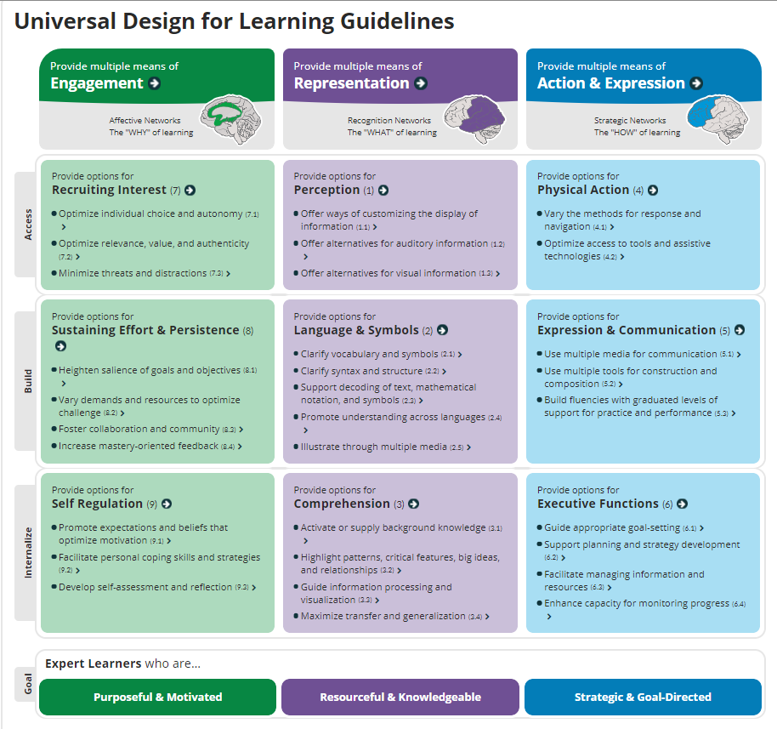
CAST (2018). Universal Design for Learning Guidelines version 2.2. Retrieved from http://udlguidelines.cast.org

Universal Design for Learning Resources
http://www.cast.org/our-work/about-udl.html#.XQENxIhKiUk
http://www.cast.org/whats-new/learning-tools.html#.XQENjYhKiUk
http://lessonbuilder.cast.org/
http://castprofessionallearning.org/about-udl/
https://www.youtube.com/user/UDLCAST?app=desktop

