6

Sample Policies and Procedures Table of Contents
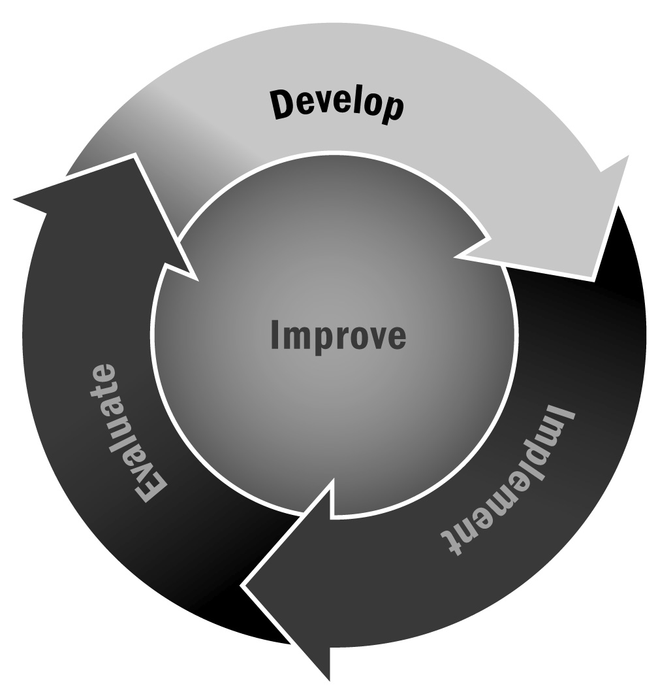
In Chapter 1, you learned that having policies and procedures promotes standardized practices that ultimately ensure safety, support staff member retention, and promote high-quality programming.
Directions: Use this sample table of contents to guide the development of your policies and procedures manual or handbook. You may decide to use all or some of the policies and procedures listed here, and you may decide to add policies and procedures specific to your program. Make sure your handbook is available in multiple formats (online and in print), at all of your locations, and in the languages spoken in your program.

Facilities Policy: To ensure a safe and secure environment that adheres to local building codes and licensure requirements
Facilities Procedures pg XX
Safety/Security
Indoor/Outdoor Maintenance
Emergency
Licensure
Weather Conditions
Special Facilities Procedures (e.g., pools, computer labs, gymnasiums)
Fire Escape Procedures
Development Policy: To secure diversified funds and goods for programming, to convene and respond to stakeholder groups, and to disseminate information broadly
Development Procedures pg XX
Board Stewardship
Fundraising
Communications
Reporting
Conflict of Interest

Accounting Policy: To uphold accounting practices to the highest standard and within the specifications of the designated business model/tax code
Accounting Procedures pg XX
Internal Controls
Financial Planning
Reporting, Revenue/Accounts Receivable
Expense/Accounts Payable
In-Kind Contributions
Asset Management
Staff/Personnel Policy: To hire and retain staff members without bias and in the interest of their professional development
Staff/Personnel Procedures pg XX
Recruitment/Hiring
Background Checks
Supervision
Promotion
Salaries/Benefits
Leave/Vacation
Staff Member Dismissal
Substitute Procedures
Program and Participant Policy: To be equitable in the recruitment, enrollment, and retention of participants; to promote the strengths of each participant and to offer high-quality programs where youth can learn and develop
Program and Participant Procedures pg XX
Enrollment/Wait Lists
Participant Inclusion
Attendance
Activity Planning and Implementation
Medical History and Intervention
Behavior Supports and Management
Discipline
Mandated Reporting
Transportation
Pick-Up and Dismissal
Bus Policies
Field Trips

Data and Evaluation Policy: To use evaluation studies and participant data ethically in program improvement efforts and for research
Data and Evaluation Procedures pg XX
Data Use
Data Storage, Security, and Sharing
Privacy and Guardianship
FERPA
Family Consent/Youth Assent for Surveys and Other Data Collection
Reporting
External Relations/Liability Policy: To protect the organization/program, staff members, and participants from potential harm or exposure
External Relations/Liability Procedures pg XX
Social Media
News Media
Advocacy
Consent (e.g., photo, information)
Other Employment
Conflict of Interest
Intellectual Property

