Comprehensive Needs Assessment Integrated Action Plan Guidance

Table of Contents

Continuous Improvement 2
What Is a Needs Assessment? 2
ADE Comprehensive Needs Assessment (CNA) 3
Principles, Indicators and Elements 3
Completing the Comprehensive Needs Assessment 4
CNA Tool Directions 6
Specific Step by Step CNA 7
Planning and Preparation 7
CNA Data Collection, and Analysis 7
Gather, review and analyze demographic data 8
Gather, review and analyze leading indicator data 8
Gather, review and analyze lagging indicator data 8
Percentage of limited English proficient students who attain English language proficiency 8
Graduation rate 8
Identify 3 or 4 Primary Needs 10
Conduct a Thorough Root Cause Analysis 11
The 5 Why Method 14
Upload the completed CNA Tool and Root Cause Analysis Templates to ALEAT 17
Integrated Action Plan 18
IAP Requirements: 18
Integrated Action Plan Diagram 19
School Integrated Action Plan (SIAP) 20
SMART GOALS 21
Sample School Site IAP Worksheet 24
LEA Integrated Action Plan (LIAP) 26
Sample LEA Integrated Action Plan Worksheet 27
IAP in ALEAT 31
ALEAT Tags 34
CNA and Integrated Action Plan Informs Grant Applications 34
Appendix A 35
MONITORING AND EVALUATION 35
Appendix B 37
Resources for Evidence-Based Strategies 37
Searchable data base of evidence-based programs, practices and interventions 37

Continuous Improvement
Continuous improvement is a process that unfolds progressively and is sustained over time. It encompasses the general belief that improvement doesn’t start and stop. It requires an organizational and professional commitment to an ongoing process of learning, self-reflection, adaptation, and growth. For example, when a school is continuously improving, a variety of changes occur in ways that cumulatively affect multiple dimensions of a school or school system.
The concept of continuous improvement also recognizes that improving school effectiveness is not only highly complex, but it entails unforeseen challenges and complications that require a sustained commitment to ongoing improvements.
Major components of continuous school improvement encompass creating, reviewing or revising the school vision; gathering and analyzing data related to that vision; planning the school’s work to align with the vision, selecting strategies, implementing the action steps; and gathering data to measure the impact.
Sustainable continuous improvement requires schools to have the knowledge, skills, and expertise needed to improve educational results and sustain improvement over time. Continuous improvement must build leader and staff capacity. The improvement cycle includes ongoing data collection that helps educators monitor progress and make adjustments in real time.

What Is a Needs Assessment?
A needs assessment is a systematic set of procedures that are used to determine needs, examine their nature and causes, and set priorities for future action. A needs assessment leads to action that will improve systems, services, processes and operations.
A needs assessment:
- Requires a team approach
- Requires gathering and analyzing data
- Informs identification of primary needs, need statements and desired outcomes
- Creates cohesion through the alignment of vision with greatest needs, root causes, and possible solutions.
- Identifies what’s working, what’s not and what’s needed
- Correlates qualitative and quantitative data

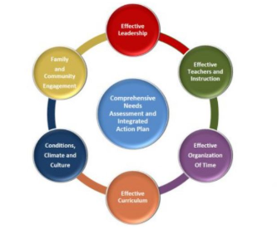
ADE Comprehensive Needs Assessment (CNA)
The CNA is required by ADE. It is designed to inform need statements, desired outcomes, goals, strategies and action steps for the Title l, ll, lll, lV, Move on When Reading and School Improvement programs.

The CNA will guide the process of evidence-based decision making in schools and LEAs to drive continuous improvement and sufficiently impact student achievement.
The CNA reflects the school’s current state. Acknowledging that state honestly and transparently, based on evidence, allows a school to determine the best next steps to reach desired outcomes. It is not about a comparison among schools. It is about identifying strengths, needs and desired outcomes specific to individual schools. The CNA will allow the school to identify the greatest needs, root causes, and possible solutions.
A limited number of well-defined desired outcomes and/or goals are a common feature of successful school and LEA improvement plans. These desired outcomes with goals, strategies and actions steps, help focus a school’s work by setting a target for student learning and achievement or systems, processes and programs that will impact achievement. By choosing strategies and action steps that leverage strengths and focus on connections and coherence, student learning and achievement increase. Carefully choose foundational small steps that lead to desired outcomes and systemic change over time.

The CNA is not a test; it is not an evaluation of good or bad. It is about knowing where you are as a school in relation to research-based exemplars of effective school systems to improve and be the best school possible in your context.

Principles, Indicators and Elements
The Principles, Indicators and Elements describe an effective school system. Developed collaboratively by a team from ADE program areas and representatives from schools and LEAs, this self- reflection process required for continuous improvement is based on current educational research and evidence based best practice.
The Principles, Indicators and Elements describe criteria applicable to all schools, no matter their size, student population, philosophy or location. Schools use the Principles, Indicators and Elements to identify primary needs when addressed and resolved result in increased student achievement and strengthened school systems leading to sustainable improvement.

Principle 1: Effective Leadership

Principle 2: Effective Teachers and Instruction
Principle 3: Effective Organization of Time Principle 4: Effective Curriculum

Principle 5: Conditions, Climate and Culture
Principle 6: Family and Community Engagement

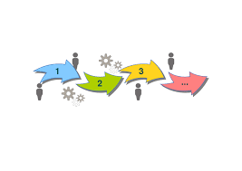

Completing the Comprehensive Needs Assessment

- Establish the Comprehensive Needs Assessment Team: a powerful, enthusiastic team from across the organization and community is essential to put new strategies into effect and transform an organization. Deciding who should take part in the guiding
coalition is crucial. Diversity is key. Building the momentum for change requires strong leadership and visible support from key people. Working as a team helps create momentum and build the sense of urgency in relation to the need for change. This team is a critical part of a comprehensive needs assessment process and should include stakeholders representing all parts of the system; principals, teachers, paraprofessionals, school office staff, parents, families, community members, and students.

The CNA team guides the CNA process, gathering and analyzing data, discussing ratings, coming to consensus on individual elements. They plan and facilitate the process itself, including appropriate involvement and representation that will lead to sustainable systemic change.
Overview:
  - Establish group norms and develop timeline
  - Understand the members’ roles and responsibilities

Establish additional work teams, if appropriate and needed
  - Always have the Principle with Indicators and Elements as the primary focus
  - Have access to ALL data
  - Know the purpose of diving into the data
  - Review the data for accuracy and consistency.
  - Using the CNA rubrics, decide on the current state through consensus
  - Identify three or four primary needs
  - Conduct root cause analysis for each need
  - Determine three or four primary needs statement and corresponding desired outcomes

- Use the rubrics in the resource document. Using the rubrics allows individual working teams facilitated by the CNA Team/Guiding coalition to discuss each indicator, elements and evidence in detail and come to consensus on final rating. Before selecting the answer that reflects the current state within each element, data need to be collected, reviewed and analyzed. The data should act as information gathering and a confirmation of the selection. The discussion is key.
- The CNA includes suggestions of data or evidence to be collected pertinent to the CNA Indicator and Element. These are suggestions of what data may be useful. While these suggestions are not required data points, we highly recommend you use multiple data sources.

- Guiding questions for gathering data:
- What data do we currently collect that is relevant to the CNA Indicator and Element?
- What additional data is needed or can contribute as evidence?

Consider five categories (Lipton and Wellman, 2012) when addressing this question (others may surface as you look at the data):

Curriculum design and implementation;

Instruction methods, materials and resources;

Teachers’ knowledge, skills and dispositions;
- Students’ knowledge, skills and dispositions; and
- Infrastructure (i.e. Schedules, programming and resources).
- Is data needed to show specific gains or losses or to better understand progression and/or effectiveness of a system or process?
- Which data points do you feel are the most meaningful and useful?
- Once the data is compiled for each indicator, the team reviews it all, preferably in the same session. This provides an opportunity for the team to share what they see in the data and to discuss what these findings mean for each CNA Element.
- Guiding questions for data review:

What patterns or trends can be found in the data?
- What are some positive areas that can be found in the data?
- What areas of need must be addressed based on the data?
- What can you infer from the data?
- What, if any, additional data is needed?
- The facilitator’s role is to ensure that all CNA team members’ voices are heard and all possible theories from the group are considered before coming to an agreement of a specific CNA Element descriptor that matches the current state.
Remember, it is THE PROCESS to determine the current reality that has the power. The DISCUSSION is what is important. The scores and the summaries of the scores guide identification of the greatest needs.

CNA Tool Directions
- Access the Comprehensive Needs Assessment (CNA) Tool from the Support and Innovation webpage CNA to RCA to IAP http://www.azed.gov/improvement/ 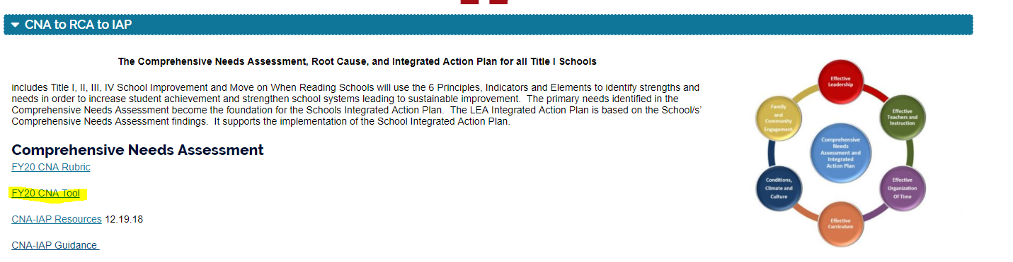
- Open the CNA Tool and save to your computer desktop.
  - Be sure to enable editing (yellow bar at the top of the screen).
- Start with Principle 1-definition
- Read Indicators one at a time with the corresponding Output.
  - Read each Element for that Indicator one at a time.
  - Answer the question by clicking on the O next to the answer that reflects the current state based on team discussion and consensus
  - Identify trends and patterns.
  - Identify possible primary needs for this principle.
  - Repeat for each Principle.

Quantitative Data: Quantitative data, both leading and lagging indicators in required. The templates allow you to collect these data all in one place.
The subgroups listed are required by ESSA.
AzMERIT/MSAA Available: http://www.azed.gov/research-evaluation/aims-assessment-results/
Graduation Rate Available: http://www.azed.gov/research-evaluation/graduation-rates/ Dropout Rate Available: http://www.azed.gov/research-evaluation/dropout-rate-study-
report/
Demographics Available: http://www.azed.gov/research-evaluation/arizona-enrollment- figures/
Discipline Available: School or LEA database/dashboard
Certification Available: http://www.azed.gov/educator-certification/

Teacher attendance, retention Available: School or LEA database/dashboard

AZELLA-The best source for multiple years of this AZELLA data is the SDELL72 report.
This report can be accessed through ADEConnect-EL Role, which is assigned at the LEA level.
For the first report, this will provide the proficiency levels; however, the LEA will need to link through AZEDS for the demographic information. For reclassification, the LEA can get a reclassification ballpark figure by using the Reassessment results and determining of the number of students who took the test, how many scored Proficient.

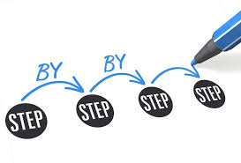
Specific Step by Step CNA

Planning and Preparation
  - Identify the Guiding Coalition-Comprehensive Needs Assessment (CNA)Team
    - The CNA team consists of people who are responsible for working collaboratively throughout the needs assessment process. Ideal team members possess knowledge of programs, the capacity to plan and implement the needs assessment, and the ability to ensure stakeholder involvement.
    - Stakeholders are those individuals with valuable experiences and perspective who provide the team with important input, feedback, and guidance and represent all factions of the school community.
  - Discuss the school vision and mission to ground the work
  - Determine CNA completion process (which may include forming additional work teams)
  - Determine timeline

CNA Data Collection, and Analysis
  - Data collection
  - Data analysis to select the Element descriptors that best match your school for all six Principles’ Indicators.
  - Discuss, discuss, discuss
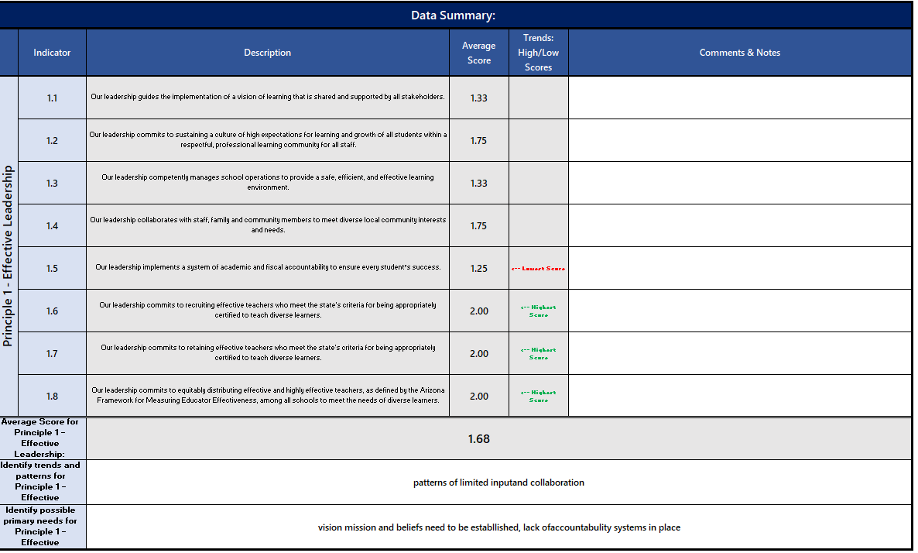
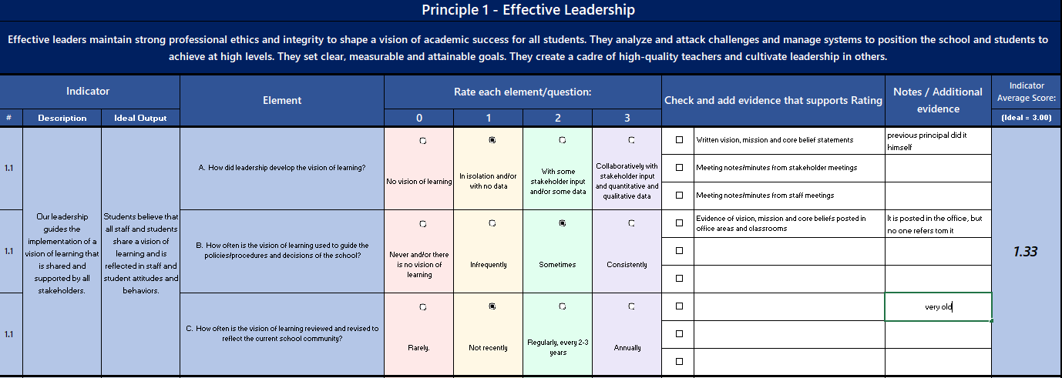
  - Reach consensus on each rating
Average score for each indicator
Trends
Possible Needs
View of CNA Tool Principle Summary
Indicator
Averag
e score

Gather, review and analyze demographic data
Guiding Questions
- How do student outcomes differ by demographics and programs?
- What is the longitudinal progress of a specific cohort of students?
- What are the characteristics of students who achieve proficiency and of those who do not?
- Where are we making the most progress in closing achievement gaps?
- How do absence and mobility affect assessment results?

Gather, review and analyze leading indicator data
Leading Indicators are formative. They track progress along the way and guide course corrections as needed.
Dropout rate Guiding Questions
    - Are there significant differences in dropout rates among subgroups?
    - Are there any trends? Who? When?
    - Student attendance rate
    - Have there been changes in the attendance rate overtime?
    - Are there trends among subgroups or grade levels?

Discipline incidents Guiding Questions
    - Have there been changes in the discipline incidents rate overtime?
    - Have there been changes in the types of discipline incidents over time?
    - Are there trends among subgroups, grade levels or teachers?

Truancy
- Have there been changes in the truancy rate overtime?
- Are there trends among subgroups or grade levels?

Teacher attendance rate
- Are there any overall trends?
- Do the trends correlate with achievement data?

Gather, review and analyze lagging indicator data
Lagging/Achievement Indicators are summative—they are longer term outcomes that enable us to reflect on the impact of a strategy.
    - Percentage of students at or above each proficiency level on State assessments in reading/language arts and mathematics, by grade and by student subgroup
    - Possible Student Achievement Guiding Questions
    - Effective collaboration to support student achievement: What processes are in place to ensure that effective collaboration is occurring to advance student achievement? Are existing processes effective?
    - Are there trends among subgroups?
    - Are there trends among grade levels?
    - Are there teacher specific trends?
    - Are there trends relative to ELA or Mathematics?

Percentage of limited English proficient students who attain English language proficiency
    - Are there trends among grade levels?
    - Are there teacher specific trends?
    - Have there been changes in the proficiency rates overtime?

Graduation rate
  - What processes are in place to support practices that positively affect graduation outcomes? What gaps exist in outcomes among student subgroups?
  - Have there been changes in the graduation rates over time? 4-year cohort? 5- year cohort? 6-year cohort?

CNA Tool Quantitative Templates
AzMERIT Data
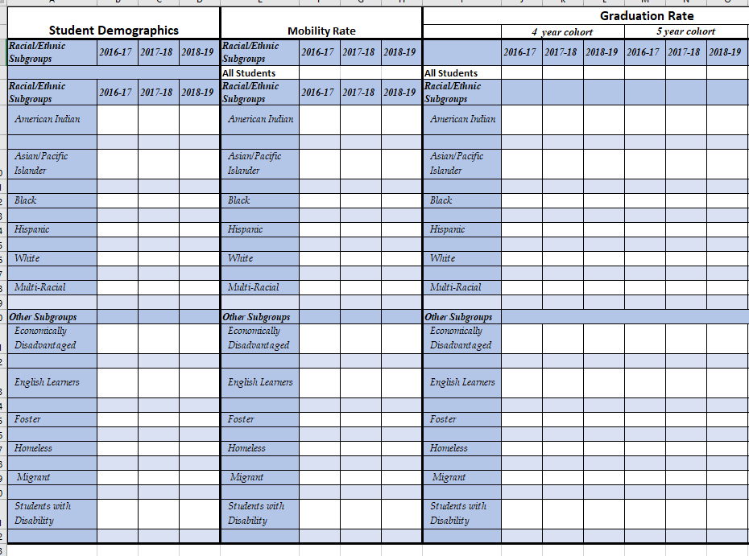
Misc. Data

Identify 3 or 4 Primary Needs
Primary need is CNA principle, indicator or element PLUS data source.
Reread the trends and patterns summaries and possible primary needs from all 6 Principles. Analyze the data you have from a variety of resources. Use the information in these summaries to Identify three or four primary needs.

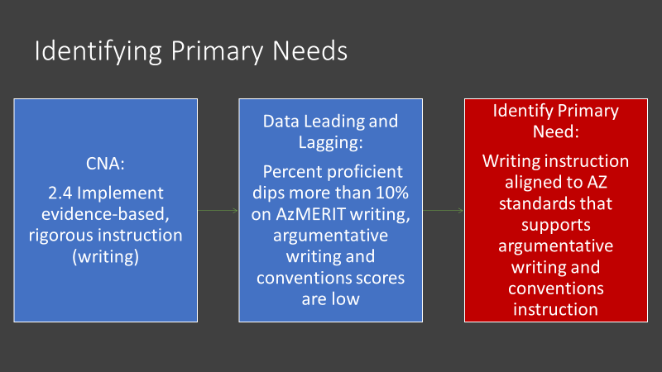

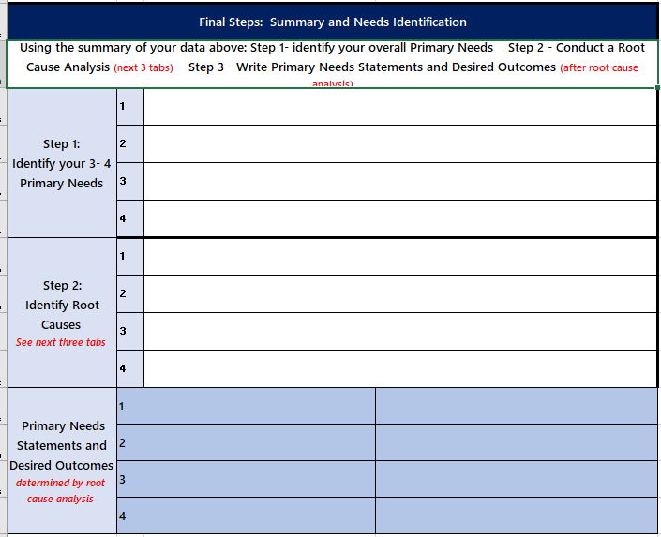
CNA Tool Final Summary

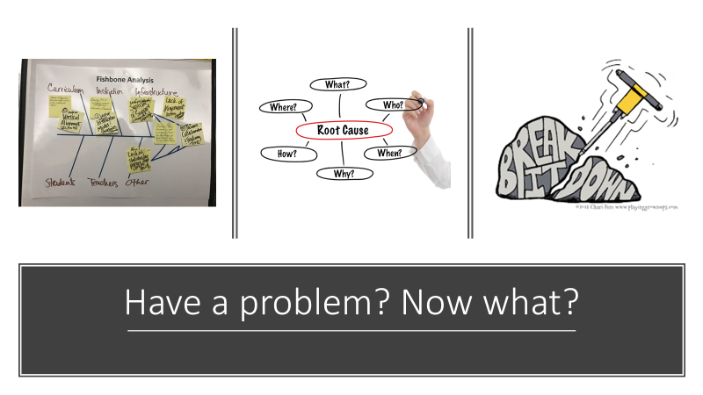
Next step is critical to successful change.

Conduct a Thorough Root Cause Analysis
for your top 3 or 4 primary needs, resulting in Needs Statements and Desired Outcomes. Root cause analyses take time! It is necessary for impactful change.
Root cause analysis is a structured team process. It allows the use of a strategic method to dig down into the primary need and determine causes and contributing factors. Often during the discussion of causes, different perspectives of the same situation are uncovered for an enhanced picture of the problem. At the end of the root cause analysis, the major cause is discovered and what needs to happen to remove the problem is determined. This is time to discuss causes, not solutions. The root cause is the one major contributing factor.
Fishbone Diagram
Root Cause:
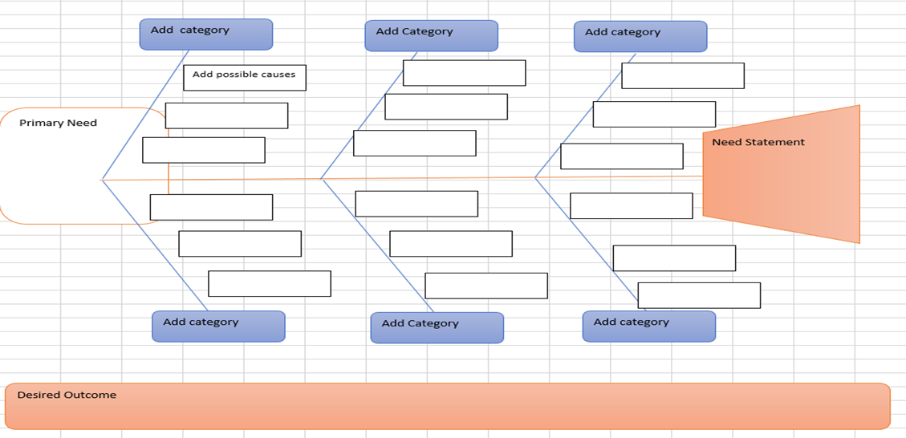

Fishbone Diagram Process Directions: The team identifies clear and specific primary needs based on patterns and trends in the CNA.
  - Choose ONE of the primary needs identified in the CNA to address first and write it in the head of the fishbone.
  - The team facilitator asks the team, “How do we know that problem exists? What are the teachers doing? What are the students doing? (see the root cause analysis questions for support with this)
  - The team recorder documents comments on the fishbone grouping items in like categories, for example: teachers, students, curriculum, assessment, etc.
  - After, all ideas are documented on the fishbone. Reread the ideas on the fishbone.
  - Highlight similar items.
  - Look at the highlighted items, what pattern or trend surfaced? That is your root cause.
  - Once the team agrees on the root cause, determine what needs to change to eliminate the root cause---what needs to change is the need statement. To verify you have gotten to the heart of the problem, ask the following:
    - Is what in the fishbone tail, if it were corrected would the problem continue?
      - If yes, you need to dig deeper and use the 5 whys.
      - If no, you found the root cause
  - If you said the problem might continue, you need to dig deeper by asking the 5 whys…asking “Why?” until the root cause has been identified.
  - It often takes three to five whys, but it can take more than five. So, keep going until the team agrees on the root cause.

Root Cause guiding questions:
- Would the problem have occurred if the cause had not been present? If no, then it is a root cause. If yes, then it is a contributing cause.
- Will the problem reoccur as the result of the same cause if the cause is corrected or dissolved? If no, then it is a root cause. If yes, then it is a contributing cause.
- Will correction or dissolution of the cause lead to similar events? If no, then it is a root cause? If yes, then it is a contributing cause.

Important note: Focus on causes you can impact, not those out of the school’s control.

Example: There are three main parts of the fish: head, body and tail.
In the head, you see the indicator that was identified in the CNA as a primary need: “2.4 Our teachers are not implementing evidence based rigorous and relevant instruction” as evidence from classroom observations, lesson plans and the % proficient on AZ Merit, combining the evidence and data was to determine that it was a primary need.
All the causes for teachers not implementing evidence based rigorous and relevant instruction were brainstormed. Target questions guide the work. After brain storming, all ideas were considered, and common trends and patterns identified; then key words or phrases that are in common were highlighted.
The root cause was identified as Teachers lack solid curriculum and training
  - The needs statement is, “written evidence-based curriculum implemented with fidelity…”
  - The Needs statement is restated it in a positive and becomes the desired outcome.

Tips
    - Use the fishbone diagram tool to keep the team focused on the causes of the problem, rather than the symptoms or solutions.
    - Consider drawing your fish on a flip chart or large dry erase board.
    - Make sure to leave enough space between the major categories on the diagram so that you can add minor detailed causes later.
    - When brainstorming causes, consider having team members write each cause on sticky notes, going around the group asking each person for one cause. Continue going through the rounds, getting more causes, until all ideas are exhausted.
    - Encourage each person to participate in the brainstorming activity and to voice their own opinions.
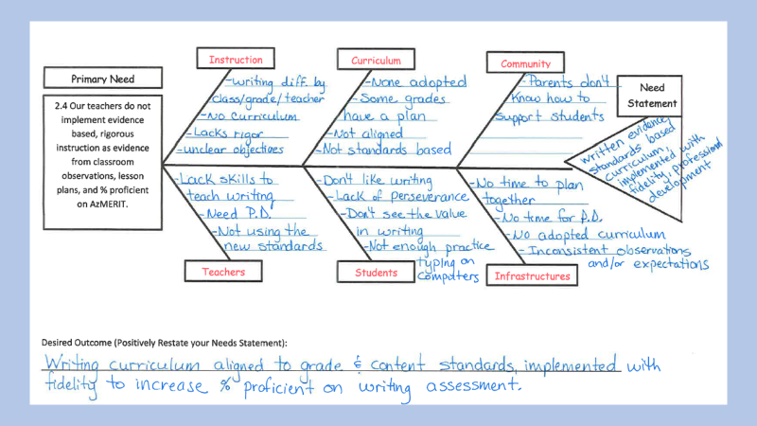
    - Note that the “5 whys” method, below, is often used in conjunction with the fishbone.
Root Cause: Teachers lack solid curriculum and training

The 5 Why Method
The 5-Whys is a simple brainstorming tool that can help teams identify the root cause(s) of a problem. Once a general problem has been recognized, ask “why” questions to drill down to the root causes. Asking the “5- Whys” allows teams to move beyond obvious answers and reflect on less obvious explanations or causes.

Step-by-step instructions

State the problem you have identified as a strategic problem to work on.
Start asking “why” related to the problem. Like an inquisitive toddler, keep asking why in response to each suggested cause.
Ask as many “whys” as you need in order to get insight at a level that can be addressed (asking five times is typical). You will know you have reached your final „why‟ because it does not make logical sense to ask why again.

The “5-Whys” is a strategy that is often used after an issue has been identified using another tool, such as a Fishbone Diagram or Process Mapping. Guard against using the “5-Why” questions on their own to avoid a narrow focus or bias.

This methodology is closely related to the Cause & Effect Fishbone diagram and can be used to complement the analysis necessary to complete a Cause & Effect diagram.
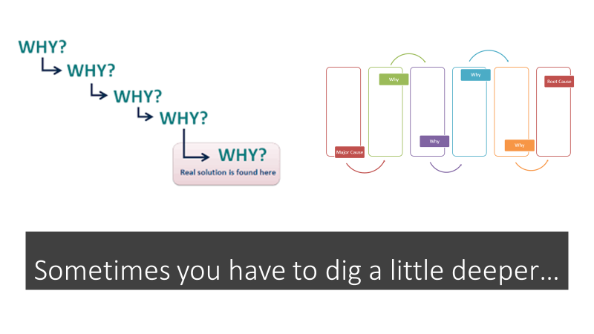

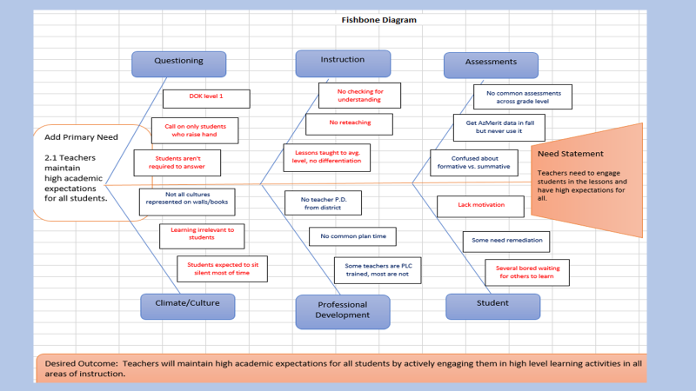

After conducting the root cause analysis, they need statement is still too general…so digging deeper is necessary
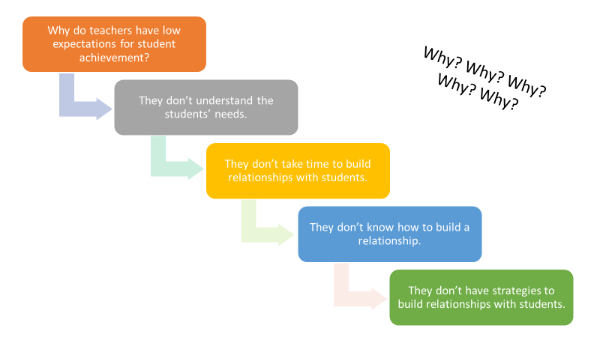
Root Cause

Tips
- Try to move on quickly from one question to the next, so that you have the full picture before you jump to any conclusions.
- be used to complement the analysis necessary to complete a Cause & Effect diagram
- The "5" in 5 Whys is just a "rule of thumb." In some instances, you may need to go on and ask "why?" a few more times before you get to the root of the problem. In others, you may reach this point before you ask your fifth "why?" If you do, be careful that you've not stopped too soon. The important point is to stop asking "why?" when the useful responses stop coming.
- As you work through your chain of questioning, you'll often find that someone has failed to take a necessary action. The great thing about 5 Whys is that it prompts you to go further than just assigning blame, and to ask why that happened. This often points to organizational issues or areas where processes need to be improved.

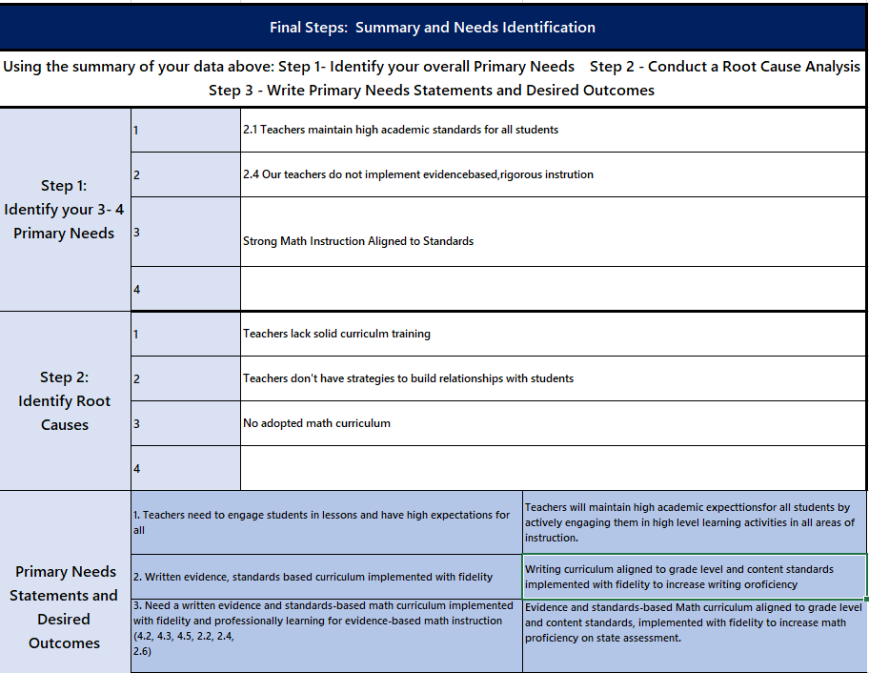
Complete CNA Tool Step 2: Identify Root Causes and Step 3: Primary Needs and Desired Outcomes i n the CNA tool

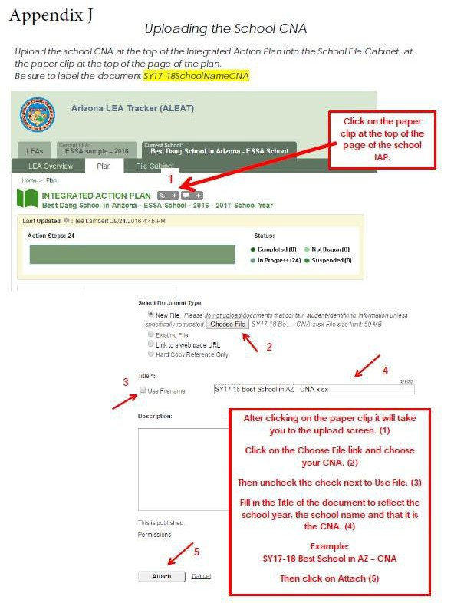

Upload the completed CNA Tool and Root Cause Analysis Templates to ALEAT

Integrated Action Plan
The Integrated Action Plan (IAP) is developed based on the School level Comprehensive Needs Assessment (CNA) and should be developed in concert with all applicable stakeholders, with opportunities for meaningful input and feedback from parents and community members, to ensure the plan is reflective of local context and needs.

The school-level IAP (SIAP) addresses three or four areas of need identified by the school’s CNA and satisfies the majority of the programmatic requirements of included state and federal grants received by the school in one comprehensive plan. This process serves to integrate and align plans required across grant programs to access state and federal grant resources and ensure a coherent, connected plan for continuous improvement. Current included programs are Title l, ll, lll, lV, MOWR and School Improvement.

The LEA-level IAP (LIAP) supports the system’s areas of focus as identified and informed by an LEA’s analysis of school CNAs and school IAPs. This provides the opportunity for the LEA to address and satisfy the majority of the programmatic requirements including state and federal grants received at the LEA level in one plan. School integrated Action Plan (SIAP) and the LEA integrated Action Plan (LIAP) are written annually.

IAP Requirements:
  - Three or four Need Statements with correlated Desired Outcomes; SMART Goals, if required
  - Evidence based Strategies
  - Evidence based Action Steps (use appropriate tags are required, funding and program tags
    - Implementation Action Steps
    - Monitoring Action Steps
      - Measures
      - Success Criteria and Evidence
    - Evaluation Action Steps
      - Measures
      - Success Criteria and Evidence

Address only the applicable Principles (all 6 are not required) based on CNA, identified three or four Need Statements and Desired Outcomes and any that address additional program area requirements. Targeted, intentional, focused actions result in real change. A “laundry list” of needs and desired outcomes will dilute focus, scatter efforts and will not result in real change.

Integrated Action Plan Diagram

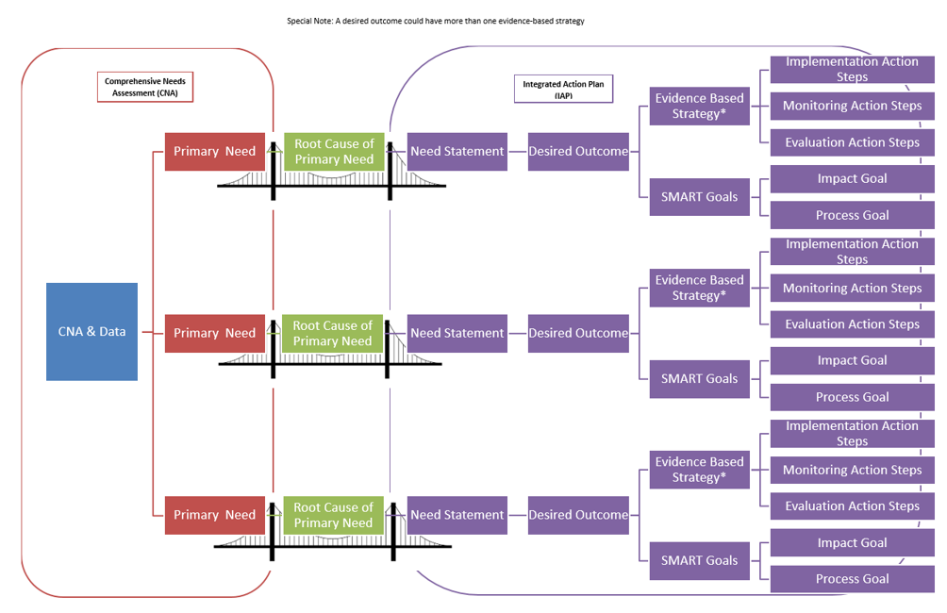

School Integrated Action Plan (SIAP)

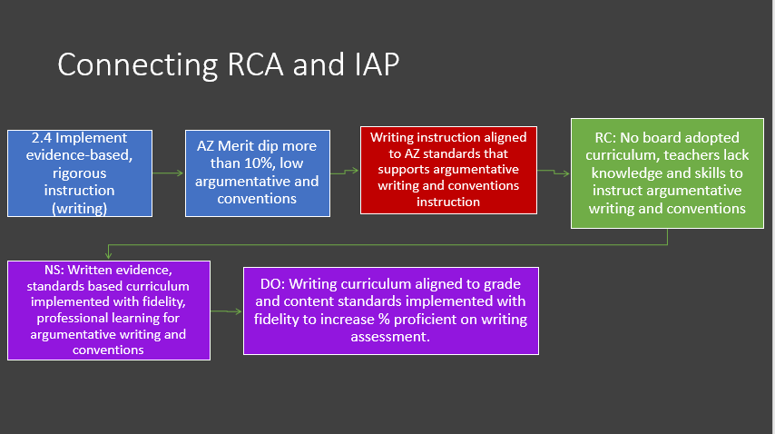
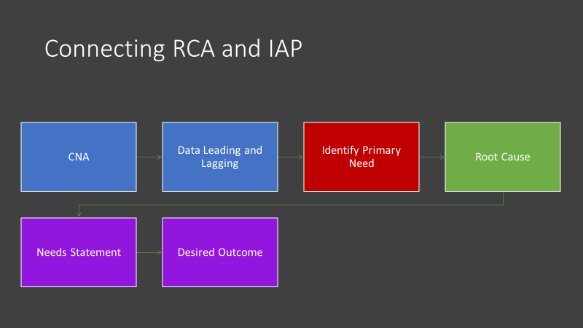

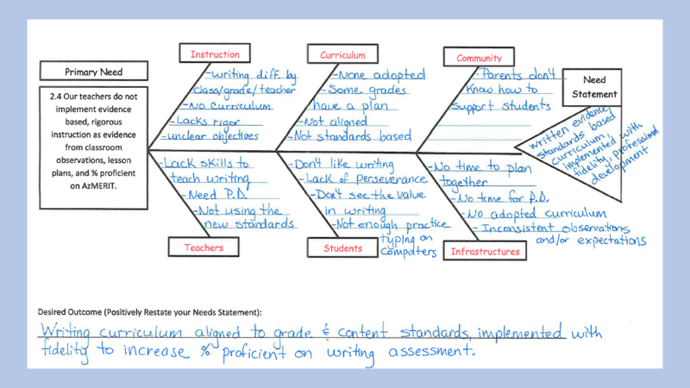

SMART GOALS

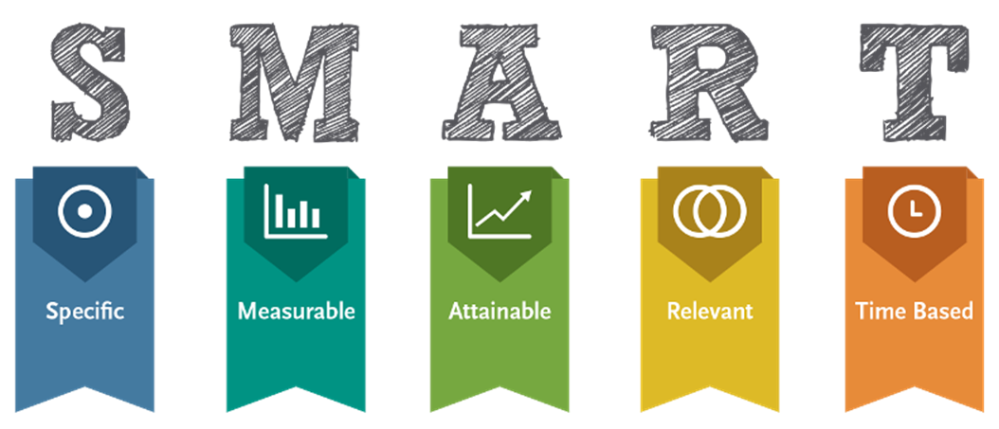
Specific + Strategic: A well-written goal addresses who will do what by when and how the results will be measured.
Measurable: The key concept here is: what gets measured, gets done. How you will measure its accomplishment?
Attainable, but Challenging: Goals that are unrealistic will only serve as a source of frustration for teachers, students, and administrators alike. Goals that are too easy generally won’t affect the kind of change needed to make significant and sustainable improvement. Goals must be attainable yet challenging.
Relevant: In the big picture, goals should link back to the stated educational aims, vision and mission of the school, derived from a careful analysis of data. Specifically, the goals address the primary and needs identified in the CNA.
Time Based: Setting a timeframe for the goal gives it urgency and helps move it to the top of the priority list of everyday activities.

There are two types of goals in th IAP.
- Process goals-imlementation of a system or procees
- Committee will research evidence based math curriculum and make a recommendation by November 1, 2019 as evidenced by written recommendation to Assistant Superintendent.
- New walkthrough data collection form will be developed and implemented by Jan. 1, 2020 as evidenced by principal walkthrough sumaries and feedback session notes.
- Impact goals-to show growth or increased proficiency, increased graduation rate, increased attendance; show impact on student performace
- Reading achievement for all students will increase by 12% from 10% to 22% proficienct and highly proficient as measured by 2020 AzMERIT.
- Attendance rate will increase by 15% from 80% to 95% for 2020 school year as evidenced by district demographic data summary report.

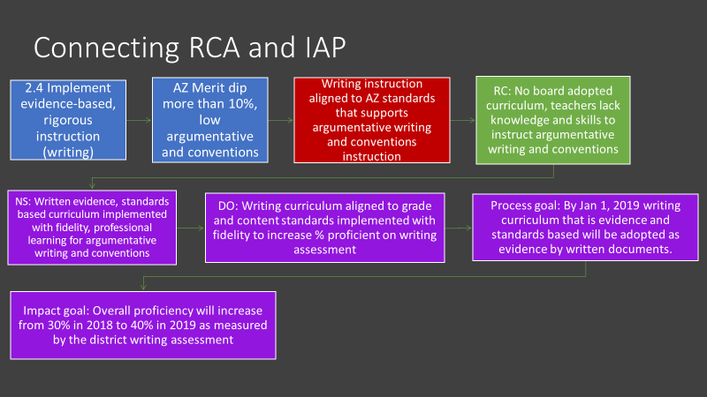

IAP Process:
  - Identify writing team to include all stakeholders
    - Establish group norms or agreements
  - Establish timeline for writing the plan
  - For each identified primary need, enter the need statement and desired outcome under the identified Principle
    - Add SMART goals as needed or required
  - Starting with the identified specific desired outcomes, backward design the evidence-based improvement strategies and action steps
  - Investigate evidence based programs, strategies or interventions to address each desired outcome (Resources available: Evidence Based Improvement Guide and Evidence Based Guidance Document on SI webpage http://www.azed.gov/improvement/ under All Schools in Improvement)
    - Generate list of possibilities
    - Investigate possibilities
    - Select evidence-based strategies
  - Add selected strategy under appropriate principle
  - Develop action steps (using actionable verbs)
    - Implementation action steps
      - Develop clear and comprehensive actionable action steps including who is responsible and the timeline
      - Align resources, funding sources, people and time to action plan
    - Monitoring action steps
      - Determine measures to monitor implementation
        - Collect information to monitor the quality of supports being provided
      - Identify and track progress and performance
        - Consider what additional information is needed to determine if action steps are working
      - Assess the degree to which the implementation plan is being followed with fidelity
      - Is the intervention, strategy, system, or process accomplishing the intended goal/s?
      - Should it be continued, or adjustments made?
    - Evaluation action steps
      - Determine measure/s to evaluate success
      - Determine criteria and evidence of success
      - Use the evidence to determine whether the intervention should continue as is, be modified, or be discontinued
      - Were desired outcomes reached?
      - Were SMART goals met?
Ensure coherence and obvious relationships between all need statements, desired outcomes, SMART goals, strategies and action steps.
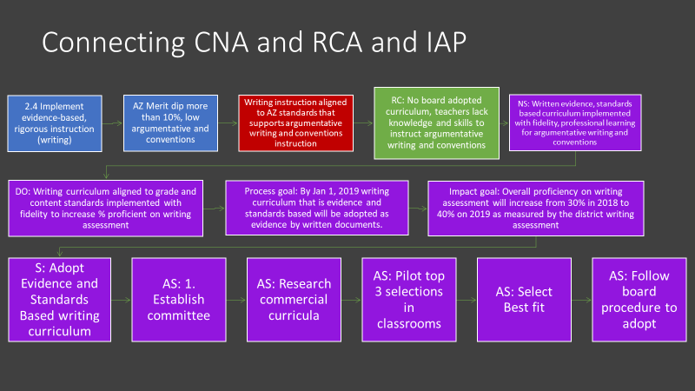
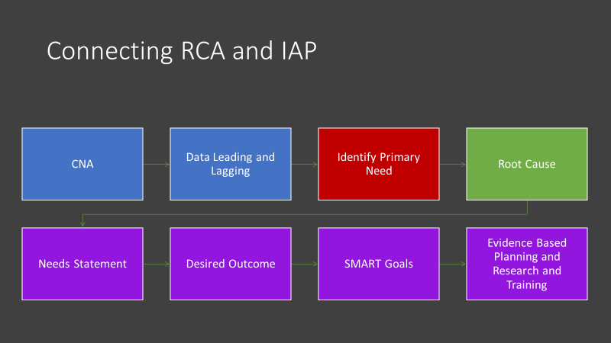

Sample School Site IAP Worksheet
SAMPLE  Primary Need #1 | Primary Need: (head of fishbone)  Strong Math Instruction Aligned to Standards
Root Cause:
No adopted math curriculum
Needs Statement: (tale of fishbone)
Need a written evidence and standards-based math curriculum implemented with fidelity and professionally learning for evidence-based math instruction (4.2, 4.3, 4.5, 2.2, 2.4,
2.6)
Desired Outcome: (Needs statement restated in a positive)
Evidence and standards-based Math curriculum aligned to grade level and content standards, implemented with fidelity to increase math proficiency on state assessment.
SMART Goal: (If the primary need is fixed how will your % proficient be affected?)
Math achievement for all students will increase by 10% moving from 0% proficient or highly proficient on 2017 AzMERIT to 15% proficient or highly proficient on 2018 AzMERIT.
 | Strategy:  Adopt an evidence and standards-based math curriculum. | Action Steps: (List all your Planning Strategies form your planning worksheet)  - Establish curriculum research committee  - Research available commercial curricula  - Visit schools with top 3 curriculum to view curriculum in action  - Select best fit curriculum  - Follow procedure to select and adopt a standards and evidence-based math curriculum
 | Strategy: Research and implement evidence-based math instruction. | Action Steps: (List all your Planning Strategies form your planning worksheet)  - Establish a committee  - Research different pedagogy and methodologies  - Select strategies to be implemented in all classrooms and/or grade level bands  - Plan PD to support implementation and training of methodologies
 | Strategy: Consistent high quality professional development and support for all teachers. | Action Steps:  - Provide bi-weekly PD for 60 mins  - Provide bi-weekly planning PD to implement strategies  - Plan and ensure PLC sharing and discussions of resources used, student work and what works instructional strategies  - Plan and implement Peer observations  - Schedule and conduct administrative walk through observations with targeted feedback and teacher action plans
 | Strategy: Monitor Implementation | Action Steps:  - Ensure teacher lesson plans reflect standards-based objectives and evidence-based instructional strategies  - Monitor teacher assessments  - Administrative walk through observation forms  - Determine successful completion of action steps on student achievement
 | Strategy: Evaluate Implementation

LEA Integrated Action Plan (LIAP)
The LEA IAP supports the implementation of the SIAP. The LEA IAP is based on:
  - A review of all School CNA results
  - Reflective questioning process and discussion
  - Identification of evidence-based strategies and action steps to support all school/s successful SIAP implementation.
  - Analyze Schools’ Comprehensive Needs Assessment (CNA) data for trends and patterns across schools.

LEA Guiding Questions
  - What patterns or trends are evident in student achievement data among the schools?
  - What patterns or trends are evident in student and teacher demographic data?
  - What patterns or trends are evident in the Leading Indicator data?
  - What patterns or trends are evident in the data regarding the 6 Principles?
  - What patterns or trends are evident in the primary needs selected by schools to be addressed in school IAPs?
  - What specific evidence-based strategies, actions and interventions can the LEA implement to support schools to successfully address identified primary needs and desired outcomes?
  - What systems, processes, procedures, operational flexibility can be put in place to support schools in implementation of School Integrated Action Plans?
  - How will these actions be monitored and evaluated? Are we doing what we said we would do? Are we doing it well? Is it impacting students learning and achievement? How do we know?
Create an LEA integrated action plan with strategies and action steps that align systems across the LEA to ensure successful school IAP implementation.
  - Three or four Need Statements with correlated Desired Outcomes and SMART Goals, if required based on school IAPs trends and necessary support
  - Evidence based Strategies
  - Evidence based Action Steps (use appropriate tags for required, funded and non- funded activities)
    - Implementation Action Steps
    - Monitoring Action Steps
      - Measures to be used
      - Success Criteria and Evidence
    - Evaluation Action Steps

      - Measures to be used
      - Success Criteria and Evidence

Plans are in ALEAT. Assurances are in Grants Management Enterprise (GME).
In order to allow for meaningful plans based on the primary needs identified in the CNA, while meeting the ESSA requirements, there are program requirements and assurances. Some assurances may require narrative description in either the SIAP or the program’s grant application. See specific program information beginning on page 43.

Sample LEA Integrated Action Plan Worksheet
SAMPLE  Primary Need #1 | Primary Need: (head of fishbone)  Strong Math Instruction Aligned to Standards
Schools that Display Primary Need:
Arizona Elementary School, Sunburst Elementary School
Root Cause(s):
No adopted math curriculum
Needs Statement(s): (tale of fishbone)
Need a written evidence and standards-based math curriculum implemented with fidelity and professionally learning for evidence-based math instruction (4.2, 4.3, 4.5, 2.2, 2.4,
2.6)
Desired Outcome: (Needs statement restated in a positive)
Evidence and standards-based Math curriculum aligned to grade level and content standards, implemented with fidelity to increase math proficiency on state assessment.
SMART Goal: (If the primary need is fixed how will your % proficient be affected?)
Math achievement for all students will increase by 10% moving from 0% proficient or highly proficient on 2017 AzMERIT to 10% proficient or highly proficient on 2018 AzMERIT.
 | Strategy:  Support Adoption of an evidence and standards-based math curriculum. | Action Steps: (List all your Planning Strategies form your planning worksheet)  - Help Research Evidence Based Programs for Elementary school  - Help facilitate the ordering of sample materials  - Meet with Curriculum Adoption Committee  - Help complete Curriculum Rubrics
 | Strategy:  Support Research and implement evidence-based math instruction. | Action Steps: (List all your Planning Strategies form your planning worksheet)  - Help Research Evidence Based PD strategies to support math PD  - Work with Site Principals to create a calendar to roll out implementation

 | Strategy:  Support Consistent high quality professional development and support for all teachers. | Action Steps: (List all your Planning Strategies form your planning worksheet)  - Support sites with funds to conduct peer observations  - Schedule and conduct meetings with site principals to review walkthrough observations and action plans  - Attend site PDs to show support for the initiatives
 | Strategy: Monitor Implementation | Action Steps:  - Monitor site data (benchmarks/interims)  - Schedule and conduct walkthroughs to see curriculum in action
SAMPLE  Primary Need #2 | Primary Need: (head of fishbone)  Parent and Community Involvement
Schools that Display Primary Need:
Dream Big Middle School, Hope Middle School
Root Cause(s):
Not enough opportunities for parent and community involvement
Needs Statement(s): (tale of fishbone)
Need to provide opportunities for the parents and community to get involved in the school (1.4, 2.7, 5.2, 5.5, 6.1, 6.2, 6.3, )
Desired Outcome: (Needs statement restated in a positive)
Provide multiple opportunities for the parents and community to get involved to promote collaboration and increase student achievement
SMART Goal: (If the primary need is fixed how will your % proficient be affected?)
Increase parent and community involvement by 20% moving from 48% on the 2018 parent satisfaction survey to 68% on the 2019 parent satisfaction survey.
 | Strategy:  Create a volunteer program for parents and community. | Action Steps: (List all your Planning Strategies form your planning worksheet)  - Hold fingerprinting at each site to facilitate volunteers  - Provide substitutes for sites so admin/teachers can train volunteers once a quarter  - Create a district volunteer guide to support volunteer training
 | Strategy: Increase communication with community | Action Steps: (List all your Planning Strategies form your planning worksheet)  - Help Research local community partnerships with site principals

 | Strategy: Support site with parent and community involvement. | Action Steps: (List all your Planning Strategies form your planning worksheet)  - Attend community events to support schools’ sites with initiative  - Have Public Relations Person go to sites to photograph events and volunteers.  - Add photos and highlight on volunteer programs on district website
 | Strategy: Monitor Implementation | Action Steps:  - Monitor sign in sheets and training  - Review parent survey data and meet with site leadership
SAMPLE  Primary Need #3 | Primary Need: (head of fishbone)  Shared Knowledge of Content Standards
Schools that Display Primary Need:
Arizona Elementary School, Sunburst Elementary School, Dream Big Middle School, Hope Middle School
Root Cause(s):
Teachers do not know how to deconstruct standards into unit plans to plan for instruction
Needs Statement(s): (tale of fishbone)
Teachers do not know their standards well enough to plan for instruction (6.2, 6.3, 6.4, 6.6)
Desired Outcome: (Needs statement restated in a positive)
Teachers will deconstruct standards to create units of instruction to increase student achievement and increase student engagement.
SMART Goal: (If the primary need is fixed how will your % proficient be affected?)
Math achievement for all students will increase by 10% moving from 0% proficient or highly proficient on 2017 AzMERIT to 15% proficient or highly proficient on 2018 AzMERIT.

Reading achievement for all students will increase by 10% moving from 5% proficient or highly proficient on 2017 AzMERIT to 15% proficient or highly proficient on 2018 AzMERIT.
 | Strategy:  Provide Training for Instructional Coaches in Backward Design | Action Steps: (List all your Planning Strategies form your planning worksheet)  - District Leadership will plan PD on Backwards Design Principles  - District Leadership will provide training to all instructional coaches and site leadership  - District will provide ongoing PD quarterly to monitor Backwards Design Implementation  - Create a District Template for Backwards Planning Units

 | Strategy: Teachers train in Backward Design | Action Steps: (List all your Planning Strategies form your planning worksheet)  - Create 2 district wide PD days on the calendar for training sites to complete initial training  - Provide substitutes for teachers to participate in one full day of training each quarter to plan for instruction for each content area (Math and ELA).
 | Strategy:  Support sites with backwards Design | Action Steps: (List all your Planning Strategies form your planning worksheet)  - Purchase Understanding by Design for each instructional coach and site principal  - Purchase Understanding by design Professional Development workbook for each instructional coach and site principal
 | Strategy: Monitor Implementation | Action Steps:  - Instructional coaches will collect data on benchmarks/interims to determine unit effectiveness  - Instructional coaches will monitor scope and sequence alignment for summer review based on unit plans

IAP in ALEAT
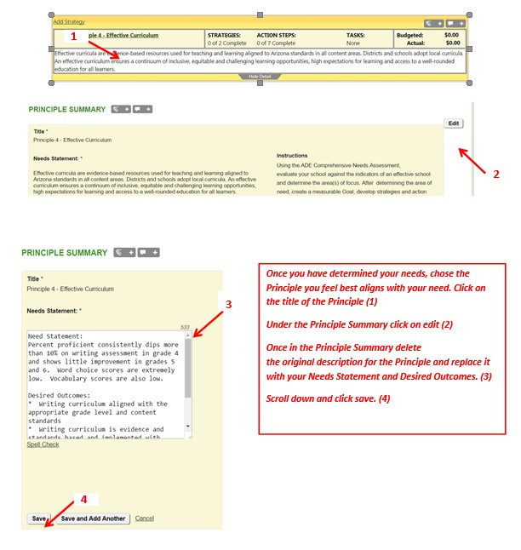

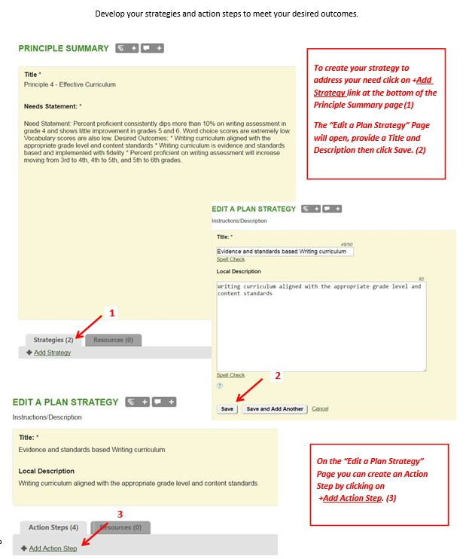

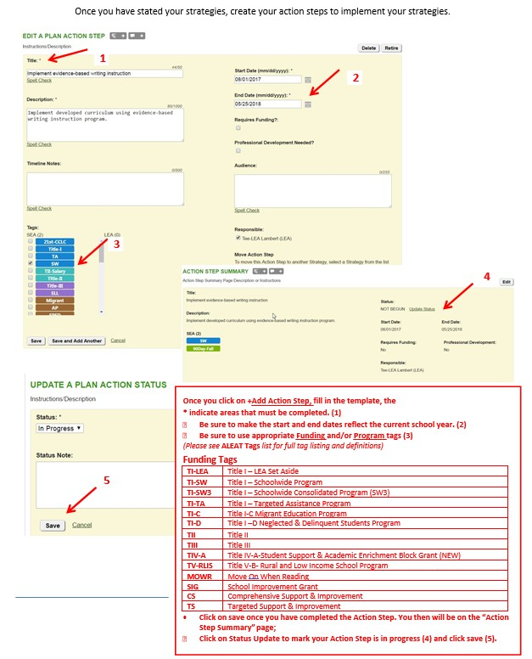

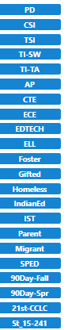
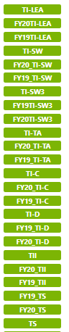
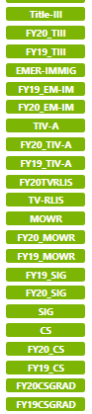
School Improvement Tags
Program Tags

ALEAT Tags

CNA and Integrated Action Plan Informs Grant Applications

The funding application in Grants Management Enterprise (GME) is based on the Comprehensive Needs Assessment (CNA) and the Integrated Action Plan (IAP). Action steps must be tagged.

Grant Applications are submitted through the ADE’s online GME System. These fiscal applications focus on accounting for expenses to be supported by a given grant, with all expenses aligned to activities that have been tagged as being supported by that grant in the IAP.

Please see grant guidance documents for specifics.
Funding Tags

Appendix A

MONITORING AND EVALUATION

Guiding Questions

Principle 1
Leading indicators are formative—they enable us to track progress along the way and make course corrections as needed.
At quarterly intervals, are the systems of academic and fiscal accountability ensuring every student’s success? How do we know?
At quarterly intervals, are collaborations with staff, family and community members present? If not, how can we change this?
At quarterly intervals, what assessments have been implemented at the school and/or district level? What is the purpose of these assessments? Has the communication of purpose and results been made available to all parties including students, teachers, parents, and leadership if appropriate?

Lagging indicators are summative—they are longer term outcomes that enable us to reflect on the impact of a strategy.
Upon reviewing the school vision, does the vision statement we currently have set the direction for the way we want our school to now? in the future? Has our school progressed toward reaching the vision? How do we know?
What characteristics does our school possess for its students to feel confident, connected, lifelong learners who are actively involved in school life?
Upon review of teacher retention data, is our system retaining effective teachers and if an opening arising, recruiting effectives teachers? If we are, what strategies are working to make sure that teachers feel valued and able to be effective? If not, what can be changed to assist in retaining teachers? If recruiting effective teachers, what systems are in place to make our system attractive and a viable option to effective teachers?
Does our system have a balanced assessment system from the classroom to the school to the district level? What evidence do we have to a balanced system? If evidence is lacking, what pieces of the system need to be addressed?

Principle 2
Leading indicators are formative—they enable us to track progress along the way and make course corrections as needed.
What evidence do we have that teachers are maintaining high academic expectations for all students throughout the school year?
How is instructional planning and implementation aligning to the state standards? How do we know?
At quarterly intervals, what role has formative assessment played in instruction for students and teachers? How do we know?
At quarterly intervals, what formative and classroom summative assessments have been implemented in the classroom? What is the purpose of these assessments? Has the communication of purpose and results been made available to all parties including students, teachers, parents, and leadership if appropriate?
At quarterly intervals, what professional learning opportunities, including PLC’s have teachers and staff had the opportunity to participate in?
At quarterly intervals, are collaborations with other teachers, staff, family and community members present? If not, how can we change this?

Principle 3
Leading indicators are formative—they enable us to track progress along the way and make course corrections as needed.
At Quarterly intervals, what non-instructional activities have occurred for students? At quarterly intervals, what non-instructional activities have occurred for staff?
Lagging indicators are summative—they are longer term outcomes that enable us to reflect on the impact of a strategy.
Upon review of the school year/daily schedule, how do we know we have maximized instruction? What evidence do we have?
How does the daily/weekly contract day(s) provide for staff needs? How do we know?

Principle 4
Leading indicators are formative—they enable us to track progress along the way and make course corrections as needed.
At quarterly intervals, what professional learning experiences have staff had the opportunity to be involved in that focus on implementation of adopted curricula? Lagging indicators are summative—they are longer term outcomes that enable us to reflect on the impact of a strategy.
Upon review, how do we know that our curricula resources are being implemented to show students’ progress in mastery of standards in specific content areas? What is our evidence that instruction and resources do not have gaps?
How do we know that our curricula are effective and provide continuous improvement for all students?
What is our evidence?

Principle 5
Leading indicators are formative—they enable us to track progress along the way and make course
corrections as needed.
At quarterly intervals, how does the school environment build mutual respect among leadership, teachers, students, and families? What evidence do we have that respect exists among and between different stake holder groups?
At quarterly intervals, how has staff had a voice in impacting school climate, conditions and culture?
At quarterly intervals, what services have we provided the fully support the academic and social needs of all students? Are these services sufficient? How do we know?

Principle 6
Leading indicators are formative—they enable us to track progress along the way and make course corrections as needed.
At quarterly intervals, how has the school maintained collaborative partnerships among families and the community?
At quarterly intervals, how have parents and families had a voice and been communicated to throughout this school period? Are we meeting the needs of all stakeholders in communicating school events, vision, and educational outcomes? How do we know?

Appendix B

Resources for Evidence-Based Strategies

NEW RESOURCE AVAILABLE HERE: ESSA-Evidence Based Requirements and Resources

Searchable data base of evidence-based programs, practices and interventions

The Every Student Succeeds Act (ESSA) states that evidence-based “means an activity, strategy, or intervention that demonstrates a statistically significant effect on improving student outcomes or other relevant outcomes based on
Strong evidence from at least one well-designed and well-implemented experimental study;
Moderate evidence from at least one well-designed and well-implemented quasi experimental study;
Promising evidence from at least one well-designed and well-implemented correlational study with statistical controls for selection bias;
or Demonstrates a rationale based on high-quality research findings or positive evaluation that such activity, strategy, or intervention is likely to improve student outcomes or other relevant outcomes; and(II) includes ongoing efforts to examine the effects of such activity, strategy, or intervention.

Integrated Action Plans are required to be evidence-based and may use any level of evidence indicated above. Funding for the 7% Title I set aside for school improvement must be used for interventions meeting only the top three tiers of evidence (strong, moderate, promising).

Evidence for ESSA Johns Hopkins University/Center for Data-Driven Reform in Education http://www.evidenceforessa.org/
This website provides information on programs and practices that meet each of the top three ESSA levels in a given subject and grade level (e.g., secondary math, elementary reading). It includes brief program descriptions, information on costs, availability, and other pragmatics, and links to program web sites. You can refine a search to look for programs that have been successful with particular populations (e.g., English learners, special education), communities (e.g., urban or rural), and other special interest areas. You can also search by program name, enabling you to find information about evidence for all programs, including those that have not yet been successfully evaluated. The website currently contains information on reading and math programs in grades K-12.
Additional topics will be added in the future, and the website will be continually updated to include new programs and to reflect new evaluations.

What Works Clearinghouse, developed by the Institute of Education Sciences (IES) (not categorized in ESSA evidence tiers; studies included here meet only most rigorous evidence criteria) https://ies.ed.gov/ncee/WWC/
The What Works Clearinghouse (WWC), established in 2002, is an entity of the Institute of Education Sciences (IES) within the U.S. Department of Education. The WWC reviews evidence of effectiveness for programs, policies, and practices using a consistent set of standards. The WWC then creates products including Intervention Reports, Single Study Reviews, Quick Reviews, and Practice Guides to present findings on evidence-based best practices. Current topics that are reviewed by WWC include, Early Childhood, Literacy, Mathematics, English Learners, Teacher Excellence, and Dropout Prevention.

Learning Policy Institute https://learningpolicyinstitute.org/product/evidence-based- interventions
Achieving an equitable school system that leads to meaningful, relevant, and engaging learning opportunities for all children will require that states, districts, and schools undertake the different tasks—such as curriculum design, access to materials, and educator development—that will enable students to develop much richer learning supported by quality instruction. This resource examines the options available to states to redefine their accountability systems as they begin to implement the Every Student Succeeds Act (ESSA). It analyzes the research base and identifies the conditions under which they have shown to be effective. The four program areas identified in this resource are: high-quality professional development, class-size reduction, community schools and wraparound services, and High School redesign.

Promising Practices Network on Children, Families and Communities
http://www.promisingpractices.net/resources_highschoolgrad.asp
This website began as a partnership between four state-level organizations to improve the well- being of children and families. The Promising Practices Network (PPN) funding has concluded, so the website has been archived and materials have not been updated since 2014.
The PPN site features summaries of evidence-based programs and practices that are proven to improve outcomes for children. All programs have been reviewed for quality and to ensure that they have evidence of positive effects.
Programs are assigned to one of three category levels: Proven, Promising, or Other Reviewed Programs. The Programs that Work section can be browsed in several ways: by outcome area by indicator
by topic
by evidence level alphabetically
PPN relied on publicly available information for reviewing a program’s effectiveness and was interested in programs as they were designed and evaluated. Programs were assigned a “Proven” or “Promising” rating, depending on whether they met the evidence criteria. The “Other Reviewed Programs” are ones which did not undergo a full review by PPN, but evidence of their effectiveness has been reviewed by one or more credible organizations that apply similar evidence criteria.
Evidence Criteria
- Types of Outcomes Affected Substantial Effect Size Statistical Significance Comparison Groups
- Sample Size
- Availability of Program Evaluation Documentation
Best Evidence Encyclopedia, developed by the Center for Data Driven Reform in Education at Johns Hopkins University (not categorized in ESSA evidence tiers) http://www.bestevidence.org/
The Best Evidence Encyclopedia (BEE) is a free web site created by the Johns Hopkins University School of Education's Center for Data-Driven Reform in Education (CDDRE) under funding from the Institute of Education Sciences, U.S. Department of Education. It is intended to give educators and researchers fair and useful information about the strength of the evidence supporting a variety of programs available for students in grades K-12. The BEE provides summaries of scientific reviews produced by many authors and organizations, as well as links to the full texts of each review. The summaries are written by CDDRE staff members and sent to review authors for confirmation. Program reviews include; Mathematics, Reading, Science Early Childhood and Comprehensive School Reform.

National Center on Intensive Intervention at American Institutes for Research
http://www.intensiveintervention.org/
This website provides information on data-based individualization (DBI), a research-based process for individualizing and intensifying interventions through the systematic use of assessment data, validated interventions, and research-based adaptation strategies.

Results First Clearinghouse Database, developed by the Pew Charitable Trusts (not categorized in ESSA evidence tiers; evaluates interventions as rated by eight national databases) http://www.pewtrusts.org/en/research-and-analysis/issue- briefs/2014/09/results-first- clearinghouse-database
This website includes a downloadable excel spreadsheet of compiled interventions by: category, policy area, intervention type and rating. The intervention rating included is based on a compilation of data from eight different clearinghouses. A direct link to the intervention website is also included in the downloadable spreadsheet. This is a great starting place to find interventions, as well as a quick check to see if interventions being used are considered effective.

Roadmap to Evidence Based Reform for Low Graduation Rate High Schools, developed by the Every Student Graduates Center at Johns Hopkins University http://new.every1graduates.org/everyone-graduates-center-roadmap-to-evidence-based- reform-for-low-graduation-rate-high-schools/ The Everyone Graduates Center provides a roadmap to evidence-based reform for low graduation high schools. Resources include full reports, presentations, and teacher resources- all focused on addressing the dropout crisis.

RAND report on school leadership interventions under ESSA (categorized in ESSA evidence tiers) http://www.wallacefoundation.org/knowledge-center/Documents/School- Leadership- Interventions-ESSA-Evidence-Review.pdf
The Every Student Succeeds Act (ESSA) presents a renewed focus on school leadership and acknowledges the importance of school principals to school improvement and effective instruction. ESSA repeatedly calls for the use of evidence-based activities, strategies, and interventions and establishes a framework with tiers of evidence when considering their proven impact on student success. This represents a shift in thinking regarding the justification of funds tied to Title funding, particularly as it relates to supporting school leadership. This report seeks to resolve some of the ambiguity that may still exist as states, districts, and schools seek to determine if activities qualify as evidence-based and therefore allowable.

Using Evidence to Create Next Generation High Schools, developed by the U.S. Department of Education (not categorized in ESSA evidence tiers) https://www2.ed.gov/rschstat/eval/high-school/using-evidence-create-next-gen- highschools.pdf
Next Generation High Schools are schools that redesign the high school experience to make it more engaging and worthwhile for high school students. In order to create such Next Generation High Schools, schools, districts, and States should utilize evidence- based strategies to transform high schools in ways that engage students and help prepare them for college and career success. Evidence-based strategies encompass a variety of approaches.
This document highlights six general evidence-based strategies to improve America’s high schools for the next generation. Though many of the effective strategies may share common features, each has been identified by the research literature as a stand-alone intervention or model for improving students’ educational outcomes. Reviewed strategies for enhancing students’ high school and college outcomes include: 1) participation in rigorous curriculum; 2) small learning communities/small schools of choice; 3) career academies; 4) dual enrollment; 5) early college high schools; and 6) college and career counseling.

Guidance can be found on the Support and Innovation Webpage
http://www.azed.gov/improvement/
New Resource Available Here: ESSA-Evidence Based Requirements and Resources
Searchable data base of evidence-based programs, practices and interventions

