Supplies List for Migrant Education Webinar

Summer Learning Activities
Writing with Your Children & Accordion Envelope Book

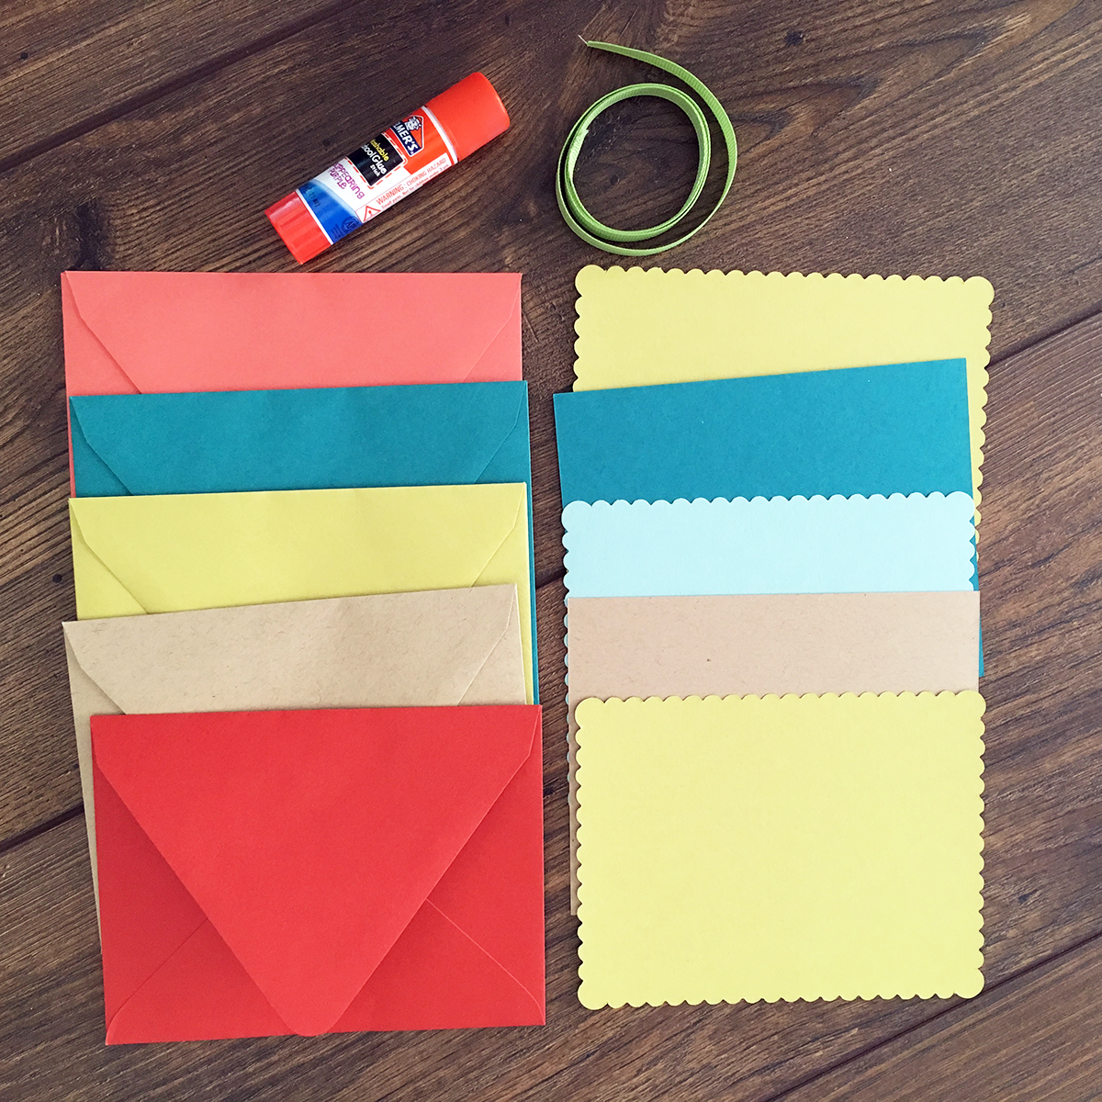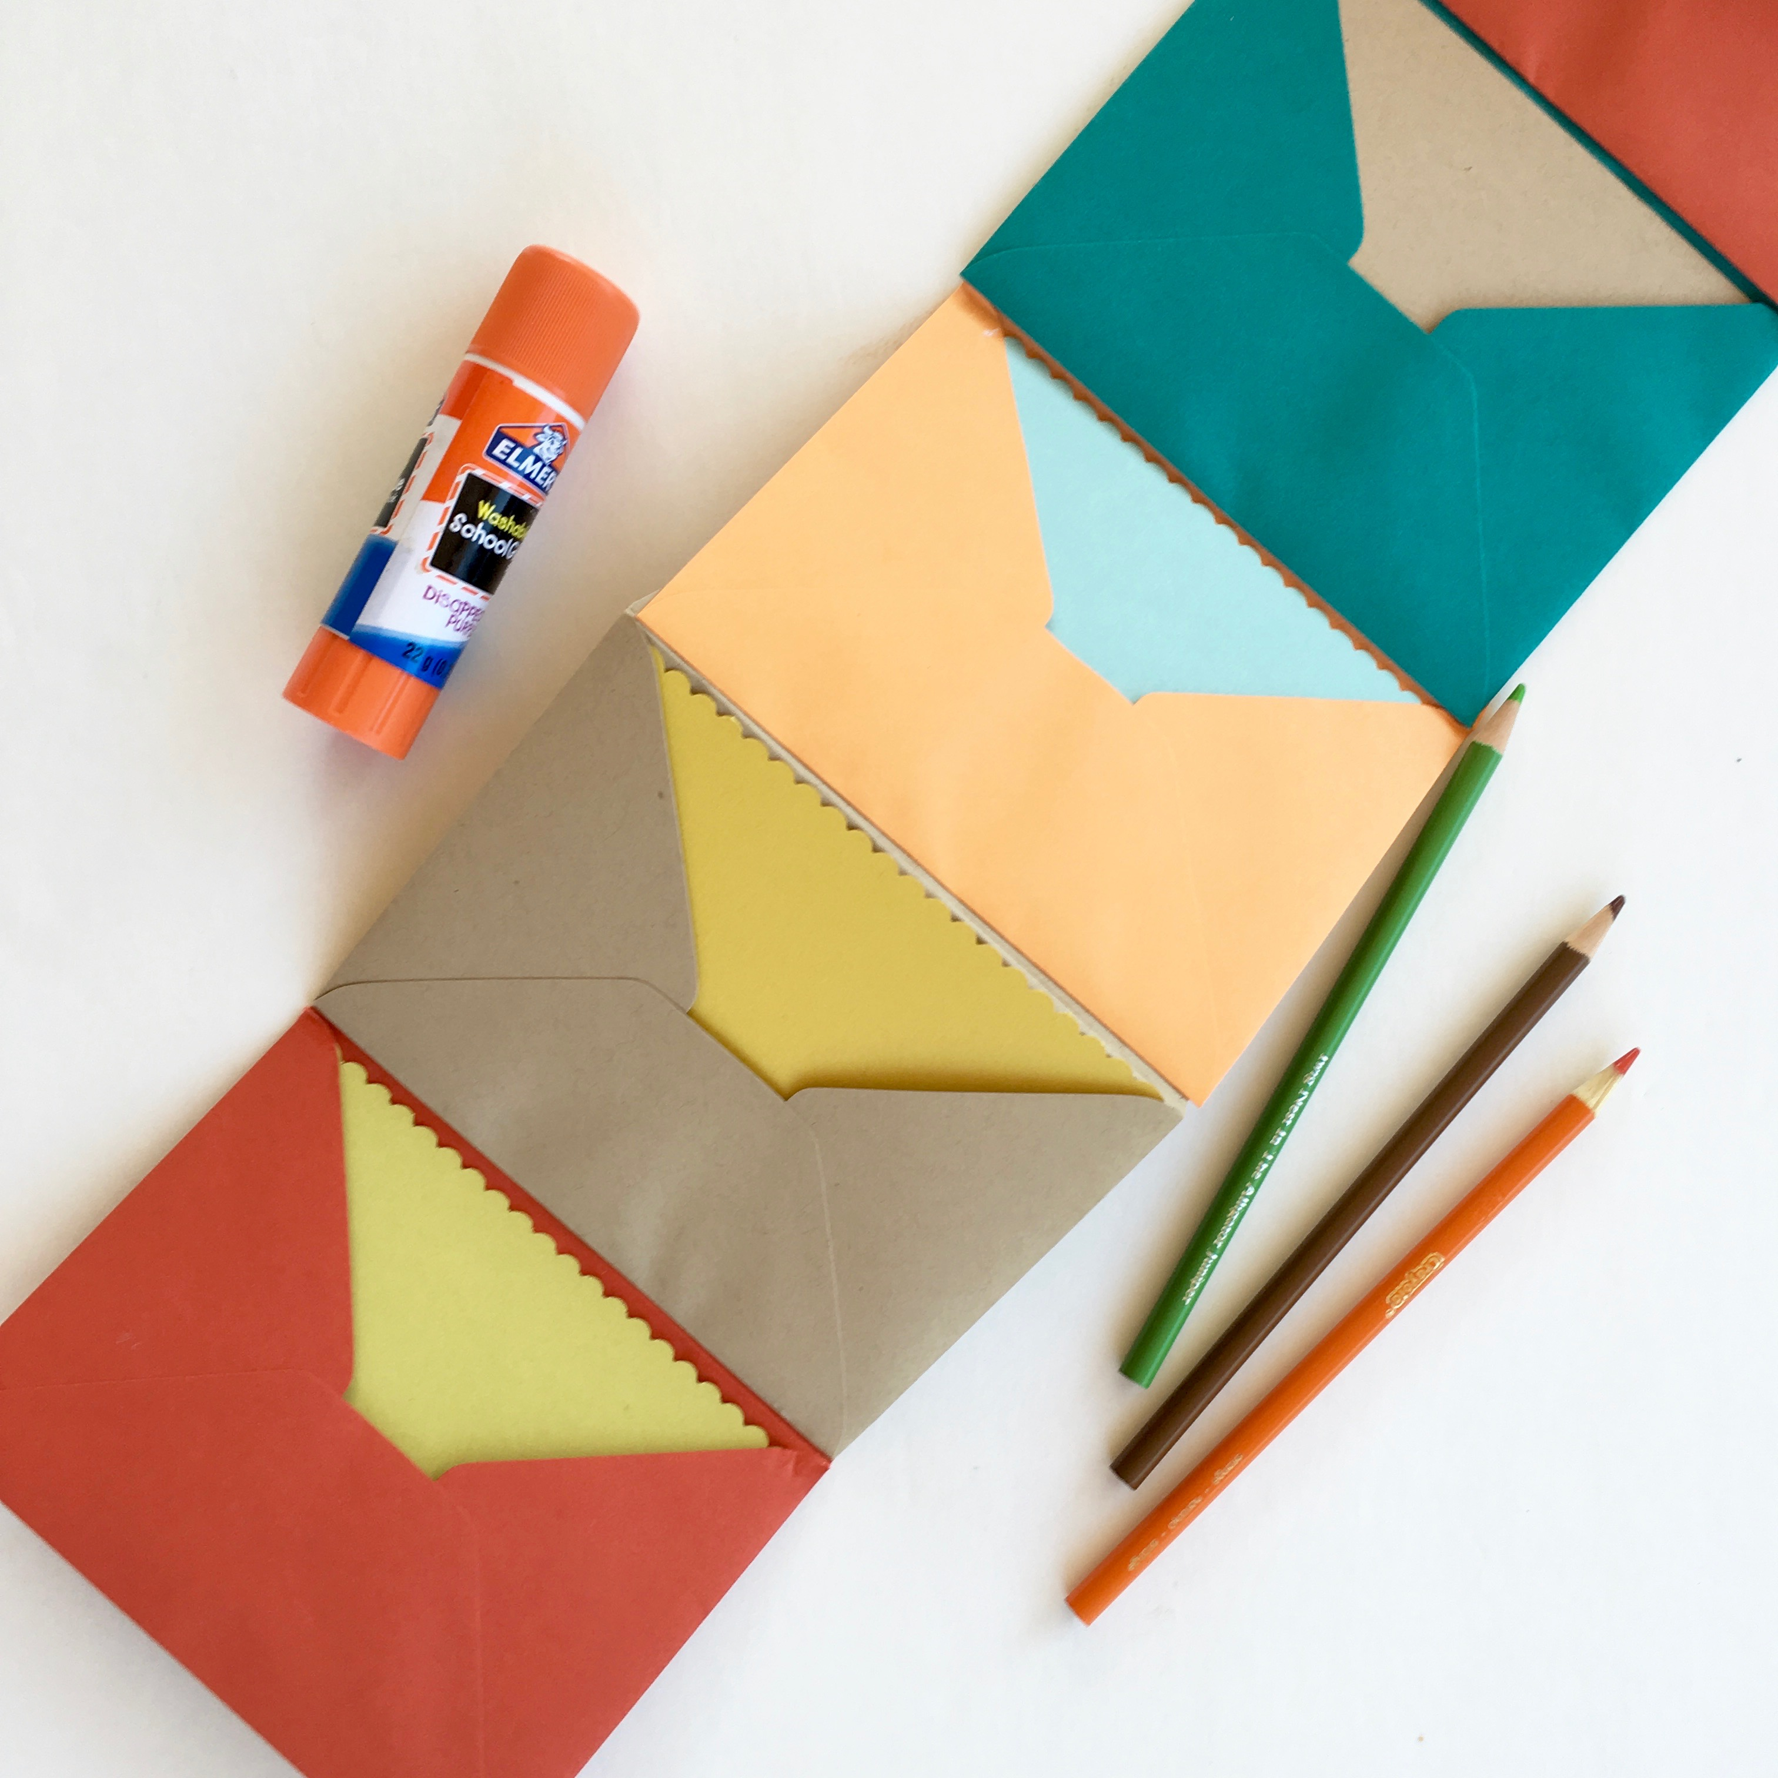

Dear Coordinators,

I am excited to join your next webinar to share a writing and bookmaking activity with your parents and their children.

Because there is very limited time before the end of the school year, I am sending a list of needed items now, so you can purchase and prepare the materials before the webinar is available.

There are two lists: Bookmaking Materials for the Accordion Envelope Book and the Summer Learning/Homework Kit. The bookmaking materials will be needed during the webinar, so families can complete the project. The homework kit has materials to take home to use during the summer for writing and journaling. The attached links below are only suggestions to help you find materials. You may already have some items on hand or have a preferred source to purchase items.

The parents and children will be writing and making the Accordion Envelope Book together. With the directions on the webinar, the parents will be able to guide their child making the book, but you may want to have childcare available for children younger than five. Looking forward to hearing about the results of this project.

Thank you, Jennifer Medina

Bookmaking Materials for the webinar - Accordion Envelope Book:

- 5 multi-colored envelopes, suggested size: A6 (4 ½ X 6 ¼)
(one set for each parent and child to share)
- 5 index cards or pieces of paper that will fit inside the envelope – suggested size 4X6 (one set for each parent and child to share, paper can be white or colored but needs to be light enough for writing and drawing)
- Glue sticks
- Colored pencils/pens/pencils
- Optional: Ribbon – enough to wrap around the envelope and tie a bow

Take home materials for Summer Learning/Homework kit:

- Optional: One copy of Gathering the Sun: An Alphabet in Spanish and English by Alma Flor Ada, Illustrated by Simón Silva
- Journal for each participant (both parent and child)
- Scissors
- Colored pencils, crayons, and/or markers for journal writing
- Pencils, pen, pencil sharpener
- Glue or glue sticks
- Any extra envelopes, index cards and ribbons so participants can make more accordion envelope books at home

Links for materials:

- Gathering the Sun: An Alphabet in Spanish and English by Alma Flor Ada, Illustrated by Simón Silva
Paperback: $6.99 per copy

https://www.amazon.com/Gathering-Sun-Alphabet-Spanish-English/dp/0688170676/ref=tmm_pap_swatch_0?_encoding=UTF8&qid=1523472384&sr=1-1

- Journal
Any blank notebook will work such as a composition notebook but if your budget allows, a journal with a nice cover and blank pages creates excitement around writing.

Cost: 4 journals for $19.99 (128 LINED pages with leather cover)

https://www.amazon.com/gp/product/B0772TBRCJ/ref=ox_sc_act_title_3?smid=A30IVHMNBV0QSZ&psc=1

or

Cost: 3 for $13.98 (100 UNLINED pages with soft cover to decorate)

https://www.amazon.com/gp/product/B0792CMV9M/ref=ox_sc_act_title_5?smid=A16MMQBSKNGESZ&psc=1

- Multi-colored envelopes
you can order any size envelopes as long as the index card or paper fits inside. The suggested size is A6 (4 ½ X 6 ¼ )

Cost: $29.88 for 200 envelopes

https://www.amazon.com/gp/product/B01DFISBQS/ref=ox_sc_act_title_7?smid=AEUNREAON1U25&psc=1

- Index cards
(4X6) or any size that will fit well into the envelopes you purchased.

Cost: $9.49 for 200 white index cards

https://www.amazon.com/gp/product/B075LQXVSL/ref=ox_sc_act_title_6?smid=A2SZ1SUT04XLWW&psc=1

