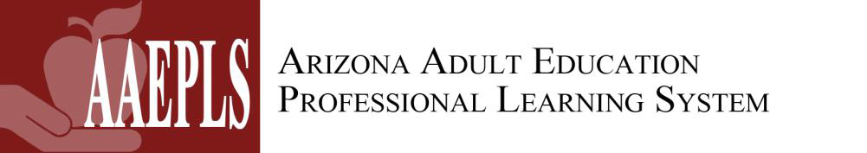

Adult Basic Education (ABE/HSE)
Lesson Plan Template & Teaching Sequence
Content Area(s) | Identify one or more content areas (e.g., math, reading, writing).
Standard(s) Addressed | Which standard(s) will students work on mastering?
Lesson Objective(s) | What skills or knowledge will students learn by the end of the lesson?
Curricular Resources | Identify the curricular resources you will use.
Anticipatory Set/Introduction | How will you activate prior knowledge and engage students for new learning?
Input and Modeling | What direct instruction will you provide? (I Do, We Do)  Identify assignments/activities that students will do together. (You Do Together)
Check for Understanding | How will you assess every student’s understanding of the lesson objectives prior to independent practice?
Independent Practice | Identify the assignment/activity for students to practice the new learning on their own? (You Do Alone)
Closure | What will you do to reinforce the lesson objectives and student learning?
Extended Learning  (Practice Outside of Classroom) | What will students do outside of the classroom (e.g., in online curriculum) to extend the lesson objectives and new learning?

