21st CCLC Continuing Grant Application Guidance

Year 1 of the 21st CCLC Grant is competitive and Years 2-5 are Continuing based on maintaining program eligibility requirements outlined in the Continuing Application.

In the event that anticipated federal funding is decreased, a proportional decrease may be made to all awardees. All funding is contingent upon receipt of federal funds.

The link to log in via the ADEConnect portal is found on the ADE Grants Management web page http://www.azed.gov/grants-management/. This page also offers system guidance and contact information for Grants Management.

You will need an ADEConnect user name and password to submit your continuing application.

The 21st Century Community Learning Centers- Continuing Grant Application is available in the Grants Management System which is accessible in the ADEConnect portal found on the ADE Home Page. It will be posted on March 1, 2018. The Continuing Application will be due June 8, 2018.

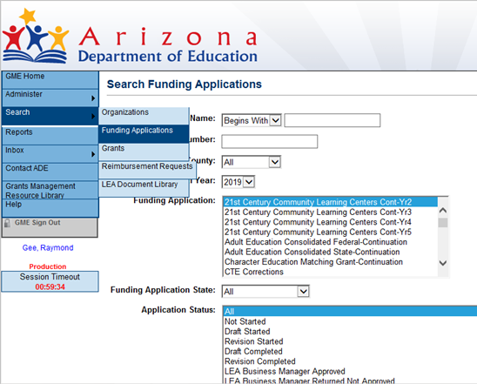
Fiscal Year- select the following fiscal year 2019. Funding Application- select “21st Century Community Learning Centers – Cont- (Yr2, Yr3, Yr4 or Yr5)” for the year of this 5 year grant your application will fall under.

If necessary, you may make minor revisions to your 21st CCLC grant in the Continuing Grant Application. However, it is important that the integrity of the initially awarded application is not compromised. Any changes must receive pre-approval from your assigned program specialist.

Significant changes or insufficient information in the “Program Details” reporting area or in the budgets of each site and narrative information explaining the budget expenditures being requested may delay approval.

Any fiscal/programmatic holds will need to be resolved before your 21st CCLC Continuing Application will be approved.

Remember that in order to submit an application, it must be approved all the way up to the “LEA Authorized Representative Approved” level.
Once the application is LEA Authorized Representative Approved, ADE can then
review and approve applications.

How to build your 21st CCLC grant budget
http://www.azed.gov/21stcclc/required-reporting/ See the 21st CCLC website’s “Required Reporting” page for the “Budget Planning Tool” under the “Continuing (Renewal) Application – Annually” Tab.

*Before submitting the 21st CCLC application ALWAYS contact your Business Manager for guidance on the most current budget coding information*

Please be specific when completing the budget narrative descriptions.

Provide the following information in your budget application:

- Staffing Requirement- Must employ at least one site coordinator per site to be on site during center hours. Note: School Administrators with contracts requiring them to be available to work 24/7 may not perform paid work in the 21st CCLC program, as that would be considered supplanting.

- Supplies – You may show items and dollar amount per type. Example: Curriculum Software (identify) = $500, Classroom Supplies – pencils, paper and
consumables at $200 per class x 15 classes = $3,000; Copier Supplies – Toner
– 8 cartridges at $50 each = $400

- Salaries - Show the formula indicating the number of staff/title x dollar amount per hour x number of hours per day x number of days per week x number of weeks = total.
List staff for both the academic year and for summer school. Example:

8 certified academic year teachers @ $25/hr. x 2 hrs. per day x 4 days per week x 30 weeks = $48,000

- External Evaluators/Consultants – Show the formula indicating the evaluator’s/consultant’s name, description of service x dollar amount per hour x number of hours per day x number of days per week x number of weeks for academic year and summer school = total. An external evaluator/consultant is not required.

XYZ Education Inc., provide evaluation services @ $50.00/hr. x 4 hrs. per day x 1 day per month x 10 months = $2,000

- Capital Expenses – Please consult with your Business Office or Internal Auditor to decide if furniture and equipment should be put in Capital or Instructional Supplies.

- Vendors – While you may have been solicited by a vendor or contractor, please be advised that the Arizona Department of Education does not endorse vendors. We do however, encourage you to seek quality services at a reasonable cost that help you meet the objectives stated in your grant.

The 21st Century community Learning Centers- Continuing Grant Application was formerly called the RENEWAL application.

