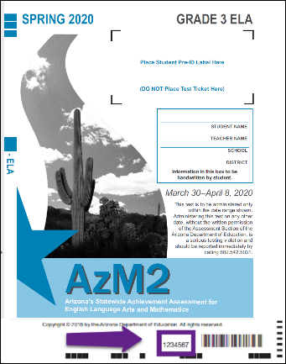
AzM2 Test Booklet Numbers

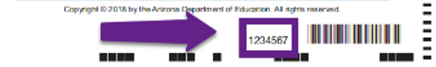

Student Name | Student SSID | Test Booklet Number

