21st CCLC Summary of Classes
Reporting Guidance

All Arizona 21st CCLC grantees must submit Summary of Classes Reports twice a year to the Arizona Department of Education using the report template and guidance provided below.

Reporting Timeline:

What are the reporting periods for the Summary of Classes Report?

- First (January) Summary of Classes Report Period
For the January report, 21st CCLC sites are submitting program information for June through December.

Jun | Jul | Aug | Sept | Oct | Nov | Dec | Jan | Feb | Mar | Apr | May

- Second (June) Summary of Classes Report Period
For the second report in June, 21st CCLC sites will simply update the January report with the second semester classes to encompass the whole program year.
Jun | Jul | Aug | Sept | Oct | Nov | Dec | Jan | Feb | Mar | Apr | May

Getting Started:
1) Download the report template from the link on the Reports page of the 21st CCLC website.

2) Complete one Summary of Classes report document for each Cycle (original grant award year) of the grant in your district. If your district has multiple award Cycle years of funding, please submit the reports for each grant Cycle in a separate Summary of Classes document.
Name each Summary of Classes report using the following steps:
Name the report with your own LEA (district) name and with the month and year the report was submitted. Also include the Cycle year of the sites in that report, if your district has more than one grant Cycle of awards. In FY19, Arizona has the following 21st CCLC grant Cycles that will be reporting:
  - Cycle XII (in Year 5)
  - Cycle XIII (in Year 4)
  - Cycle XIV (in Year 3)
Click “File” then “Save As”
- Summary of Classes (LEA, Cy _), Jan (year)
- Summary of Classes (LEA, Cy _), June (year)

3) Provide information for each 21st CCLC school site on a separate tab.
Within each Summary of Classes report document, there are enough tabs for 10 separate site reports. Tabs are located at the bottom of the spreadsheet. Again, remember to group sites based on grant Cycles in separate Summary of Classes documents.
… etc.
Rename the tabs at the bottom of the sheet with the School Name by right clicking on the tab.

4) Fill out all fields in the Summary of Classes report.
Type in the OFFICIAL District/Organization Name and the School Site Name.
To find your official District/LEA and School Site Name, go to the ADE website www.azed.gov

Hover over “Schools & Teachers” in the dark blue Menu at the top of the home page, then hover of “Schools” and select either “Search: District Schools” or “Search: Charter Schools” in the menu that appears.

Enter the name of your school or district under “Enter the Entity Name,” then click on the “View More Details” link to find the official names of your District/LEA and School Sites

Tips for other data fields:
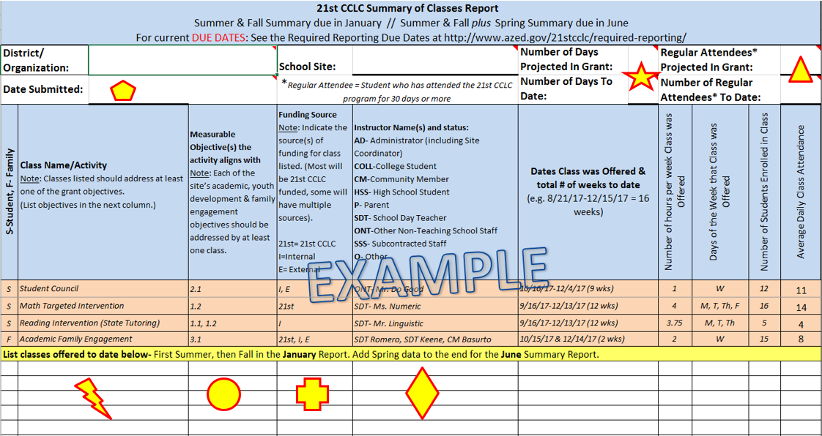

Enter the date you are submitting the report below the district name.

Enter the Projected Number of Program days approved in the site’s 21st CCLC application for FY18 and the Number of Program days to date for the reporting period (i.e.- Fall report will include the number of program days from summer plus fall, through December 31).

Enter the Projected Goal of Regular Attendees from the site’s approved 21st CCLC application for FY18 and the Regular Number of Attendees to date at the top right of the page for each school site.

List each class separately. If you are offering more than one class with the same name, please include the teacher’s name or some identifier (ex. 3rd Grade Reading- Ms. Angelou, 3rd Grade Reading-Mr. Yazzie).

Include the measurable grant objective number(s) after each class name/activity to show which of your own 21st CCLC grant objective(s) each class is designed to support.

Enter the funding source of the class/activity. Most activities will be funded through the 21st CCLC grant, but sites often combine with other funding sources that have different requirements. This indicator allows us to see your partnerships in action and helps if we have questions about class size, instructors, etc.
The options are 21st for 21st CCLC funding, I for Internal funding (including from M&O, Title I, State Tutoring, Migrant Funding, etc- any funds managed by the LEA), and E for External funding (including any funding that is managed outside of the LEA). Each class/activity can have multiple funding sources.

Enter the name of the Instructor and the abbreviation for their status. If more than one Instructor for that class (a tutor and an assistant because of the larger class size, etc.), enter both names and both of their statuses.

Why the status abbreviation?
Each of these statuses align to those asked for in the federally required Annual Performance Report (see the Required Reports page of our website for more guidance).
      - This way, your Summary of Classes report becomes even more helpful in completing the federally required reporting.
Status options are:
      - AD- Administrator (Site Coordinator, Principal, District Level staff, etc.)
      - COLL-College Student
      - CM-Community Member
      - HSS- High School Student
      - P- Parent
      - SDT- School Day Teacher
      - ONT-Other Non-Teaching School Staff (Librarian, teacher’s assistant, attendance clerk, etc.)
      - SSS- Subcontracted Staff
      - O- Other (someone who does not fit into any of the above categories)

5) Email your Summary of Classes Report as an attachment to your ADE 21st CCLC Program Specialist.
Find due dates on the Required Reporting button on the 21st CCLC website (http://www.azed.gov/21stcclc/required-reporting/).

Thank you in advance for completing this and all your 21st CCLC reports on time. Early submissions of reports are always welcome.

