If you are an ADEConnect direct sign user only and need to reset your ADEConnect password?, it’s now
Easier, Faster and the Power Is In Your Hands!
Note: Student Information System (SIS) users will continue to maintain their passwords in the SIS.
Note: Resetting your ADEConnect password does not impact your access to Common Logon.

- Just click one of the Forgot Password? links on the ADEConnect sign in page and start from there:
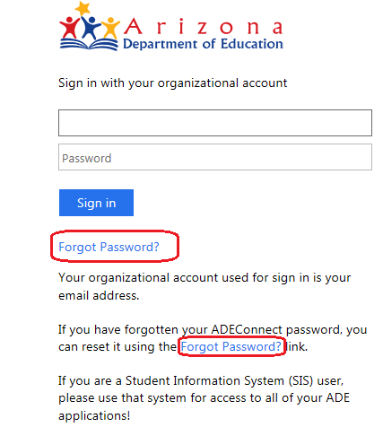

- Follow all of the instructions on the screens to request a password reset

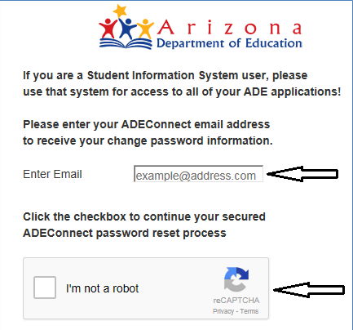

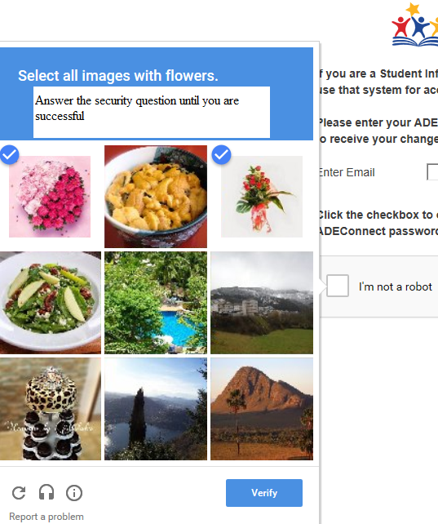

SUCCESS!
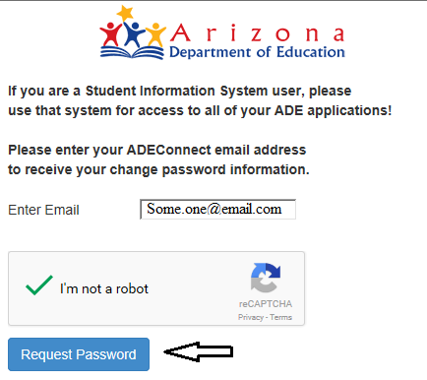

- Once you have successfully completed the password reset process, the ADEConnect email address you entered will receive the Password Reset information

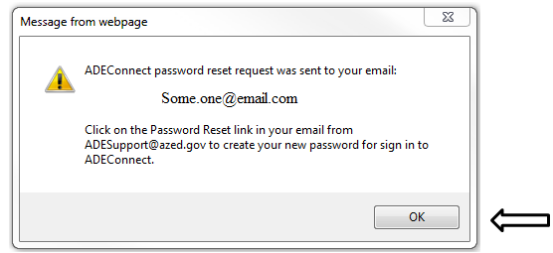

- In your email look for the “Your ADEConnect Password Reset Request” email from ADESupport@azed.gov:

  - Click the Password reset link ( it will redirect you to the Password reset screen)

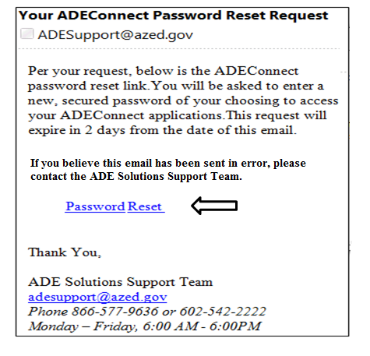

- Enter your New and Confirm New Passwords based on the ADE Password Policy

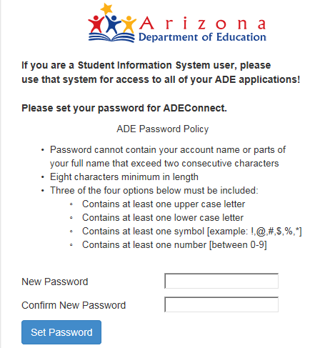

Success!
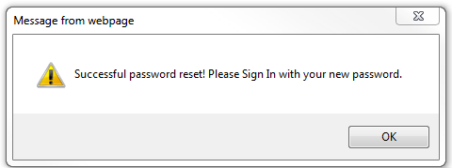

- Now, Sign in to ADEConnect with your email address and your new secured password!

