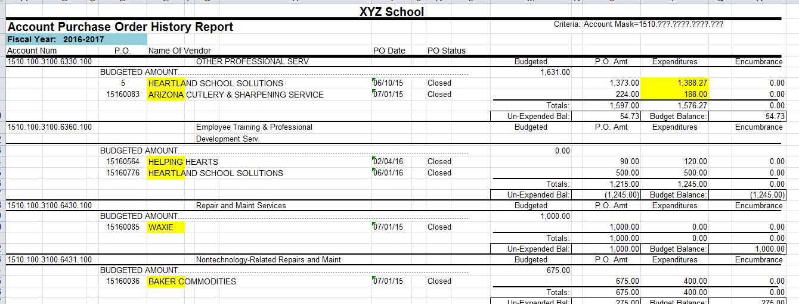 | VENDOR PAID LIST  - Pull the report from your accounting software  - Include all purchases from the School Food Service Account (i.e. 510 account)  - Include all purchases from July 1, 2018 – June 30, 2019
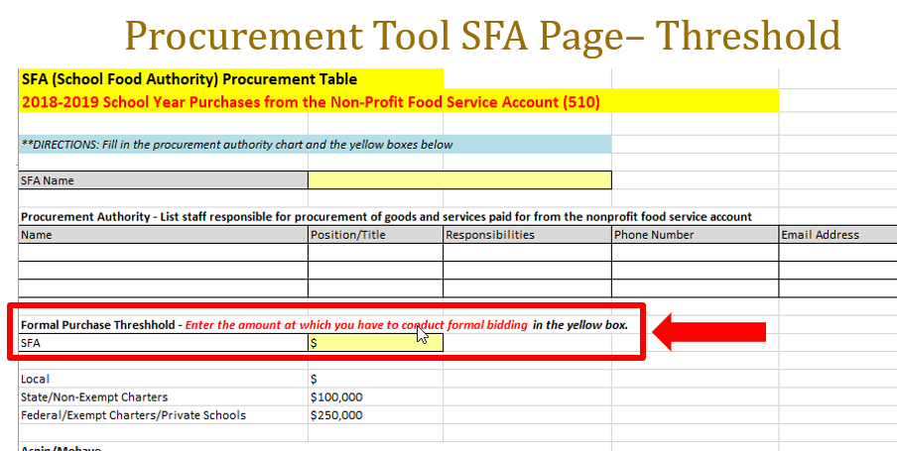 | PROCUREMENT TOOL – SFA PAGE  - Complete ALL information  - List each purchase only once  - When entering purchases, consider both the amount and the process
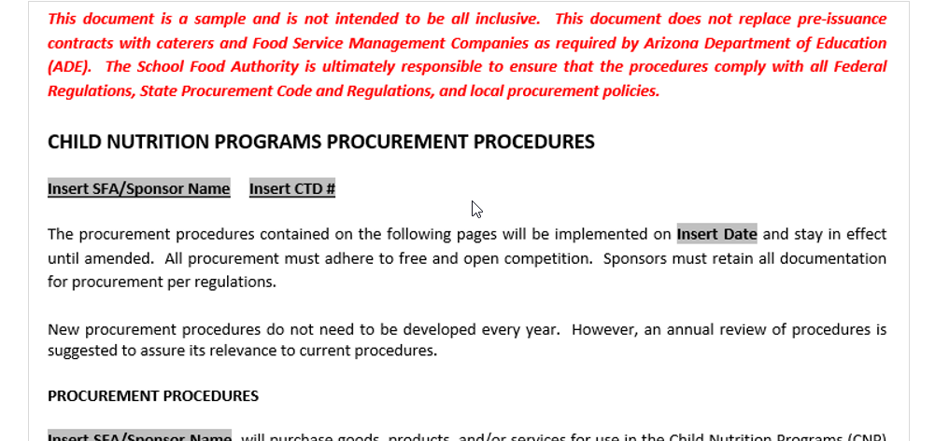 | CNP WRITTEN  PROCUREMENT PROCEDURES  - Complete ALL information  - List only one threshold amount  - Include all purchase methods  - Use job titles, not names of individuals
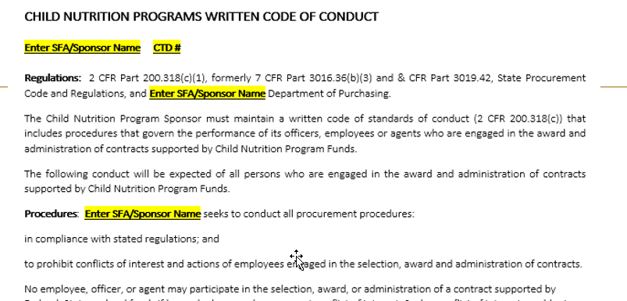 | CNP WRITTEN  CODE OF CONDUCT  - Complete ALL information  - List disciplinary actions  - Use job titles, not names of individuals

