21st CCLC Summary of Classes
Reporting Guidance

All Arizona 21st CCLC grantees must submit Summary of Classes Reports twice a year to the Arizona Department of Education using the report template and guidance provided below.

Reporting Timeline:

What are the reporting periods for the Summary of Classes Report?

First (January) Summary of Classes Report Period
For the January report, 21st CCLC sites are submitting program information for June through December.

Jun | Jul | Aug | Sept | Oct | Nov | Dec | Jan | Feb | Mar | Apr | May

Second (June) Summary of Classes Report Period
For the second report due in June, 21st CCLC sites will simply update the January report by adding the second semester classes to encompass the whole program year.
Jun | Jul | Aug | Sept | Oct | Nov | Dec | Jan | Feb | Mar | Apr | May

Getting Started:
1) Download the report template from the link on the Reports page of the 21st CCLC website.

2) Complete one Summary of Classes report document for each Cycle (original grant award year) of the grant in your district. If your district has multiple award Cycle years of funding, please submit the reports for each grant Cycle in a separate Summary of Classes document.
Name each Summary of Classes report using the following steps:
Name the report with the appropriate abbreviation for the term, the Fiscal Year, and your own LEA (district) name. Also include the Cycle year of the sites in that report, if your district has more than one grant Cycle of awards. In FY20, Arizona has the following 21st CCLC grant Cycles that will be reporting:
  - Cycle XIII (in Year 5)
  - Cycle XIV (in Year 4)
  - Cycle XV (in Year 1)
Click “File” then “Save As”
- For report due in January: SOC1.FY20.(LEA,Cy _)
- For report due in June: SOC2.FY20.(LEA,Cy _)

3) Provide information for each 21st CCLC school site on a separate tab.
Within each Summary of Classes report document, there are enough tabs for 10 separate site reports. Tabs are located at the bottom of the spreadsheet. Again, remember to group sites based on grant Cycles in separate Summary of Classes documents.
… etc.
Rename the tabs at the bottom of the sheet with the School Name by right clicking on the tab.

4) Fill out all fields in the Summary of Classes report.
Type in the OFFICIAL District/Organization Name and the School Site Name.
To find your official District/LEA and School Site Name, go to the ADE website www.azed.gov

Hover over “Schools & Teachers” in the dark blue Menu at the top of the home page, then hover of “Schools” and select either “Search: District Schools” or “Search: Charter Schools” in the menu that appears.

Enter the name of your school or district under “Enter the Entity Name,” then click on the “View More Details” link to find the official names of your District/LEA and School Sites.

Summary of Classes data fields and key
Below is a screenshot of the Summary of Classes template. For information about how to fill in each section, see the corresponding icon in the data field key on the next pages.
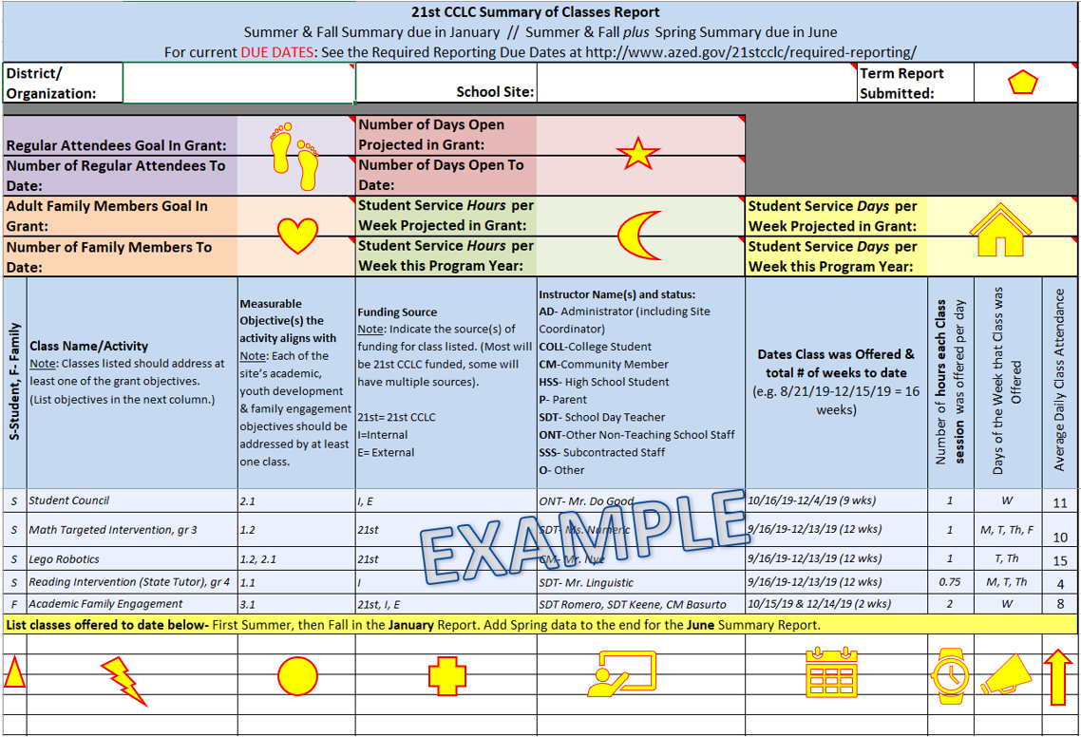
Summary of Classes Data Field Key:

Select the Term from the drop down for the report you are submitting- SOC1 or SOC2.
Enter the Projected Goal of Regular Attendees from the site’s original approved 21st CCLC application and the Regular Number of Attendees to date for the reporting period (i.e.- Fall report will include regular attendees with attendance from summer plus fall, through December 31, Spring report will be Summer + Fall + Spring).

Enter the Projected Number of Program days approved in the site’s original 21st CCLC application and the Number of Program days to date for the reporting period (i.e.- Fall report will include the number of program days from summer plus fall, through December 31, Spring report will be Summer + Fall + Spring).

Enter the Adult Family Member Goal from the site’s original approved 21st CCLC application and the number of Adult Family Members to date for the reporting period (i.e.- Fall report will include Adult Family Members from summer plus fall, through December 31, Spring report will be Summer + Fall + Spring).

Enter the Student Service Hours per week approved in the site’s original 21st CCLC application and the average number of hours per week the center was open for Student Services for the reporting period.
Enter the Student Service Days per week approved in the site’s original 21st CCLC application and the average number of days per week the center was open for Student Services for the reporting period.

For the next fields of the report (below the example):
Report each term separately!
Indicate a new term is being reported by listing all classes/activities for one term grouped together, followed by the next term grouped together, or by leaving a blank row in the sheet and then starting the next term below.

Why report them separately?
Each term has unique classes and rosters of students and ADE wants to see what took place over that timeframe. Additionally, this will allow the Summary of Classes to be a tool to help complete the Annual Performance Report, a federal report submitted by term three times each year- summer, fall, and spring (see the Required Reports page of our website for more guidance).

Indicate whether the activity was focused on Student Services (S) or Family Services (F). Family can include activities with Adult Family Members served only or activities where both students and Adult Family Members were both served.

List each class/activity in the 21st CCLC umbrella of services (whose hours and attendance you’re counting towards the requirements of the 21st CCLC grant) separately.
If you are offering more than one class with the same name, please include the teacher’s name or some other identifier (ex. 3rd Grade Reading- Ms. Morrison, 3rd Grade Reading-Mr. Ishiguro).

Include the measurable grant objective number(s) to indicate how the class/activity is aligned to your 21st CCLC grant objective(s). Some classes may have only one and some may be tied to multiple objectives.

Enter the funding source of the class/activity. Most activities will be funded through the 21st CCLC grant, but sites often strategically combine with other funding sources. This indicator allows us to see your partnerships in action and helps if we have questions about class size, instructors, etc.
The options are “21st” for 21st CCLC funding, “I” for Internal funding (including from M&O, Title I, State Tutoring, Migrant Funding, etc- any funds managed by the LEA), and “E” for External funding (including any funding that is managed outside of the LEA). Each class/activity can have multiple funding sources.

Enter the name of the Instructor and the abbreviation for their status. If more than one Instructor for that class (a tutor and an assistant because of the larger class size, etc.), enter both names and both of their statuses.
Why the status abbreviation?
Each of these statuses align to those asked for in the federally required Annual Performance Report in the Staffing section (see the Required Reports page of our website for more guidance).
This way, your Summary of Classes report becomes even more helpful in completing the federally required reporting.

Status options are:
      - AD- Administrator (Site Coordinator, Principal, District Level staff, etc.)
      - COLL-College Student
      - CM-Community Member
      - HSS- High School Student
      - P- Parent
      - SDT- School Day Teacher
      - ONT-Other Non-Teaching School Staff (Librarian, teacher’s assistant, attendance clerk, etc.)
      - SSS- Subcontracted Staff
      - O- Other (someone who does not fit into any of the above categories)

Enter the dates and number of weeks a class/activity was offered. Most classes will have the same begin/end dates and weeks, but there are various reasons a class/activity might have different dates and weeks. Pay special attention to classes start ended early or started late- this demonstrates continuous improvement or adapting to the needs of the site!
Enter the number of hours each class/activity was offered PER DAY. Ex: If a class/activity was offered 4 days a week for 1 hour each day, enter “1” here.
Tip- this will allow for easy translation into the Annual Performance Report, as this language aligns to what’s requested in that report in the Activities section.

Enter the abbreviation for the days of the week the class/activity was offered.

Enter the Average Daily Attendance for the class- how many students are present in the class each day, on average?
This will tell ADE if you have an allowable class size for the 21st CCLC grant funding. It will also help you complete the Annual Performance Report, as the same question is asked in the Activities section of the report.

5) Email your Summary of Classes Report as an attachment to your ADE 21st CCLC Program Specialist.
Find due dates on the Required Reporting button on the 21st CCLC website (http://www.azed.gov/21stcclc/required-reporting/).

Remember: Reporting due dates are requirements and can determine a site’s substantial compliance! Early submissions of reports are always welcome.

Thank you!

