Arizona K-12 Standards Common Definitions
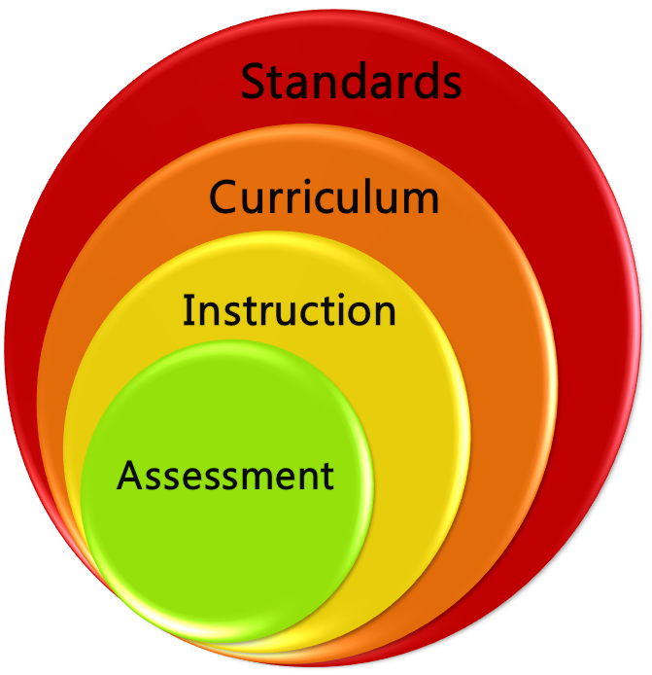
Standards - What a student needs to know, understand, and be able to do by the end of each grade. Standards build across grade levels in a progression of increasing understanding and through a range of cognitive demand levels. Standards are adopted at the state level by the State Board of Education.
Curriculum - The resources used for teaching and learning the standards. Curricula are adopted at a local level by districts and schools. Curricula include scope and sequence of K-12 standards and/or learning objectives/targets aligned to the state standards. Comprehensive curricula are necessary to plan the pace of instruction, align standards and grade level expectations horizontally and vertically, set district assessment and professional development calendars and guide teachers as they deliver instruction.
Instruction - The methods and processes used by teachers in planning, instruction and assessment. Instructional techniques are employed by individual teachers in response to the needs of the students in their classes to help them progress through the curriculum in order to master the standards.
Assessment – The process of gathering information about student learning to inform education-related decisions. Assessments can reflect a wide variety of learning goals/targets using a range of methods serving many important users and uses at a variety of levels from the classroom to the boardroom. In this sense, assessment is an essential part of informing the teaching and learning process.

