Arizona Mathematics Standards

Fourth Credit Mathematics – General Guidance
Arizona DepaRtment of Education

High Academic Standards for Students
September 2018
Background

In December 2007, the Arizona State Board of Education adopted R7-2-302.02 which increased the graduation requirements to include a fourth credit of mathematics beginning with the graduation class of 2013.
Fourth-credit mathematics course guidance was developed in 2008 with the adoption of specific Algebra 2 standards. A list of possible courses guided local educational agencies’ as they implemented common standards for Algebra 2 and continuing or new fourth credit math courses. Guidance linked the possible fourth credit courses to the 2008 Arizona Mathematics Standards. Current research supported the implementation of a fourth credit for math so the pathway of mathematical learning was seamless through to career and college opportunities.
For many districts, the fourth-credit requirement for mathematics posed a significant challenge. Multiple pathways besides Precalculus were needed to meet the needs and future goals for all students. New mathematics course pathways were developed and available to students to support their success in all four credits of high school mathematics and achievement of their future college and career goals. The 2008 Fourth Credit Guidance document supported these new pathways with options linked to the 2008 Mathematics Standards.
In 2010, Arizona adopted new state Mathematics Standards. The standards were identified by conceptual categories rather than sequential courses. Some common standards existed between Algebra 1 and Algebra 2, making it difficult to establish what the learning boundary was between the two courses. Plus Standards were also included in the 2010 Mathematics Standards. The Plus Standards represented content that all high school students should experience.
A new state level assessment was adopted in 2015 in grades 3 through high school for mathematics. This assessment would move the assessment system towards computerized administration, allowing for standard accommodations for all students as well as a higher level of rigor or cognitive demand represented in the individual assessment questions. The state level assessment moved to end-of-course assessment in high school for Algebra 1, Geometry, and Algebra 2.
In December 2016, the State Board of Education approved the Arizona Mathematics Standards from Kindergarten through Algebra 2. The high school standards are presented by sequential courses. The Arizona Mathematics Standards also include Plus Standards which represent content that every high school students should have the opportunity to experience either in a fourth credit course or as an extension of content in Algebra 1, Geometry, or Algebra 2 course content.
Introduction

Arizona places a high value on a rigorous four credit mathematics pathway in high school as it provides a solid foundation for a post-secondary education or career pathway. We believe that four years of high-quality instruction around significant mathematics will prepare students to leave high school with quantitative literacy and critical thinking processes that will lead to sound decision-making in their personal lives, and enable them to become active, engaged citizens who are able to determine the truth and validity of reasoning and claims used in scientific, economic, social, and political arenas. A four-year mathematics pathway will also help students see themselves as capable mathematical and statistical practitioners, and help them appreciate the beauty, complexity, and practicality of mathematics and statistics.

According to the National Mathematics Advisory Panel, success in mathematics education is important to individual citizens because it leads to more options in college and career pathways, as well as increasing the prospects of a higher income. Horn & Nunez (2000) and Horowitz (2005) both found that the probability of a student’s enrollment in a four-year college is correlated to the completion of high school mathematics programs beyond Algebra 2.

As the U.S. population continues to become more diverse, we must make sure that educational opportunities mirror the diversity of the broader population (National Research Council, 2002). The variety of fourth-year credit courses in mathematics available to students will not only prepare them for post-secondary life but will honor the needs of a diverse population. Ma and Wilkins (2007) highlight the crucial role mathematics educators play as we explore and expand the ways we can use mathematics coursework to improve student achievement and confidence. Diverse mathematics courses must be made available and accessible as one of the pathways that leads to student success.

To assist in providing guidance in the development of fourth-year mathematics content and options, the Arizona Department of Education created and facilitated an Advanced Mathematics Committee (AMC). Committee members were chosen from self-completed applications for inclusion in the committee. Members included professors and instructors of institutes of higher education, high school math teachers, and school district mathematic coaches and specialists. This group of Arizona educators provided expert content knowledge and knowledge of research in mathematics education essential skills needed for the critical work of developing rigorous, relevant, and varied mathematics course options for Arizona students.

According to the NCTM Standards (2000), mathematical power is achieved by students who can confidently engage in complex mathematical tasks, effectively draw on knowledge from a wide variety of mathematical topics and concepts, productively approach problems from differing perspectives, flexibly and resourcefully solve problems in a productive and reflective manner, capably and effectively communicate their ideas and results, and clearly see the value of mathematics as a vital tool to approach and solve a variety of issues. Instead of primarily focusing on the memorization of procedures and formulas and the repetition of exercises, the National Research Council (1989) calls on us to bring these critical thinking skills to the forefront of mathematics education, and the development and implementation of a variety of fourth-year options in significant mathematics can help us achieve that goal. According to the NCTM publication, Catalyzing Change in High School Mathematics (2018), to maximize students’ opportunities after high school and prepare them to actively engage in democratic society, high schools should ensure that all students enroll in a mathematics course every year in high school and complete four years of high school mathematics including a mathematics or statistics course during their last year of high school.

In this document there are suggestions for fourth-credit courses that have standards with significant mathematics. This is by no means an all-encompassing list. However, this document may help local districts to address the needs for diverse populations of students to be successful in fourth credit courses that are both meaningful and mathematically significant. With full implementation of the 2016 Arizona Mathematics Standards and extended opportunities for rigorous fourth-credit math courses, “pockets of excellence will change to systemic excellent by providing mathematics education that supports the learning of all students at the highest possible level” (2014).
The provided guidance regarding fourth-credit math courses will assist LEA’S in providing access and equity to support mathematics programs. Such programs promote that ideal that all students have access to a high-quality mathematics curriculum that supports effective teaching and learning with; high expectations; and the support and resources needed to maximize students learning potential (2014).

R7-2-302. Minimum Course of Study and Competency Requirements for Graduation from High School- Adopted by the Arizona State Board of Education - January 2018
Only sections related to math are included in this document

1. Subject area course requirements. The Board establishes 22 credits as the minimum number of credits necessary for high school graduation. Students shall obtain credits for required subject areas as specified in subsections (1)(a) through (e) based on completion of subject area course requirements or competency requirements. At the discretion of the local school district governing board or charter school, credits may be awarded for completion of elective subjects specified in subsection (1)(f) based on completion of subject area course requirements or competency requirements. The awarding of a credit toward the completion of high school graduation requirements shall be based on successful completion of the subject area requirements prescribed by the State Board and local school district governing board or charter school as follows:

c. Four credits of mathematics to minimally include:
i. Three credits containing course content in preparation for proficiency at the high school level on the statewide assessment and aligned to the Arizona Mathematics Standards for Algebra I, Geometry, and Algebra II. These three credits shall be taken beginning with the ninth grade unless a student meets these requirements prior to the ninth grade pursuant to subsection (1)(c)(iii). The requirement for the third credit covering Algebra II, may be met by, but is not limited to the following: a math course comparable to Algebra II course content; computer science, career and technical education and vocational education, economics, science and arts courses as determined by the local school district governing board or charter school.

ii. A fourth credit that includes significant mathematics content as determined by the local school district governing board or charter school.

iii. Courses successfully completed prior to the ninth grade that meet the high school mathematics credit requirements may be applied toward satisfying those requirements.

iv. The mathematics requirements may be modified for students using a Personal Curriculum pursuant to R7-2-302.03.

High School Course Pathways
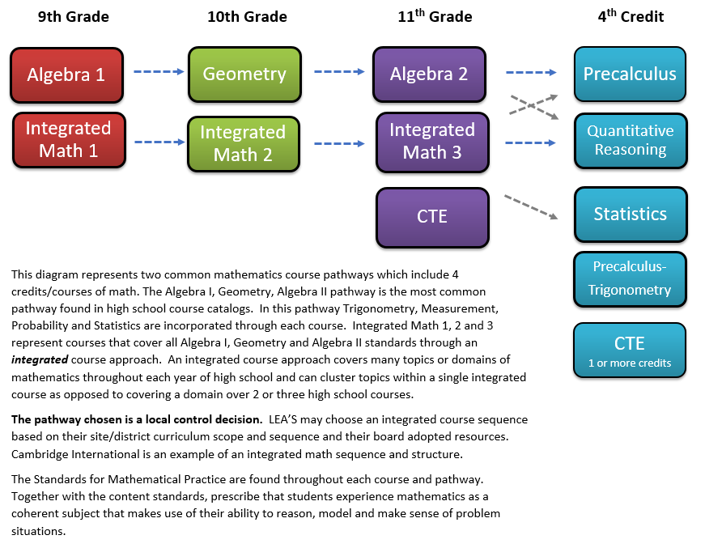
High School Course Pathways – Fourth-Credit Options

The first action item of the Advanced Mathematics Committee (AMC) was to analyze all fourth-credit math courses entered by LEA’s in the Student, Teacher, Course Catalog. This analysis produced thirty-two pages of fourth-credit courses with over thirty different courses entered by LEA’s. From this extensive list, the AMC then categorized courses by those that already had standards associated with them and those that had confirmed dual credit/enrollment options.
 | Current Fourth-Credit Course Titles January 2017 | Current Standards | Dual Credit/Enrollment | AZ Public Institutes of Higher Education  SUN#
1 | Precalculus |  | X | MAT 1187
2 | College Algebra |  | X | MAT 1151
3 | College Mathematics |  | X | MAT 1142
4 | Quantitative Reasoning |  | X | MAT 1142
5 | Discrete Math |  | X | MAT 2227
6 | College Algebra/Trigonometry |  | X | Varies by site
7 | Statistics |  | X | Varies by site
8 | AP Calculus AB | X | X | MAT 2220
9 | AP Calculus BC | X | X | MAT 2230
10 | AP Computer Science | X | Not accepted by ABOR as math credit
11 | AP Statistics | X | X | Varies by site
12 | International Baccalaureate (IB) HL and SL | X | X | Varies by site
13 | Cambridge A Level | X | X | Varies by site

Based on data, the AMC determined that all courses and programs that are Advanced Placement in nature already had current standards and confirmed dual credit/enrollment opportunities. The only course in question for math credit was AP Computer Science. Currently, the Arizona Board of Regents does not accept AP Computer Science as a math credit towards college admission.
High School Course Pathways – Advanced Mathematics Committee Work

Data provided by the AMC members and from higher education established which current fourth-credit options had confirmed dual credit/enrollment opportunities. Based on the dual credit/enrollment data, it was determined that there were 7 courses that LEA’s offered that would benefit from guidance and standards.

Guidance and Standards
Precalculus
College Algebra
College Math
Quantitative Reasoning
Discrete Math
College Algebra/Trigonometry

The AMC analyzed the most common fourth-credit courses and the articulation to higher education and career training to determine the focus of their work on guidance related to course standards. Their rationale is listed below.

College Algebra –Algebra 2 Comparison
An analysis of the higher education College Algebra syllabus to the Arizona Mathematics Standards for Algebra 2 adopted in 2016 provided data that the current Algebra 2 high school course was more rigorous in standards than the current College Algebra syllabus. A second piece of data that was critical concerning some of the higher education systems was the knowledge that College Algebra, in some higher education systems, does not count as a math credit if you are entering a Bachelor of Science program. College Algebra, even with dual credit, would only count as an elective if you are in a Bachelor of Science program, with the first math credit that is accepted being Calculus. These pieces of information discouraged the committee from creating guidance standards for College Algebra.
College Algebra/Trigonometry
This course had multiple course titles and did not have a consistent set of standards or syllabus. In most high school systems, this course is two different semester courses. It was decided that this would not be a starting place for guidance development.

College Math –Quantitative Reasoning Comparison
Through review of course syllabi from different institutes of higher education in Arizona, it was determined that Quantitative Reasoning (QR) and College Math aligned very closely. This analysis supported the creation of guidance for Quantitative Reasoning. For students entering higher education in a Bachelor of Arts program, College Math was predominately an initial math credit. With the knowledge that existing QR syllabi and other state standards closely aligning to College Mathematics, developing support for QR seemed like the appropriate place to focus the work of the AMC.

Discrete Mathematics- Quantitative Reasoning
Discrete Mathematics standards currently exist in the 2016 Arizona Mathematics Plus Standards. Limited in nature, these standards are foundational for Computer Science and can also be found in some Quantitative Reasoning standards from other states. The committee decided that the current Plus Standards on Discrete Mathematics would benefit from inclusion in guidance and standards in a Quantitative Reasoning course.

Precalculus
The AMC did not need a lot of data to determine that developing guidance and standards for Precalculus would greatly benefit the field. With the knowledge that Calculus was an initial math credit for students in a Bachelor of Science program, developing support for Precalculus seemed like the appropriate place to focus the work of the AMC.

The decision to focus actions on the development of guidance for Quantitative Reasoning and Precalculus was also guided by the following information.
- Plus Standards represent additional math content that every high school student should have the opportunity to experience either in a fourth credit course or as an extension of content in Algebra 1, Geometry, or Algebra 2. Many Plus Standards would be included in standards guidance for Precalculus or Quantitative Reasoning.
- Precalculus and Quantitative Reasoning represent two different pathways within high school mathematics education.
- Precalculus and Quantitative Reasoning could provide students with dual credit/enrollment opportunities.
The AMC was committed to providing the field with resources that would ensure that math pathways are rigorous and are developed coherently across institutions and improve math pathways. The AMC defined systems to include all high school, higher education institutes and career programs. All actions taken by the AMC supported the articulation among all systems and the goal of a positive and successful transition from high school to career and college.

High School Course Pathways – Additional Credit Options
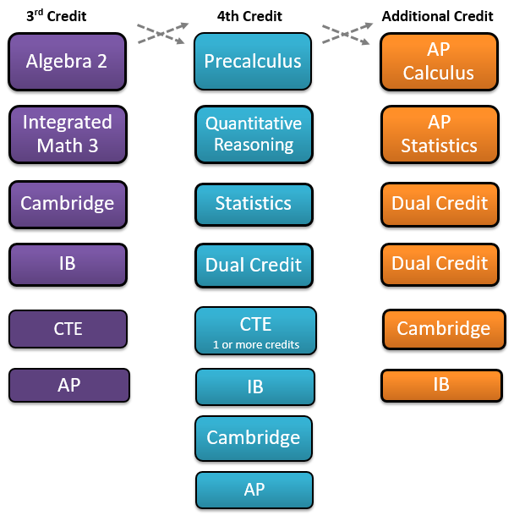
These are examples of the multitude of different pathways that can be created within different credit levels. These options allow for students to explore different pathways of mathematics over the course of their high school courses/credits. All course/credit options are local control decisions that are adopted by the local Governing Board and approved by the Arizona Board of Regents (ABOR).

Advanced Program Credit and Program Information

Each LEA created a course catalog with options to complete the four credits and additional credit options for mathematics credit to satisfy high school graduation and possibly earn college credit or advanced placement in college prior to graduating high school. All course options are a local decision and can be found in the site/district course catalog or through the District/LEA Mathematics Department website. For additional information on Advanced Placement Programs, please visit the Arizona Department of Education website. Contacts for additional information are listed on the Advanced Placement homepage.

Limited descriptions of some of the most common advanced placement opportunities or programs are listed below.

Dual Credit or Dual Enrollment is the enrollment of a high school student in a college course for which dual credit (both college and high school credit) is attempted and recorded on both the student’s secondary and postsecondary academic record. A college course offered for Dual Credit/Enrollment is: (1) an on-site or online college course taught by the postsecondary institution, or (2) a specially scheduled college course taught at the high school. Postsecondary institutions must adhere to Board of Regents Policy and must comply with all accreditation requirements for awarding credit.

Advanced Placement or AP enables students to pursue college-level studies while still in high school. Through more than 30 courses (3 math credit courses- Calculus AB, Calculus BC, and Statistics), each culminating in a rigorous exam, AP provides willing and academically prepared students with the opportunity to earn college credit, advanced placement, or both.

International Baccalaureate or IB is comprised of four programs from Preschool through high school that focus on teaching students to think critically and independently, and how to inquire with care and logic. The International Baccalaureate program also has a Diploma program where students take IB exams and can receive college credit, advanced placement or both. The IB pathway can include all four courses at high school or can branch out to include Precalculus and Calculus/AP Calculus. It is a local decision how the IB and Diploma program are implemented at the high-school level.

Cambridge International is a program and curriculum adopted at the local level for multiple grade levels and subjects. These curriculum and high-school pathways can be associated with the Diploma Program and assessment. Passing exam scores/grades can earn college credit, advanced placement or both. The Cambridge curriculum can include all courses at high school or can branch out to include Precalculus and Calculus/AP Calculus. It is a local decision how the Cambridge International curriculum and Cambridge Diploma Program are implemented at the high school level.

References

Arizona Department of Education. (2016, Dec 16). Arizona Mathematics Standards. Retrieved from http://www.azed.gov/standards-practices/k-12standards/mathematics-standards/.

Horn, L., & Nunez, A. (2000). Mapping the road to college: First-generation students’ math track, planning strategies, and context of support (NCES 2000-153). Washington, DC: U.S. Department of Education.
Horowitz, J.E. (2005). Inside high school reform: Making the Changes that Matter. San Francisco: WestEd.
Ma, X., & Wilkins, J. (2007). Mathematics coursework regulates growth in mathematics achievement. Journal for Research in Mathematics, 31. 454-482.
National Council of Teachers of Mathematics, (2000). Principles and standards for school mathematics, NCTM: Reston, VA.
National Council of Teachers of Mathematics, (2014). Principles to Actions: Ensuring Mathematical Success for All, NCTM: Reston, VA.
National Council of Teachers of Mathematics, (2018). Catalyzing Change in High School Mathematics: Initiating Critical Conversations, NCTM: Reston, VA.
National Mathematics Advisory Panel (2008). Foundations for Success: The Final Report of the National Mathematics Advisory Panel. U.S. Department of Education: Washington, DC.
National Research Council (1989). Everybody counts: A report to the nation on the future of mathematics education. Washington, D.C., National Academies Press.
National Research Council (2002). Scientific Research in Education. Washington, D.C, National Academies Press.

