What’s Your Style?
Style #1: | Style #2: | Style #3: | Style #4:
- Outgoing  - Focused on the big picture  - Drawn to Risk  - Adaptable  - Imaginative  - Likes to brainstorm  - Spontaneous  - Try new things | - Diplomatic  - Empathic  - Traditional  - Relationship Oriented  - Intrinsically motivated  - Nonconfrontational  - Collaboration | - Quantitative  - Logical  - Focused  - Competitive  - Experimental  - Deeply Curious  - Directness  - Likes to solve problems | - Methodical  - Reserved  - Detail-Oriented  - Practical  - Structured  - Loyal  - Organized  - Predictable  - Likes a detailed plan

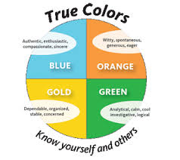
Samples of Personality Activities
https://businesschemistry.deloitte.com/Login/Index?ReturnUrl=%2f#/
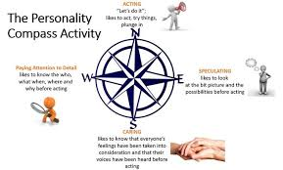
https://www.uc.edu/content/dam/uc/sald/docs/Leadership/Instructions_True_Colors.pdf
http://schoolreforminitiative.org/doc/compass_points.pdf

