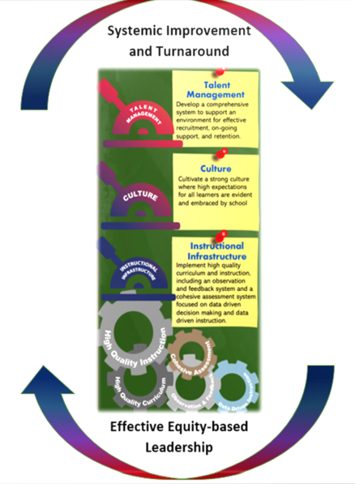
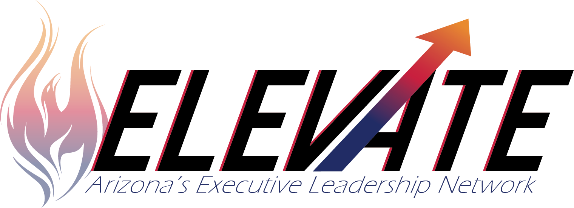

Cohort 5 Application

October 15, 2019 | ELEVATE Cohort Application Released  Telephone assistance with applications:  Devon Isherwood (ADE) Office: 602-364-0379  Cell: 480-242-6573  Trish Geraghty (ADE) Office: 602-542-2291
Applications will be approved as they are received | ELEVATE Cohort Applications Due to:  Trish Geraghty trish.geraghty@azed.gov  Sean Carney sean.carney@azed.gov
March 1, 2020 | Systemic Leadership Grant is available - opens
May 30, 2020 | Systemic Leadership Grant - closes
Dec. 8-9, 2020 | ELEVATE LEA Leadership Team Bootcamp
Feb. 23-25, 2021  May 11-13, 2021  Aug. 31, Sept. 1-2, 2021  Nov. 2-4, 2021  Jan. 25-27, 2022  May 3-5, 2022  Aug. 23-25, 2022  Oct. 25-27, 2022 | ELEVATE Cohort 5 Year 1 & 2 Convenings  Current Location Black Canyon Conference Center  Tentative Schedule  Day 1  AM - LEA Leadership Teams only  PM - LEA Leadership Teams and Principals only  Day 2 and 3 LEA and School Leadership Teams

An evidence-based, executive leadership program developed and presented by the Support and Innovation Unit of the Arizona Department of Education in collaboration with WestEd. ELEVATE centers on equity-focused leadership and develops the knowledge, competencies and skills necessary for systematic and systemic change by strengthening the culture of learning and high expectations for all, instructional infrastructure and talent management at the systems level within LEAs and schools.

Vision: ELEVATE seeks to improve LEA and school systems in order to significantly increase and sustain quality outcomes for all Arizona Students.
Mission: ELEVATE develops and empowers LEA and school leaders to focus on equity, improving teaching and learning that results in rapid and significant gains in student achievement
ELEVATE Theory of Action
If we develop equity focused leaders’ skills and competencies to facilitate systemic change by creating and sustaining
- a high quality, cohesive instructional infrastructure
- a strong culture of learning and high expectations for all
- a strategic, evidence-based talent management system
Then student achievement significantly improves, and student subgroup achievement gaps are reduced

- LEA Information
Provide the following information for the LEA.

LEA Name
Mailing Address
Physical Address
Phone Number
Superintendent |  | Phone # | Email
Secondary Contact |  | Phone # | Email

- LEA Level Participants (small LEAs, minimum of 2)
The LEA Leadership Team includes the Superintendent and the principals’ supervisor, if other than the Superintendent,
as well as other LEA leaders who will have primary responsibility for ensuring implementation and sustainability of the ELEVATE goals. It is recommended that other LEA Leadership Team members include Assistant Superintendents and/or directors of Curriculum and Instruction, Assessment, Student Services, SPED, ELL, Federal Program Director.
Name | Role | Email | Phone Number
 | Superintendent

- Please share why your LEA is interested in participating in ELEVATE.

- Recognition of the need for change and willingness to create and implement a bold plan of action is essential to any systemic turnaround or improvement initiative. Briefly describe why your LEA and selected schools are ready and willing to implement systemic changes.

To help us better understand your LEA, please answer the following:
- Describe the LEA’s demographics including size, number of schools and the communities you serve?

- Describe the teaching and administrative staff; veteran teachers/administrators vs. beginning teachers/administrators, certified vs. noncertified, turnover, etc.

- What are the LEA’s current initiatives?

- Does your LEA currently partner with any external provider or third-party organizations for purposes such as data systems, talent recruitment, professional development or mentoring? If so, please briefly describe who and their role.

School Participation
ELEVATE is about systemic change, therefore when determining schools to participate, please consider:
  - Schools identified as Comprehensive or Targeted Support and Improvement (must be included to be eligible for grant funding)
  - All schools in a small LEA
  - In larger LEAs, schools that strategically fit together; serve with like populations or schools in a feeder pattern
  - Schools with the capacity and commitment to implement systemic change

Total number of schools in the LEA?
Participating schools
School Name | School Leader(s) Name & Position | Federal Label and/or letter grade
*Add more lines as needed

LEA and school leadership development is foundational to systemic school improvement. System ownership is critical to sustainable success. The ELEVATE program is committed to working collaboratively with LEA and school teams to improve systems to improve outcomes for all students.
The LEA’s commitment is essential in this process.

LEA Commitments
LEA Leaders commit to:
- Making ELEVATE a top LEA priority
- Communicating with internal and external stakeholders the commitment and purpose of participating in ELEVATE
- Participating in two-day LEA Leadership Bootcamp
- Participating in Gallup StrengthsFinder to support a strength-based approach to leadership development
- Attending and actively participating in all eight, three day ELEVATE convenings
- Using the ELVATE culture of learning and high expectations for all, instructional infrastructure and talent management continua to guide and monitor growth
- Having an ELEVATE mentor to provide on-site support for the school leader at least twice per month
- Conducting monthly site visits to participating schools and principals to observe implementation of ELEVATE learning and the 90-day plans

School Commitments
School Leaders commit to:
- Making ELEVATE a top school priority
- Attending and actively participating in all eight, two and one-half day ELEVATE Convenings with the Leadership Team
- Implementing new learning from the convenings
- Participating in Gallup StrengthsFinder to support a strength-based approach to leadership development
- Using the ELVATE culture of learning and high expectations for all, instructional infrastructure and talent management continua to guide and monitor growth
- Creating and implementing 90-day plans, including evidence of growth
- Meeting at least twice a month with assigned ELEVATE mentor focusing on ELEVATE learning and 90-day plan

Superintendent Signature Date

or

Charter Holder Signature Date

