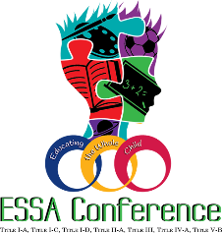
ESSA Conference 2020: Educating the Whole Child
The Arizona Department of Education is excited to announce that the ESSA Conference 2020 will be run entirely through the Guidebook app. The Guidebook app is an easy way to register for sessions, take surveys, and stay up to date with the latest event news and announcements.
All participants are encouraged to download the Guidebook app and register for sessions as soon as possible.
Downloading the app:
- To download the app, visit http://guidebook.com/getit in a web browser or find the app in the Google Play Store or the iOS App Store.
- To access the ESSA 2020 app, tap the Find Guides magnifying glass in the bottom right.
  - Passphrase: Tap the Find Guides magnifying glass in the bottom right, then tap the blue button that says Have a passphrase? and enter essa2020. Tap to download and open the guide that appears.
  - QR Code: Tap the Find Guides magnifying glass in the bottom right, then the QR icon in the upper right next to the silhouette icon. Scan the QR Code below:
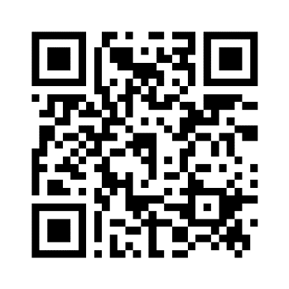
Registering for sessions:
- Tap the icon in the top-right corner of the app screen to sign up or log in to your account.
  - To log in with an existing account, click on the Log in portion of Already have an account? Log in and provide your email address and password.
  - To create a new account, click Sign up with Facebook or Sign up with Email, or you can choose one of the More ways to sign up at the bottom of the screen.
  - App passwords must be at least eight characters in length and contain at least one number. Please refer to this article if you have any trouble logging in or cannot remember your password.
- To register for sessions, tap the menu bar in the upper left, then tap Schedule. You can find everything you need to know about sessions in the Schedule. Tap on the dates at the top of the screen to navigate through the schedule. Tap on a session name to get more details.
  - You may see colorful dots on some sessions. These indicate schedule tracks, which are tags for sessions according to topic, intended audience, etc.
  - Below the session description text, you may see links to other items in the guide, surveys, PDFs, and/or website as additional resources.
  - Tap on the plus sign (+) to add a session to your My Schedule.
  - To access your personal schedule, tap My Schedule at the bottom of the screen.
Need additional help?
- Check out the Guidebook Tutorial.
- Email Erin.Henderson@azed.gov or call at 602-542-7847.
- Help will be available on-site at the conference.

