Forms and Colors
- Knows geometric shapes: Ask your child to identify the geometrical figure with his finger and say the name of the form.

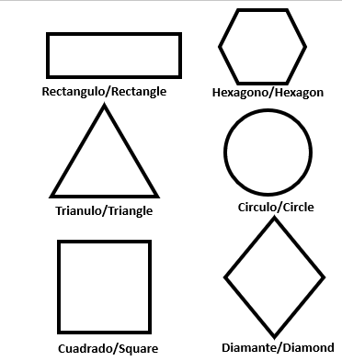

- Recognizes and says 9 colors? Ask your child to identify the color and say the name.

Azul/Blu Amarillo/Yellow Verde/Green Café/Brown

Morado/Purple Rojo/Red Blanco/White Negro/Black

Anaranjado/Orange

Reading
- Knows their full given name.
- Can write their name, using a capital letter for the first letter

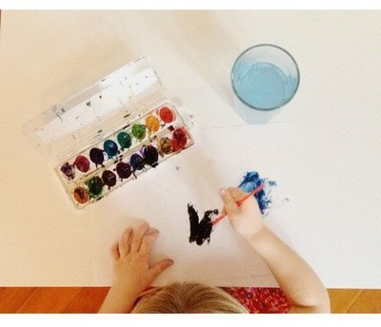
Arizona Migrant Education Program is dedicated to the academic progress of their children. If you would like more information about support for
kindergarten children, please contact your local Migrant Education Program.

Arizona Migrant
Education Program
Contact
MEPInbox@azed.gov
1535 West Jefferson Bin 31
Phoenix, AZ 85007

Pre-School
Foundation for academic success

Resources
Ideas on how to use this guide

The Migrant Education Program offers a list of skills that accompanies this guide for preschoolers. Circle the word or item that your child knows. After reading a book for 10-15 minutes, take this sheet out and focus on 1-2 areas reviewing the circled items they already know and adding 1-2 new items. Celebrate their success by praising their success and having them share their new skill multiple times with everyone they know.

*The instructions for the activities are written in green color

Literacy
- Knows all the letter names. Ask your child to identify with a finger while he is saying the name and the sound of the letter.
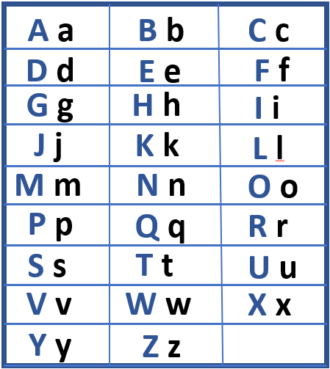
- Knows cheers, chants, or songs.
- Recognizes the letters in their name.
- Can tell a story in sequence.
- Can follow words left to right, top to bottom, page to page.
- Can retell a story or event.

- Knows 10 or more letter sounds/syllables. Ask your child to point to the short vowel sound and letter name with their finger while they pronounce the sound out loud. 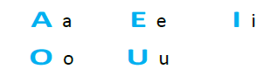
- Can identify the first sound in a word. Ask your child to name the first letter of the following words. 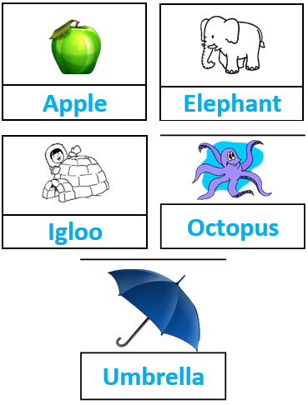

- Can break words into syllables. Ask your child to divide different words in sylla-bles, for example: Um-bre-lla, ta-ble .

Mathematics
- Can identify the numbers 0-10. Ask your child to point the number with his finger while he says the number aloud.

9 6 4 1 7 5
11 8 3 10 0 2

Ask your child to write the numbers, 0 to 10 in sequence

- Can count out loud to 20.
- Can sort items by color, shape, or size.
- Can point to and count 10 items out loud.

