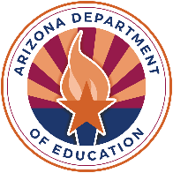
- Meets [frequency] about school health & safety
- Led by [name/position]
- Designates a [district and/or school] official to ensure that schools use the wellness policy
Current members include: [parents, students, teachers, administrators, food services representatives, other school staff, school board members, community partners, the public, other]

Actively recruiting!

District Wellness Committee

This institution is an equal opportunity provider.
- [Insert goals that were not started/completed for nutrition promotion, nutrition education, physical activity, and other activities.]

We met these goals:

Our future plans include:

- [Insert goals that were successfully completed for nutrition promotion, nutrition education, physical activity, and other activities.]

- [State whether your school met district policies for meal standards, competitive foods & drinks, celebrations, rewards, fundraisers, and marketing]

- [Insert your school’s activities related to plans for implementing the district wellness policy, triennial progress assessments, and public notifications]
We are still working on these:

Our Wellness Goals
[Year] Wellness Policy Report
[School Name]

[Your district logo here]
Our District Wellness Policies
Planning, Tracking, & Sharing

