Completing the Success Gaps Rubric & Action Plan Activity:

Subsequent Submission

Success Gaps Rubric (SGR)

Step #1:
After reassembling your SSIP Team, update your SSIP Team members, if necessary, and review the guidance for subsequent completion of the activity with fidelity. Beyond the directions, examples have been provided with screenshots and videos that can be used at the SSIP Team’s discretion.
Examples:
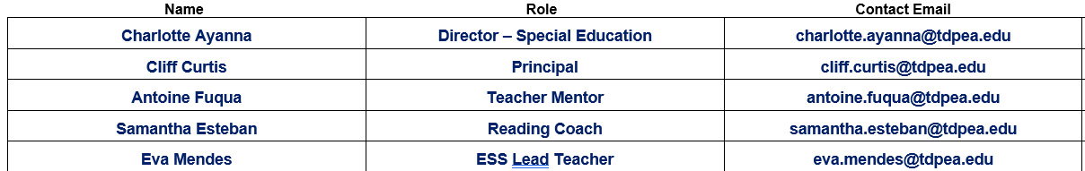

Step #2:
Review the Evidence for Consideration and any related notes that your SSIP Team has documented up to this point. Beginning with the submission date or period, document updates to evidence and related notes, where applicable.
- Example:

Step #3:
Review each level of implementation and decide as a team which level would most appropriately fit the current level of implementation in your learning community. Document your learning community’s current level in the next line of the submission periods.
- Example:
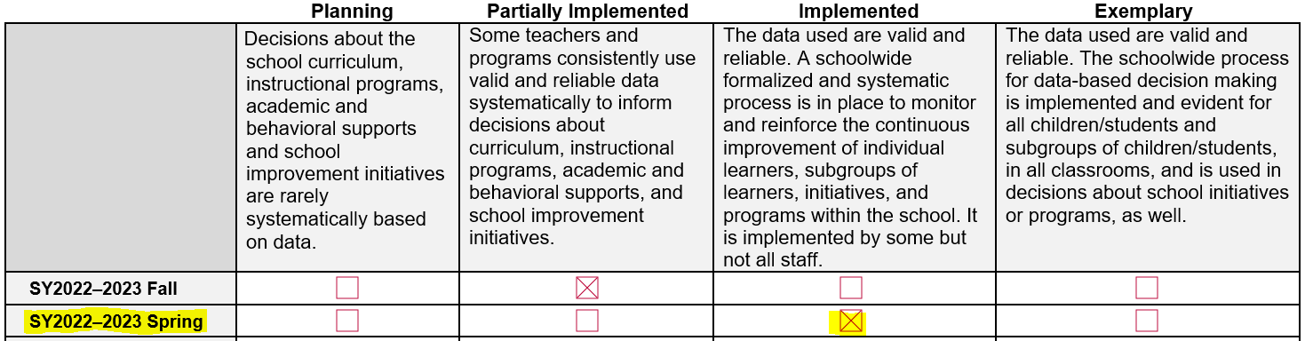

Step #4:
After the SSIP Team completes all 15 system indicators, review any changes in levels of system implementation and any implications on current and future initiatives.

The Action Plan (AP)

With your SSIP Team, transition to the documentation of initiative(s) on the AP.
Step #1
Begin by reviewing the guidance for subsequent completion of the activity with fidelity.
- Examples:

Step #2
Until an initiative has reached its goal, complete one or more Update lines for that initiative, indicating the submission period for the progress update. In connection to Rubric Levels of Implementation, at which point an initiative that has reached its goal, the SSIP Team can either choose to either:
- When the initiative continues to be connected to one of the lower levels of systemic implementation, reset the Baseline and Goal to continue pursuit and documentation of the initiative.
- Indicate that a higher level of Rubric implementation has been achieved (w/ submission period) and cease documentation of that initiative.
- Examples:
Note: Every Action Plan must show documentation of one ongoing Action initiative at each SSIP submission period.
Note: When updating initiatives that are connected to the SSIP Contract, make sure to maintain alignment between the SSIP Action Plan and the CEAE Planned Expenditures narrative at the bottom of the activity document.

