The SSIP Contract Process Within the Success Gaps Rubric and Action Plan (SGR & AP) Activity

Step 1
For each Indicator [Art.1-Example], the SSIP Team uses their consideration of evidence [Art.2-Example] to determine their community’s level of implementation for that Indicator [Art.3-Example].
[Art.1]
[Art.2]
[Art.3] 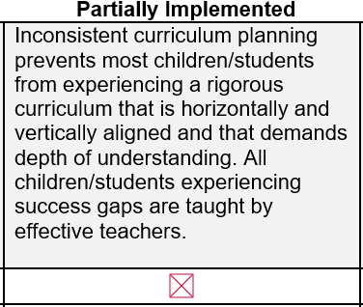
Step 2
With capacity and existing initiatives in mind, the SSIP Team then chooses no more than three of their lowest Rubric Indicators for the development of initiative(s) in the SSIP Action Plan.

Step 3
If the SSIP Team decides that the initiative(s) will incur expense that SSIP may support with contract funds, the Team can indicate this at the bottom of each Action [Art.4] and refer to the final page of the SGR & AP document for eligibility requirements and allowable expenses.
[Art.4]

Step 4
The SSIP Team reviews the SSIP Contract Eligibility [Art.5-Example] and Allowable Expenses [Art.6-Example] to determine if they believe intended initiative expenses are in alignment and writes a brief Planned Expenditures statement to make this connection explicit for a reviewer [Art.7-Example]
[Art.5]
[Art.6]
[Art.7] 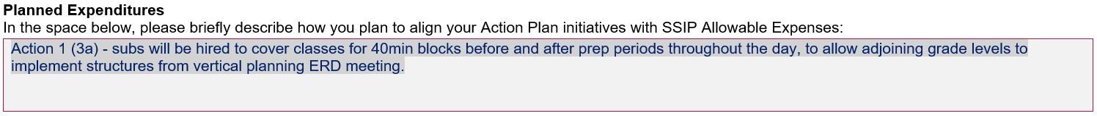

Step 5
After the Public Education Agency (PEA) SSIP Team completes the SGR & AP activity, indicating their intention to pursue an SSIP contract and completing the Planned Expenditures narrative, the Team submits the document to their PSM Specialist with a-cc to both their SSIP Coordinator and ESS Projects. After review, the PEA SSIP Team will receive feedback on both the SGR & AP activity and contract process.
Step 6
Using the SSIP Invoicing Guide and guidance from correspondence, the PEA SSIP Team submits the evidence of expenses to ESS Projects, with a-cc to both their SSIP Coordinator and PSM Specialist, within 30 days of incurring an SSIP initiative-aligned expense. After review, ESS Projects and/or your SSIP Coordinator will contact you with details about reimbursement.
Note: Public Education Agencies are eligible for up to $5,000.00 of SSIP contract reimbursement in each year of SSIP. Any time there is a change to Action Plan initiatives that are connected to contract reimbursement, such as closing and beginning a new initiative, the SSIP Team will need to reconsider the contract alignment process, beginning in Step 3, above.

