ELG Submissions in EMAC Guidance

LEA Administrators must assign an LEA AND School User to the ELG task in EMAC before schools can access and complete the ELG report.
Follow these steps to access EMAC:
- Go to ADEConnect Menu
- Select Applications
- Select EMAC

LEA Administrator steps to assign ELG to LEA and School Users in EMAC:
- You will see Unassigned Tasks on your Dashboard here:
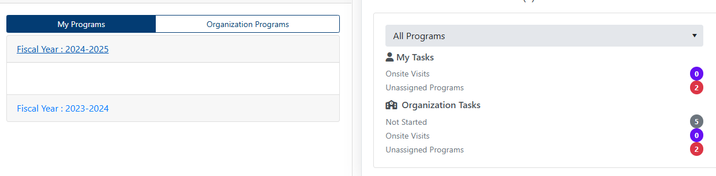

- Under Home (on top), select Assign Program Cycle:
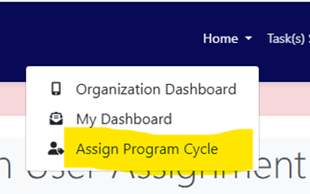

- Select Fiscal Year, Organization (must be at School level, not District Level), and ELG Program & Cycle, then click Search.
- Select Assignment, then in the drop-down box, select both LEA and School Users (may be the same person assigned to both), and select Add User. You can select the Users tab to view a list of available EMAC users for your organization.
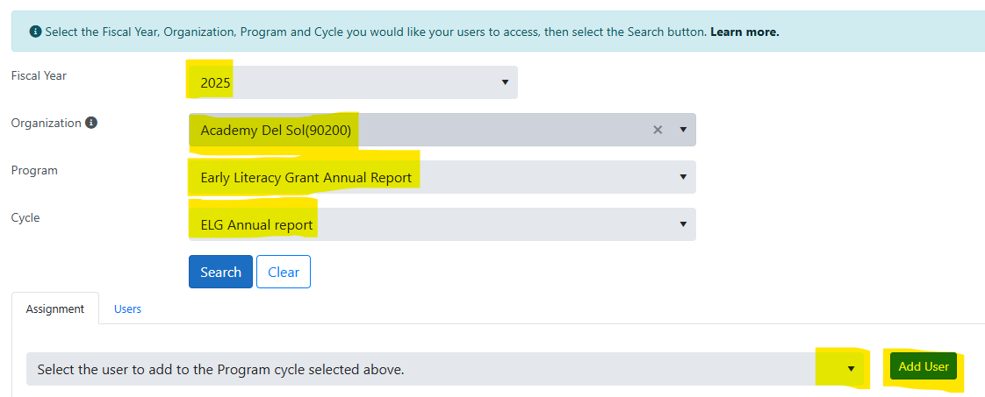
- If the LEA or School User is not shown in the drop-down box, the LEA Administrator will need to add the name (delete old ones as needed). LEA Administrator name changes need to be made through ADE Connect (Support information under Help button).

School User instructions to complete and submit ELG report:
- Select the number behind Not Started under My Tasks (if this is not showing, contact your LEA Administrator to assign the task to you). Make sure the correct year is selected for the Early Literacy Grant Annual Report.
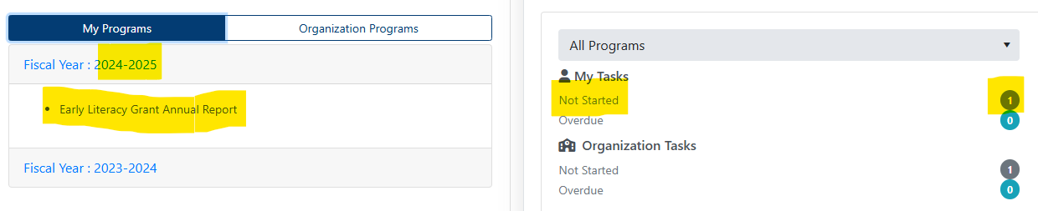
- Next, select the pencil icon under Actions (bottom right):
- Scroll down and select Not Started:
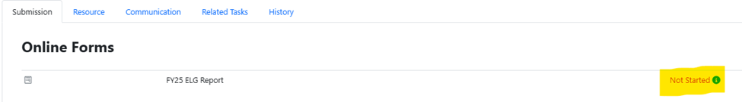
- This will take you to the form where you will fill in the ELG information. You can save your information as a draft if you need to come back and finish/submit it later (Save Draft at bottom). Select Complete when finished.
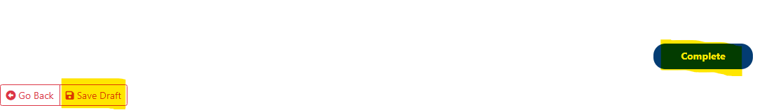
- Important: Once you have completed and submitted the information in the ELG Report as a School User, your submission will go to your LEA User, who will then need to review it and send on the final submission to ADE.

