NEW: AZ Virtual Family Engagement Center Launched
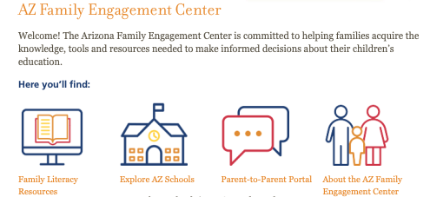

The virtual Arizona Family Engagement Center is now live on the Read On Arizona website. This new resource for Arizona families includes free family literacy resources, a parent-to-parent portal, and a new parent information data tool, Explore Arizona Schools, to help parents make informed choices about their child’s school. The virtual center is part of the Statewide Family Engagement Center Project. Partners include: National Center for Families Learning, Read On Arizona, Arizona Department of Education, Make Way For Books, Southwest Human Development and Unite For Literacy.

Visit the new AZ Family Engagement Center.

